**“Genomic Exploration of HPV-Associated Head Neck Squamous Cell Carcinoma Occurrence in Bangladesh: An Integrative Histopathological Analysis and Molecular Profiling of HPV”**



**A dissertation submitted to the Shahjalal University of Science and Technology in partial fulfillment of the requirements for the Master of Science (MS) Degree in Biochemistry and Molecular Biology**

**Submitted By**

**Registration No:** 2021423006

**MS Session:** 2021-22

**10th January 2025**

**Department of Biochemistry and Molecular Biology**

**School of Life Science**

**Shahjalal University of Science and Technology**

**Sylhet-3114, Bangladesh**

**Dedicated To**

**My Beloved Parents**

**My Respected Teachers**

**Acknowledgments**

Foremost, I want to express my gratitude to Almighty Allah for the wisdom, strength, peace of mind, and good health. He bestowed upon me to complete my dissertation.

I place on record my sincere gratitude to my supervisor **Dr. Shamim Ahmed**, Professor, Department of Biochemistry and Molecular Biology, Shahjalal University of Science and Technology, Sylhet-3114, for allowing me the opportunity to enroll my thesis under his kind supervision and for his patience, motivation, and immense knowledge. His guidance helped me throughout the research and writing of this thesis. I could not have imagined having a better advisor and mentor for my thesis study. I am extremely thankful and indebted to his valuable guidance and encouragement.

I am also grateful to my co-supervisor **Dr. S M Rashed Ul Islam,** Associate Professor, Department of Virology, Bangabandhu Sheikh Mujib Medical University for giving me the chance without any hesitation to conduct my thesis in their laboratory and allowing me to complete my thesis and providing me with excellent assistance. His profound knowledge and support throughout the period have shaped this dissertation into a meaningful format. The door to reach him was always open whenever I had any concerns or was stuck at a dead end and he, by his simple but significant solution, steered me in the right direction. I want to thank all the faculty members of the Virology Department.

A special mention to **Dr. Syed Farhan Ali Razib,** Associate Professor**,** Department of Otolaryngology**,** BSMMU**, Dr. Bishnu Pada Dey,** Associate Professor**,** Department of Pathology**,** BSMMU, **Dr. Afzalun Nessa**, Professor**,** Department of Virology**,** BSMMU, and **Md. Shafayet Jamil**, Medical Technologist, Covid Lab, BSMMU, for their assistance and guidance during the research. I am also appreciative of everyone who has assisted me with my thesis work, both internally and externally.

Finally, I must express my very profound gratitude to my parents, friends, and juniors for providing me with unwavering support and endless encouragement during my studies as well as during the process of researching and writing this thesis. This accomplishment would not have been possible without them.

Md. Sayeam Khandaker

10th January 2025

**To Whom It May Concern**

I hereby certify that in accordance with the laws of Shahjalal University of Science and Technology, Sylhet-3114, Bangladesh, the thesis work entitled **“Genomic Exploration of HPV-Associated Head Neck Squamous Cell Carcinoma Occurrence in Bangladesh: An Integrative Histopathological Analysis and Molecular Profiling of HPV”**described here is entirely own work of **Md. Sayeam Khandaker** bearing Registration No. **2021423006**, **Session:** 2021-22. This thesis does not contain any materials which were previously published or written by another person, except duly referred. The work was conducted under my supervision and was enrolled in the degree of Master of Science in Biochemistry and Molecular Biology at the Shahjalal University of Science and Technology, Sylhet-3114, Bangladesh. The work was carried out at the **Department of Virology,** Bangabandhu Sheikh Mujib Medical University, Shahbag, Dhaka -1000, Bangladesh. All information provided in the thesis paper has been obtained and presented following academic rules and ethical guidelines.

I hereby endorse his thesis to be submitted for evaluation.

Signature of the Co-Supervisor

**Dr. S M Rashed Ul Islam**

Associate Professor

Department of Virology

Bangabandhu Sheikh Mujib Medical University, Shahbag, Dhaka -1000, Bangladesh

Signature of the Supervisor

**Dr. Shamim Ahmed**

Professor

Department of Biochemistry and Molecular Biology

Shahjalal University of Science and Technology

Sylhet-3114, Bangladesh

**Guidelines for the MS Dissertation Writing**

**General recommendations**

* A total number of page limit (A4 size): not more than 90 pages, including references.
* Margins: 2.5 cm on all four sides.
* Font size 12, line space 1.5, Font: Times New Roman.
* Page numbering: The title page is not counted in the numbering of pages. The other page numbers are counted in the numbering pages. Number the preliminary pages (for example acknowledgments, table of contents, and abstract) that precede the main text with lower-cap Roman numbers beginning with I. Put page numbers at the bottom right end or center. Number the main text consecutively beginning with Arabic number 1.
* Print on a single side.
* Plagiarism shall be quantified into the following levels: **Overall, up to 25% and up to 2% single source will be the acceptable limit for thesis/dissertation**. The similarity check for plagiarism shall exclude the following: all quoted (not more than 1% of total texts) of work reproduced with all necessary permission and attribution; all references, bibliography, table of content, preface, and acknowledgments; all generic terms laws/ common phrases, standard symbols, and standard equations.

**Contents**

* Title page: The title page is the very first page of your dissertation. Do not number the title page. Use the template provided for the title page.
* Acknowledgments (**Except examiner’s copies (2)**).
* Guidelines to writing MS dissertation.
* Abbreviations.
* List of tables, graphs, and figures.
* Table of contents (Abstract, Introduction, Materials and Methods, Results, Discussion and Conclusion, References, and Appendices).
* Supervisor’s consent form.

**Recommendations for each section**

**• Abstract:**

* Word limit: not more than 350 words
* Keywords: Include **up to ten** keywords related to the thesis. These Keywords should be listed in the thesis after the abstract, separateds by commas.

**• Introduction**: The introduction provides the context for your dissertation by summarizing what is currently known about your research and stating the hypothesis or questions you have been studying. The introduction should briefly describe the rationale of the work and the approaches you took.

* Informative and relevant to the study plan is necessary to be understood.
* The significance of the study.
* Hypothesis and Aim of the Study.
* Can not copy figures from other sources, must reproduce the figure that you want to include in the thesis. In the case of a recreated figure, cite the original paper.

**• Material and Methods:** In the “Materials and Method” section you clearly explain how you did the study in detail so that a person with a scientific background could repeat the experiment just by reading your materials and methods section.

* Reagents/chemicals/kits with company names and their origins should be written for the reagent that has been used for the experiments.
* The information about the solution should be written in a standard format such as μM, mM, %, (w/v, v/v), etc. when a procedure is described using pertinent solutions.
* Centrifugation speed should be mentioned in RCF format (xg)
* Instrument models and origin that have been used for the experiment should be indicated in parentheses in describing the procedure.
* Describe how the data were analyzed (e.g. statistical software package name and version or any other software that has been used).
* No repetition of the same method in different sections.

**• Results:** The results section presents the results without interpretation using text, figures, graphs, and tables.

* Describe in section as data observed or concluded.
* No repetition of results in table, graph, or figure.
* The description should be precise and logical.

**• Figures and Tables:**

* The table with the title and footnote should be written precisely.
* Each figure or graph must have a legend. The reader must be able to understand the figure/graph from the legend alone without the text of the result section.

**• Discussion:** The discussion should interpret your results and explain how they led to a new understanding of the question or hypothesis you were studying. Find out a similar study and correlate the findings with the present study. Why is the different from the others, if any?

* What are the similarities of the present study with the other's findings, if any?
* What is the novelty of your study?
* What is the outcome(s) and limitations of this study?
* How would this research help the current and future direction of the field?

**• References:**

* Limit: not more than 80
* References should include only articles that are published or in the press. For referencing in a press article, please confirm with the cited journal that the article is accepted and, in the press, include the DOI number and online publication date. Unpublished data, submitted manuscripts, abstracts, and personal communications should be cited within the text only. Submitted articles should be cited as unpublished data not shown or personal communication.
* In-text citations should be written in **Harvard style** and not numbered, e,g. “Smith et., al 2015; Smith and Jones, 2015.”
* In the reference chapter, organize the reference list **alphabetically** and then number them.
* Should be relevant and updated

**Abbreviation**

|  |  |  |  |  |  |  |
| --- | --- | --- | --- | --- | --- | --- |
| **℃** | Celsius degree | | **G** | | | |
| **µL** | Microliter | | **GMM** | Genotyping Master Mix | | |
| **µM** | Micromolar | | **H** | | | |
| **mL** | Milliliter | | **H&E** | | Hematoxylin and Eosin | |
| **M** | molar | | **HNSCC** | | Head-Neck Squamous Cell Carcinoma | |
| **mM** | Millimolar | | **HPV** | Human Papillomavirus | | |
| **rpm**  **rcf** | revolutions per minute  Relative centrifugal force | | **I** | | | |
| **IHC** | | Immunohistochemistry | |
| **pH** | Potential of hydrogen | | **L** | | | |
| **Tm** | Melting Temperature | | **LDA** | | | Linear Discriminant Analysis |
| **LR** | | | Logistic Regression |
| **L1** | | | Late Gene 1 |
| **A** | | | **M** | | | |
| **AUC** | Area Under the Curve | | **ML** | | Machine Learning | |
| **C** | | | **P** | | | |
| **CDK** | | Cyclin Dependent Kinase | **PCR** | Polymerase Chain Reaction | | |
| **CE** | | Counter Electrode | **pRb** | Retinoblastoma Protein | | |
| **E** | | | **R** | | | |
| **EGFR** | | Epidermal Growth Factor Receptor | **RT-PCR** | | Real-Time Polymerase Chain Reaction | |
| **E1** | | Early Gene 1 | **ROC** | | Receiver-operating Characteristic Curve | |
| **E1** | Early Gene 2 | | **S** | | | |
| **F** | | | **SCC** | | Squamous Cell Carcinoma | |
| **SMM** | | Screening Master Mix | |
| **FFPE** | | Formalin Fixed Paraffin Embedded | **U** | | | |
| **UV** | Ultraviolet | | |

# List of Figures

|  |  |  |  |  |
| --- | --- | --- | --- | --- |
| **SL. NO.** | | **Figure Captions** | **Page No.** | |
| **Figure 1.1** | Worldwide incident and mortality rate due to cancer in 2022 | | | 2 |
| **Figure 1.2** | Ranking of Bangladesh in incident and mortality rate of Head-Neck Squamous Cell Carcinoma | | | 3 |
| **Figure 1.3** | Carcinoma of Squamous Cell | | | 4 |
| **Figure 1.4** | General Mechanism of HNSCC Development | | | 7 |
| **Figure 1.5** | Genomic organization of the Human Papillomavirus | | | 10 |
| **Figure 1.6** | Movement of HPV in stratified squamous epithelia during their life cycle | | | 12 |
| **Figure 1.7** | Mechanistic pathway of HPV-associated Head-Neck Squamous Cell Carcinoma | | | 13 |
| **Figure 1.8** | Areca-associated HNSCC development pathway | | | 15 |
| **Figure 1.9** | Non-infective factors cause the development of HNSCC | | | 17 |
| **Figure 1.10** | Microscopic visualization of tissue for histopathological analysis | | | 20 |
| **Figure 1.11** | Principle of Sanger sequencing | | | 21 |
| **Figure 1.12** | Principle of immunohistochemistry (IHC) | | | 22 |
| **Figure 2.1** | An overview of the study | | | 25 |
| **Figure 2.2** | Dehydration of tissue samples through progressively higher concentrations of alcohol and clearing via xylene | | | 29 |
| **Figure 2.3** | Tissue sectioning for staining and histopathological study | | | 31 |
| **Figure 2.4** | Slide preparation after Hematoxylin & Eosin staining | | | 33 |
| **Figure 2.5** | Agarose gel preparation | | | 44 |
| **Figure 2.6** | Sample DNA loaded into the gel | | | 45 |
| **Figure 2.7** | Slide preparation for immunohistochemistry | | | 50 |
| **Figure 3.1** | Pre-sampling procedure | | | 53 |
| **Figure 3.2** | Punch biopsy for tissue sampling and preservation | | | 54 |
| **Figure 3.3** | Sample distribution by gender and source of the collected tissue | | | 54 |
| **Figure 3.4** | Formalin Fixed Paraffin Embedded head-neck tissue block preparation | | | 55 |
| **Figure 3.5** | Histopathological analysis of head-neck tissues through Hematoxylin and Eosin staining | | | 56 |
| **Figure 3.6** | Head-Neck Squamous Cell Carcinoma (HNSCC) status distribution with grading among all collected tissue samples | | | 57 |
| **Figure 3.7** | Habitual risk factors and familial history evaluation of HNSCC patients | | | 59 |
| **Figure 3.8** | DNA extraction from HNSCC-positive tissue | | | 59 |
| **Figure 3.9** | HPV status in the HNSCC tissue sample | | | 60 |
| **Figure 3.10** | Genotyping of HPV from head neck cancerous tissue samples | | | 61 |
| **Figure 3.11** | Two distinct sets of primers of the HPV L1 gene | | | 62 |
| **Figure 3.12** | Prepared solution for 1st round PCR | | | 63 |
| **Figure 3.13** | Gel electrophoresis band of 1st round PCR amplified product | | | 63 |
| **Figure 3.14** | Preparation of 2nd round PCR mix. | | | 64 |
| **Figure 3.15** | Gel electrophoresis band of 1st round PCR amplified product | | | 64 |
| **Figure 3.16** | Chromatogram analysis from Sanger sequencing data | | | 65 |
| **Figure 3.17** | Confirmation of HPV strain via nucleotide BLAST searching | | | 66 |
| **Figure 3.18** | Immunohistochemical Analysis of pRb and cyclin D1 protein in head-neck Tissue. | | | 68 |
| **Figure 3.19** | Immunohistochemical analysis of p16INK4a and p53 protein in head-neck tissue | | | 69 |
| **Figure 3.20** | Host protein expression analysis in HPV-positive HNSCC sample | | | 70 |
| **Figure 3.21** | Distribution of HPV-positive HNSCC status with grading and age among all HNSCC-positive samples | | | 71 |
| **Figure 3.22** | Habitual risk factors and familial history evaluation of HPV-positive HNSCC patients | | | 73 |
| **Figure 3.23** | Predictive risk factor assessment for developing Head-Neck Squamous Cell Carcinoma (HNSCC) | | | 74 |

# List of Tables

|  |  |  |
| --- | --- | --- |
| **SL. NO.** | **Table Captions** | **Page No.** |
| **Table 1.1** | Classification of malignant neoplasm according to ICD-10 head and neck Subsites | 5 |
| **Table 2.1** | A list of required reagents for Hematoxylin solution preparation. | 32 |
| **Table 2.2** | Composition of the RT-PCR mixture for HPV screening | 38 |
| **Table 2.3** | Amplification profile of real-time PCR | 39 |
| **Table 2.4** | Composition of the RT-PCR mixture for HPV genotyping | 39 |
| **Table 2.5** | List of the primer sets for PCR amplification of HPV major capsid protein (L1 region) | 40 |
| **Table 2.6** | Preparation of 10 µM primer working solution | 41 |
| **Table 2.7** | Composition of first-round nested PCR mix | 41 |
| **Table 2.8** | First-round PCR (Nested-PCR) amplification profile | 42 |
| **Table 2.9** | 10X Tris-Borate-EDTA (TBE) buffer preparation | 42 |
| **Table 2.10** | Required reagents for 1.5% and 2% agarose gel preparation | 43 |
| **Table 2.11** | Composition of first-round nested PCR mix | 45 |
| **Table 2.12** | Second-round PCR (Nested-PCR) amplification profile | 46 |
| **Table 2.13** | Required ingredients of cycle sequencing reaction mix for Sanger sequencing | 47 |
| **Table 2.14** | Thermal cycling profile for cycle sequencing reaction | 47 |
| **Table 3.1** | Socio-demographic profile and clinical characteristics of study participants (N = 214) | 58 |
| **Table 3.2** | Consensus sequences of the HPV L1 gene detected from different HNSCC samples | 66 |
| **Table 3.3** | Socio-demographic profile and clinical characteristics of HPV-positive HNSCC patients (N = 53) | 72 |

**Table of Contents**

ContentsPage No**.**

**List of Figures** VII

**List of** **Tables** X

**Abstract** XV

**Chapter One: Introduction**

1.1 Preface 1

1.2 Epidemiology of Cancer 1

1.2.1 Global Perspective 1

1.2.2 Bangladesh Perspective 2

1.3 Head Neck Squamous Cell Carcinoma 3

1.3.1 Head Neck Cancer 3

1.3.2 Head Neck Cancer in Squamous Cell 4

1.4 Risk Factors of Developing HNSCC 6

1.4.1 HNSCC Arises Due to Infective Causes 7

1.4.1.1 Human Papillomavirus (HPV) 8

1.4.1.1.1 Taxonomy and Evolution of HPV 8

1.4.1.1.2 HPV Genome and Function of Viral Proteins 9

1.4.1.1.3 Mechanism of Infection and Life Cycle of HPV 10

1.4.1.1.4 Molecular Events of HPV Associated HNSCC Development 12

1.4.2 HNSCC Arises Due to Non-Infective Causes 14

1.4.2.1 Areca Nut-Associated HNSCC 14

1.4.2.2 Tobacco and Alcohol-Associated HNSCC 16

1.4.2.3 Other risk factors associated with HNSCC 16

1.5 Epidemiology of HNSCC in Bangladesh 17

1.6 Molecular Approaches in HNSCC Diagnosis 19

1.6.1 Histopathology for HNSCC Detection 20

1.6.2 Real-Time Polymerase Chain Reaction 20

1.6.3 DNA Sequencing 21

1.6.3.1 Sanger Sequencing 21

1.6.4 Immunohistochemistry 22

1.7 Aim of the Study 24

**Chapter Two: Materials and Methods**

2.1 Overview of this Study 25

2.2 Preparing the Questionnaire 26

2.3 Study Design 26

2.4 Study Place 26

2.5 Study Population 27

2.6 Selection Criteria 27

2.7 Study Specimen 27

2.8 Ethical Statement 28

2.9 Participant’s Consent 28

2.10 Sampling and Data Collection 28

2.11 Paraffin Embedding 29

2.12 Histopathological Study of Head Neck Tissues 30

2.12.1 Microtomy 30

2.12.2 Hematoxylin and Eosin Staining Procedure 31

2.12.2.1 Hematoxylin Staining Solution Preparation 32

2.13 Genomic DNA Extraction from Cancerous Tissue 34

2.13.1 Extraction from Paraffin-Embedded Cancerous Tissue Sections 34

2.13.2 Extraction from Freshly Collected Cancerous Tissue 36

2.14 Measurement of Extracted DNA Concentration and Purity 37

2.15 Molecular Screening of HPV through RT-PCR: 37

2.15.1 HPV Screening through RT-PCR 38

2.15.2 Genotyping of HPV through RT-PCR: 39

2.16 Strain Specificity of HPV through Sanger Sequencing 40

2.16.1 Primer Selection 40

2.16.2 Primer Reconstitution 41

2.16.3 Nested PCR for L1 Gene Amplification 41

2.16.3.1 First-Round PCR Amplification 41

2.16.3.2 PCR Amplification Products Visualization via Gel Electrophoresis 42

2.16.3.2.1 Preparation of 10X Tris-Borate-EDTA (TBE) Buffer 42

2.16.3.2.2 Preparation of Agarose Gel 43

2.16.3.2.3 Procedure of Electrophoresis and Amplicon Visualization 44

2.16.3.3 Second-round PCR Amplification of L1 gene 45

2.16.3.3.1 Visualization of 2nd round PCR Amplification Products 46

2.16.4 Nucleotide Sequencing 46

2.16.4.1 PCR Product Purification (1st Purification Step) 46

2.16.4.2 Cycle Sequencing 47

2.16.4.3 Purification of Cycle Sequencing Product (2nd Purification Step) 48

2.16.4.4 Capillary Electrophoresis 48

2.17 Bioinformatics Analysis 48

2.17.1 Chromatogram Analysis 48

2.17.2 Phylogenetic Tree Construction 49

2.17.3 Mutational Analysis 49

2.18 Immunohistochemistry for both HPV Positive and HPV Negative HNSCC Tissue Sample 49

2.19 Statistical and Machine Learning Analysis 51

**Chapter Three: Results**

3.1 Preparatory Steps for Sample Collection 53

3.2 Specimen Collection 53

3.3 Overview of Sample Collection 54

3.4 Tissue Embedded in Paraffin Block 54

3.5 Histopathological Analysis 55

3.6 Socio-Demographic Profile of Study Cohort 57

3.7 Addiction Profiles and Familial History of HNSCC Patients 58

3.8 Extracted DNA from Cancerous Tissue 59

3.9 Molecular Profiling of Human Papillomavirus 60

3.9.1 HPV Screening 60

3.9.2 HPV Genotyping 61

3.10 HPV Strain Specificity through Sanger Sequencing 62

3.10.1 Performing Nested PCR and Gel Electrophoresis 62

3.10.2 Visualization of 1st Round Amplified Product 63

3.10.3 Prepared Solution for 2nd Round PCR 64

3.10.4 Visualization of 2nd Round Amplified Product 64

3.10.5 Retrieve the Nucleotide Sequence of the L1 gene 65

3.11 BLAST Search 66

3.12 Immunohistochemical Analysis 67

3.13 Correlation Between Host Protein Expressions in HPV-Positive HNSCC Sample 70

3.14 Socio-Demographic Profile of HPV-associated HNSCC Patients 71

3.15 Addiction Profiles and Familial History of HPV associated HNSCC Patients 73

3.16 High-risk Factor Evaluation and Validation of ML Classifier Model in HNSCC 73

**Chapter Four: Discussion**

4.1 Discussion 75

4.2 Limitations 82

**Chapter Five: Conclusion and Future Aspects**

5.1 Concluding Remarks and Future Aspects 83

**Chapter Six: References** 84

**Chapter Seven: Appendices** 90

# Abstract

The present devastating status of the HNSCC in Bangladesh has raised the concern to understand the underlying factors associated with this disease. HPV is one of the most critical factors accountable for developing HNSCC. The amplifying rate of infection has been reported across several regions of the Asian continent and propagated in a multitude of people. The hidden factor that conduces the detrimental circumstances of HNSCC in our country has not been revealed yet due to the limited studies on HPV-associated HNSCC. To surmount this issue, we aimed to identify the occurrence of HPV-associated HNSCC through genomic exploration and HPV as the prime factor responsible for HNSCC through Machine Learning approaches. In this study, among 416 clinical samples, 214 HNSCC-positive cases were observed histopathologically which were then subjected to molecular screening. The strain and their mutations in the L1 gene of HPV were identified from the Sanger sequence retrieved data in bioinformatics approaches. Validating HPV as the principal cause of HNSCC, host protein expressions were observed in the HPV-positive samples through immunohistochemistry. Finally, the best feature among all known factors that cause cancer was identified from the dataset using ML classification modules. The 53/214 (24.8%) HNSCC-positive samples were HPV DNA positive where a large number, 62.2%, and 30.2%, malignancy occurred in the buccal mucosa, and tongue respectively. In all these tissues, HPV16 was the main etiological agent, existing in 95% of cases. Along with HPV16, high-risk HPV18, 31, and 33 were also detected as causative factors of HNSCC development. Moreover, the differential expression of host cellular markers p16INK4a, pRb, cyclin D1, and p53 confirmed HPV as the main causal factor of developing HNSCC in these 53 samples. Linear Discriminant Analysis (the best-fitted model) with an AUC of 0.874 identified HPV infection as the best feature to classify cancer samples, which aligns with our hypothesis. In contrast, the others 181/214 (75.2%) of HNSCC occurred due to non-infective agents including betel quid, smoking, smokeless tobacco, alcohol, etc. Collectively, this study demonstrates that HPV-associated HNSCC poses a significant threat which is probably the unwitting cause of enhancing the occurrence and recurrence rate in Bangladesh. This insight might help to pave the way to reduce the destructive nature of HNSCC and enlighten the clinical community of Bangladesh regarding HPV-associated HNSCC.

**Keywords**: Head Neck Squamous Cell Carcinoma, HNSCC, HPV, p16INK4a, HPV profiling, Sanger sequencing, immunohistochemistry, machine learning model.

# Chapter One

# Introduction

# 1.1 Preface

The biological system of humans is a complex but beautifully coordinated, fully programmed, and encoded system. This orchestra of biological systems is nothing but the coordination of cellular activity at the molecular level. The cellular mechanisms, namely cell cycle regulation, mitosis or miosis, replication, transcription, translation, metabolisms, and finally, programmed cell death (apoptosis), need native protein structures to be performed perfectly. However, cancer is a combination of diseases caused by several somatic mutations in DNA that disrupt these cellular mechanisms by directing faulty protein synthesis, causing uncontrolled cell cycles, downregulating apoptosis, and other dysfunctions; hence, in cancer, the faulty cell continues to proliferate without any regulation (American et al., 1996). In addition to these mutations, there are some viral agents, known as “tumor viruses” or “oncogenic viruses”, which cause cancer by altering the normal regulation of cell division and cell growth. By integrating their genomic material into the host DNA or affecting crucial signaling pathways, they control the cell proliferation process, like as, the activation of oncogenes, inactivation of tumor suppressor genes, and disruption of the host homeostatic mechanisms that typically prevent abnormal cell growth. Furthermore, the oncogenic viruses possess the ability to escape the intricate defense mechanism of the host, allowing them to survive and resist cell death that causes tumor formation, eventually contributing to the progression of metastatic cancer development (Carrillo-Infante et al., 2007).

# 1.2 Epidemiology of Cancer

# 1.2.1 Global Perspective

The term “Cancer” is a generic term for a large group of disease threats to the world because of its detrimental nature. In the 21st century, cancer is the world’s most significant public health challenge. As reported by the Global Cancer Statistics (GLOBOCAN), a part of the World Health Organization (WHO) International Agency for Research on Cancer (IRAC) Global Cancer Observatory, an estimated 20 million recent cases of cancer were diagnosed globally in 2022 with 9 million deaths of cancer. The maximum incidence and mortality rates were observed in Asia, where approximately 50% of the people from the Asia region were affected from which nearly 60% of the people died (“Cancer Today,” n.d.; “State of cancer care in Bangladesh | The Daily Star,” n.d.).

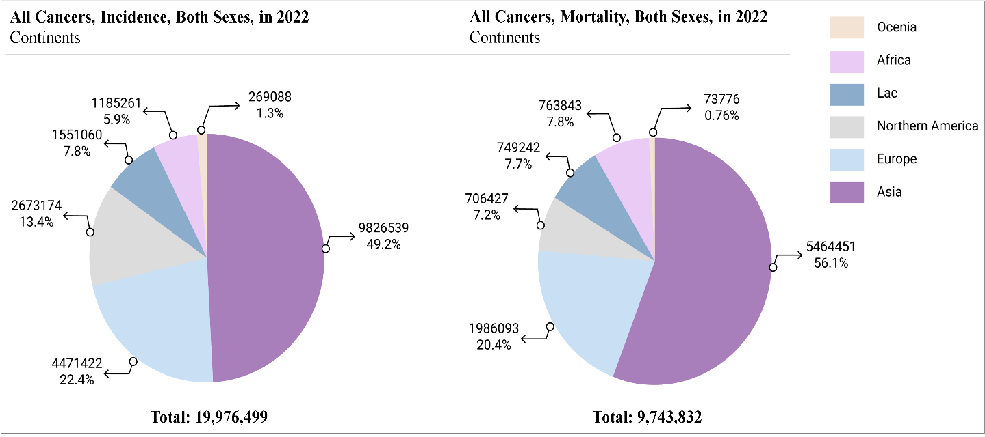**Figure 1.1:** **Worldwide incident and mortality rate due to cancers in 2022.** [Plotted with Adobe Illustrator V.10.0.2 (“Cancer Today,” n.d.)]

The most prevalent cancerous sites in Asia are the lung, breast, colorectum, oral, lip, prostate, and liver, as well as malignancy of the pharynx and larynx (“Cancer Today,” n.d.). A larger portion of these cases involve the head-neck region, including the oropharynx, oral cavity, hypopharynx, and larynx. Head-neck region-associated carcinoma has become a major concern for the scientific community due to demographic factors specific to the Asian continent.

# 1.2.2 Bangladesh Perspective

In Bangladesh, a small and densely populated country in Asia, the cancer prevalence is rising day by day. Following the latest information for 2022, 167,256 new cancer cases were reported, resulting in 116,598 cancer-related deaths which marks an increase from 2020. Approximately 156,775 new cancer cases were identified, and 1,08,990 individuals were dead. The most frequently occurring cancers for both sexes were the oesophageal, lip and oral cavity, lung, breast, cervical, hypopharyngeal, stomach, and laryngeal cancers indicating that head-neck associated carcinoma was the most prevalent in Bangladesh.

Head and neck-associated carcinoma pose a significant threat to the Asia region due to its high incidence and mortality rates. Bangladesh ranks 2nd in incidence and 3rd in mortality for lip and oral cancers, a major component of head-neck cancers. Along with hypopharyngeal and laryngeal carcinomas, these cancers are particularly dangerous for the Bangladeshi population(“Cancer Today,” n.d.).

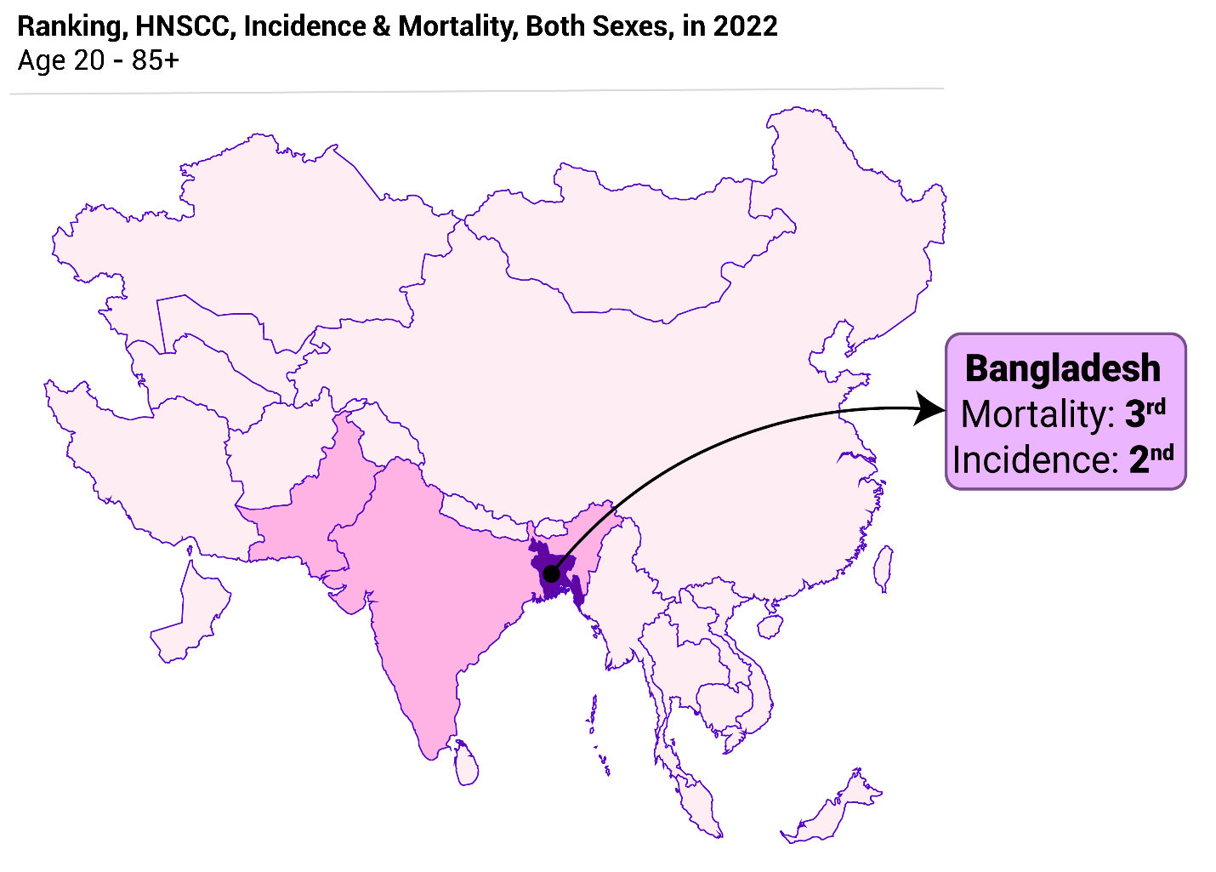**Figure 1.2**: **Ranking of Bangladesh in incident and mortality rate of Head-Neck Squamous Cell Carcinoma.** Based on GLOBOCAN data, in the continent of Asia, Bangladesh ranks 2nd in incidence and 3rd in mortality. Here, HNSCC refers to Head-Neck Squamous Cell Carcinoma. [Plotted with Adobe Illustrator V.10.0.2 (“Cancer Today,” n.d.)]

# 1.3 Head Neck Squamous Cell Carcinoma

# 1.3.1 Head Neck Cancer

Head-neck cancer refers to a diverse group of malignant tumors that can develop in or around the head and neck region including the throat, nose, mouth, sinuses, larynx, and salivary glands. These cancers typically arise from the squamous cells, lining the moist, mucosal surfaces of these regions, leading to the most common form known as squamous cell carcinoma (SCC) (Chin et al., 2006). However, other types of malignancies, such as adenocarcinomas, sarcomas, and lymphomas, are considered as non-squamous cell cancers, but they are distinct from squamous cell carcinoma (SCC) in both origin and classification." can also occur in the head-neck region (Chiesa-Estomba et al., 2023). But, the most common and prevalent carcinoma in the head-neck region is squamous cell carcinoma compared with non-squamous cell carcinoma.

# 1.3.2 Head Neck Cancer in Squamous Cell

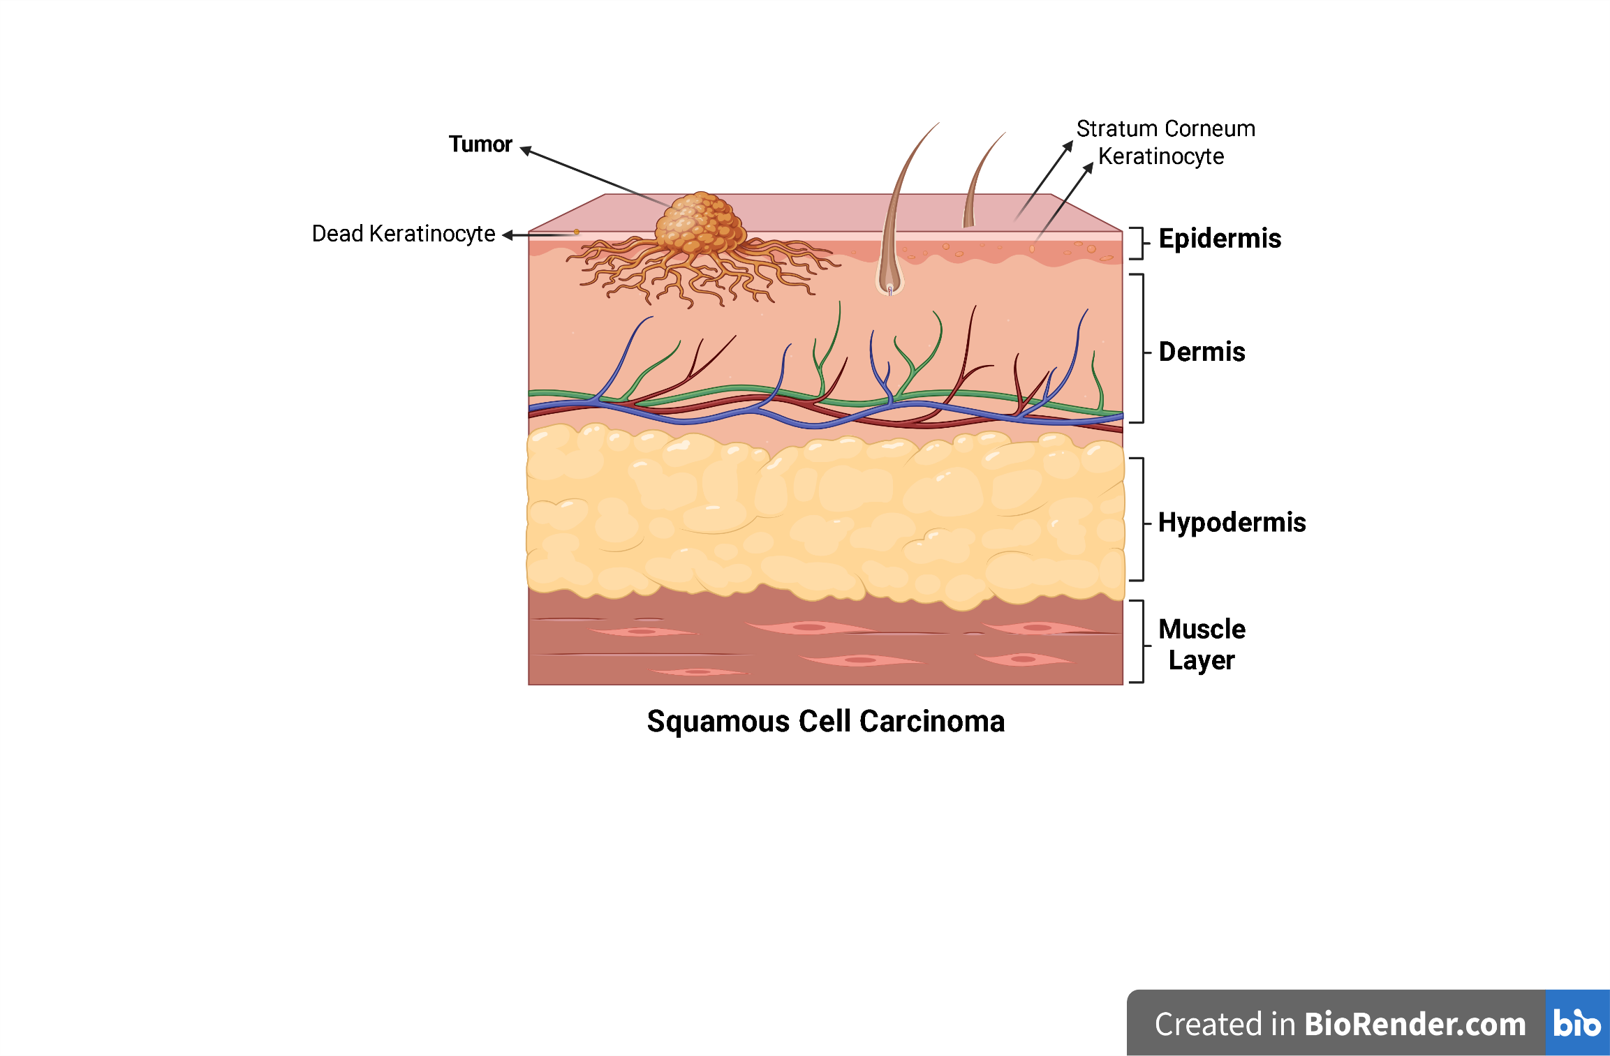Squamous cell carcinoma (SCC) is a type of carcinoma arising from squamous cells which are flat, thin cells that build up the outer layer of the epidermis and line various mucosal surfaces in the body (“What Is Skin Cancer? Causes, Pictures, Types, and More,” n.d.). In several parts of the head and neck regions **(Table 1.1)** SCC develops from the mucosal epithelium with some distinct features including (“Head and neck cancers - Symptoms and causes - Mayo Clinic,” n.d.):

**Figure 1.3: Carcinoma of Squamous Cell.** [Plotted with Adobe Illustrator V.10.0.2 (“Squamous Cell Carcinoma | Front Range Dermatology,” n.d.)]

**Table 1.1: Classification of Malignant Neoplasm According to ICD-10 Head and Neck Subsites** (“ICD-10 Version:2019,” n.d.)

|  |  |  |
| --- | --- | --- |
| **Head Neck Sites** | **Head Neck Subsites** | **ICD-10 Classification** |
| **Oral cavity** | Borders of the tongue | C02.1 |
| Gingiva | C03 |
| Floor of the mouth | C04 |
| Hard palate | C05.0 |
| Buccal mucosa | C06.0 |
| Vestibular fold | C06.1 |
| Retromolar area | C06.2 |
| **Oropharynx** | Base of the tongue | C01 |
| Soft palate | C05.1 |
| Tonsil | C09.9 |
| Vallecula | C10.0 |
| Pharyngeal walls | C10.2 & C10.3 |
| **Hypopharynx** | Pyriform fossa | C12 |
| Cricoid region | C13 |
| **Larynx** | Vocal Cord | C32.0 |
| Supraglottic | C32.0 |
| Epiglottic | C32.1 |
| Aryepiglottic fold | C32.1 |
| **Nasopharynx** | Roof | C11.0 |
| Pharyngeal tonsil | C11.1 |
| Floor | C11.3 |
| Septum | C11.3 |

**ICD:** *International Statistical Classification of Diseases and Related Health Problems*

1. Persistent non-healing mouth sores
2. Lumps, swelling, or thickening in the oral cavity, gums, or neck.
3. Red or White color patches inside the mouth.
4. Bleeding during coughing and in the parts of several subsites of the oral cavity.
5. Chewing or swallowing difficulty and feeling pain in the lesion region.
6. Ear pain
7. Dramatically weight loss, etc.

With these signs and symptoms, Head Neck Squamous Cell Carcinoma (HNSCC) progressively becomes more menacing for an individual, markedly exacerbating over time and leading to difficulty in survival. As a consequence, it is the 6th most common cancer in the world, causing approximately 350,000 deaths annually and a 40% - 50% morbidity and mortality rate within five years (Yu et al., 2022) where above 65% of these cancers have occurred in Brazil, Uruguay, France, Eastern Europe, and some South Asia countries, a high-risk geographical area (Warnakulasuriya, 2009). In these regions, HNSCC of the oral cavity is more frequent than pharyngeal and laryngeal carcinoma (“Cancer Over Time,” n.d.).

# 1.4 Risk Factors of Developing HNSCC

There are several risk factors associated with Head-Neck Squamous Cell Carcinoma (HNSCC) (Sun et al., 2022), also classified into two groups that are responsible for developing HNSCC.

1. Infective causes – HPV, EVB, HCV, and HBV.
2. Non-infective causes – Alcohol, Tobacco, Betel Quid, Batel Leaf, Inadequate nutrition, and Poor Oral hygiene.

These factors are also responsible for any type of molecular alteration in an individual. As like as carcinogenic agents, these are responsible for changing the molecules that control the cellular signaling pathways involving cell cycle arrest, DNA repair mechanism, and apoptotic process. Mutations or degradation of p53, a tumor suppressor gene, p16INK4a activation, a cyclin-dependent kinase (CDK) inhibitor, and overexpression of cyclin D1 and epidermal growth factor receptor (EGFR) are more common in HNSCC.

**Figure 1.4: General mechanism of Head-Neck Squamous Cell Carcinoma (HNSCC) development**. Non-infective agents cause HNSCC by inducing mutation and infective agents, HPV, conduces HNSCC by the degradation of cellular protein (p53, pRb) and upregulation of the APOBEC gene. [Plotted with Adobe Illustrator V.10.0.2]

# 1.4.1 HNSCC Arises Due to Infective Causes

GOLBACAN data 2020 indicates that oncogenic infectious agents are spreading rapidly in Asia compared to other regions. Although a small percentage of HNSCC cases occur due to infectious agents, the number is increasing gradually nowadays (“GLOBOCAN 2020: New Global Cancer Data | UICC,” n.d.). There are some oncogenic viruses including Human papillomavirus (HPV), Epstein–Barr virus (EBV), Hepatitis C virus (HCV), and Hepatitis B virus (HBV) have also been recognized as responsible agents for causing HNSCC. From these, HPV is a major etiological agent for causing malignancy in a large part of the head and neck whereas EVB and HBV are closely associated with nonkeratinizing nasopharyngeal carcinomas (NPCs) (Mahmutović et al., 2021). The other is also a risk factor for head-neck cancer where a meta-analysis reports by investigating 8 observational studies of an important effect of HCV in HNSCC. However, due to their low sample size, the inference of these studies has been limited (Borsetto et al., 2020). Among these, HPV is crucial for developing cancer in a larger portion of the head-neck region. A study reported that HPV-associated HNSCC is increasing dramatically, specifically in the oropharyngeal region, and worldwide around 25% of HNSCCs are caused by orally transmitted HPV. However, this percentage of HPV association also varies between the head-neck anatomical sites such as between oral, oropharyngeal, and laryngeal regions.

# 1.4.1.1 Human papillomavirus (HPV)

# 1.4.1.1.1 Taxonomy and Evolution of HPV

Taxonomically, HPV is a member of the “Papillomaviridae” family which is a species-specific type of papillomaviruses. Actually, papillomaviruses are known as the oldest viruses among others, originating approximately 330 million years ago, from the Paleozoic era (Syrjänen, 2018). Around 90 million years ago, these viruses started to develop with mucosal tropism, leading to the evolution of human papillomaviruses (HPVs) (Mahmutović et al., 2021). According to a recent update, almost 280 types of papillomaviruses have been detected yet in vertebrates where around 200 types infect the human body and are predominately classified into 5 genera (Mahmutović et al., 2021):

1. ∝-papillomavirus
2. β-papillomavirus
3. γ-papillomavirus
4. mu-papillomavirus and
5. nu-papillomavirus

Among these, the ∝-, β-, and γ papillomavirus are great in numbers and ∝ papillomavirus is most prevalent in the mucosa (Mahmutović et al., 2021). Along with this, mucosal HPVs are classified into two groups based on their carcinogenic role (Dunne and Park, 2013).

1. Oncogenic or high-risk HPVs
2. Non-oncogenic or low-risk HPVs

The World Health Organization International Agency for Research on Cancer (IARC) classified 12 strains of HPV including, HPV-16, 18, 31, 33, 35, 39, 45, 51, 52, 56, 58, and 59 as high-risk carcinogenic types in humans. In contrast, some strains such as HPV- 6, 11, 40, 41, 42, 43, 44, 54, 61, 72, 81, etc are categorized as low-risk carcinogenic types. The non-oncogenic types are linked to causing anogenital warts and recurrent respiratory papillomatosis (RRP) whereas the oncogenic strains are the critical risk factors for developing several types of squamous cell malignancy in the head-neck region (Dunne and Park, 2013; Mahmutović et al., 2021). Among them, HPV types 16, 18, 31, and 33 are more threatening while approximately 90% of HPV-associated HNSCC occurs due to HPV 16 (de Martel et al., 2017a; Smith et al., 2017a).

Though several types of HPV differ due to their genomic consequences, all of them are members of the Papillomaviridae family and have some of the same morphological features. Human papillomaviruses are closed, small icosahedral nonenveloped viruses with 50–55 nm diameter and 5×106 Da weight which have both hexavalent and pentavalent capsomeres in their capsids. These viruses have around 8 kbp long circular double-stranded monopartite genomic DNA (“Papillomaviridae,” n.d.) that contains some crucial genes that are solely responsible for the integration of viral genomic DNA into the host and the development of cancer. The distinct genomic features of these individual genes make HPV a threat to the host.

# 1.4.1.1.2 HPV Genome and Function of Viral Proteins

The genetic makeup of HPV is highly conserved evolutionarily, presenting a 1% divergence rate per 40,000–80,000 years. The double-stranded viral genome has three important regions (Araldi et al., 2018; Tommasino, 2014):

1. **Early region-** It is crucial for viral DNA replication, transcriptional regulation, control of the host cell cycle, and several cellular signaling events. Additionally, it modulates the host defense mechanism and induces structural modifications in the infected cell (Graham, 2010; Tommasino, 2014).
2. **Late region-** It is vital for viral transmission, spread, and survival in a host body. Two important structural proteins of HPV, L1, and L2, are coded from this region (Graham, 2010; Tommasino, 2014).
3. 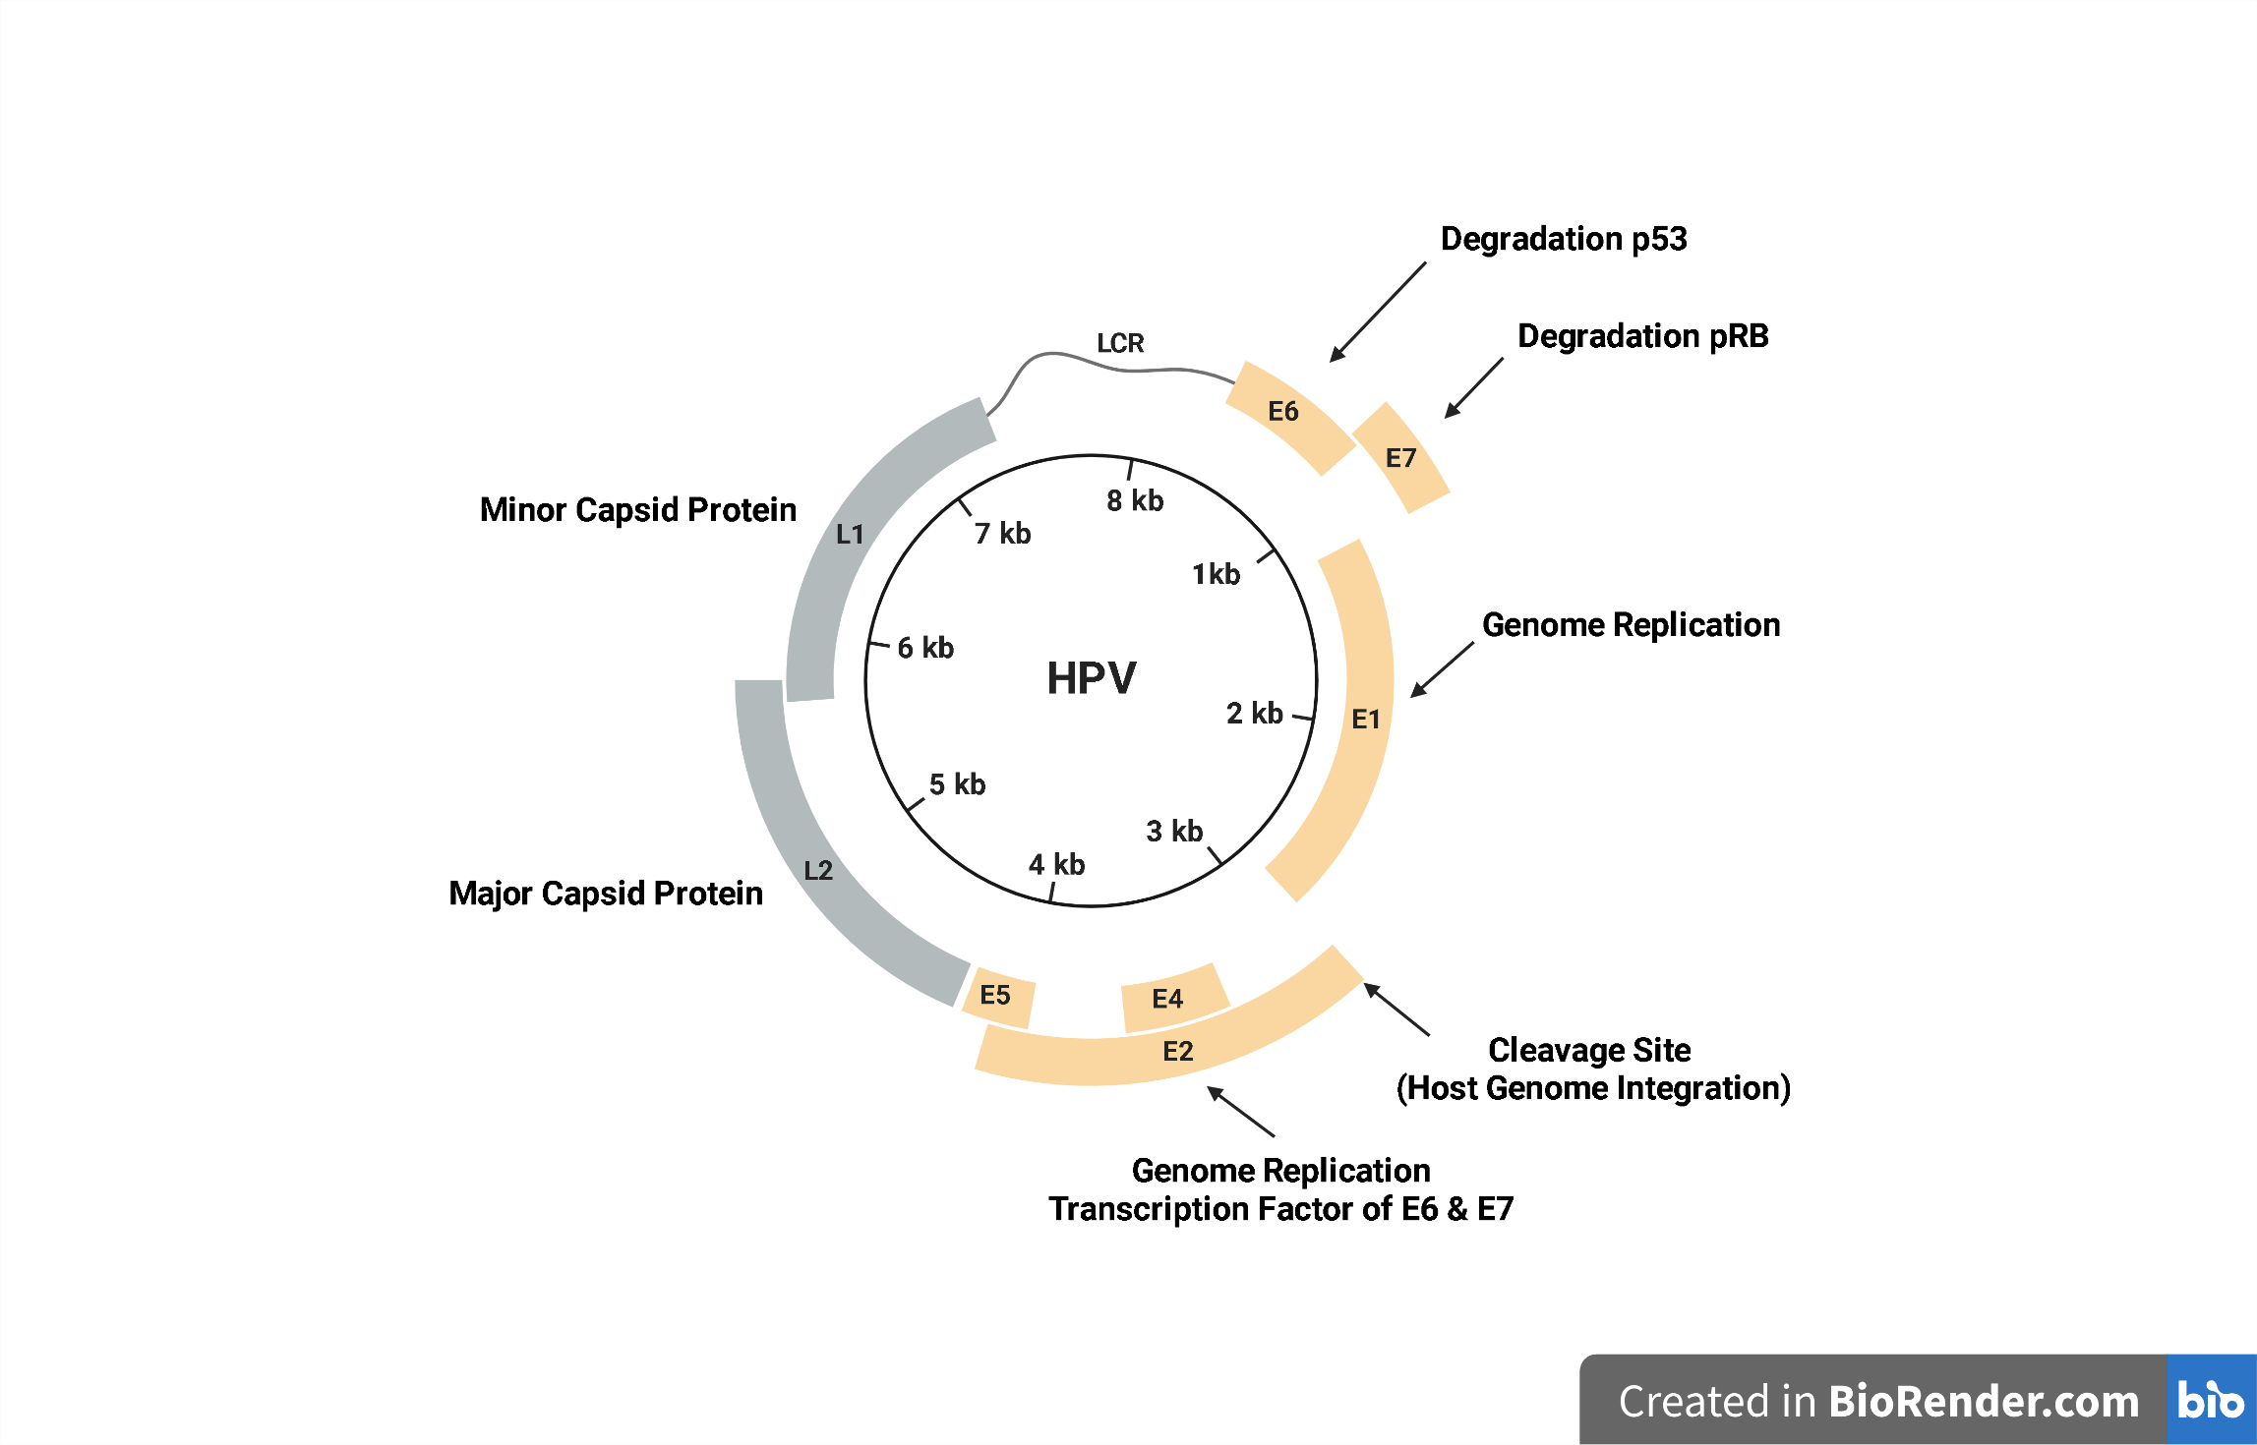**Long Control Region (LCR)-** It is a noncoding AT-rich sequencing and poly T repeats region between the L1 and E6 open reading frames (ORFs), also contains important regulatory elements that regulate DNA replication and transcription of HPV, including the ori site (Araldi et al., 2018; Nelson and Mirabello, 2023).

**Figure 1.5: Genomic organization of the Human papillomavirus.** Here, the locations of the early (E1-E2, and E4 - E7), late genes (L1 and L2), and long control region (LCR) of the circular genome of HPV are shown. [Reproduce with permission (Nelson and Mirabello, 2023)]

The 1st two regions are named based on the timing of viral protein expression from these regions or protein-coding open reading frames (ORFs) that occur after the viral infection.

# 1.4.1.1.3 Mechanism of Infection and Life Cycle of HPV

HPV infection occurs basically due to the initiation of sexual activity. Sexual contact including oral, anal, and vaginal sex is the most common mode of transmission. One study reports that a 28.5% infection rate was observed in college-aged women after their first sexual intercourse within one year which increased gradually to nearly 50% after three years (Wang and Palefsky, 2015). Even individuals with one or multiple lifetime sex partners are at risk of HPV transmission, occurred through vaginal, anal, oral-genital, or genital-genital contact (Winer et al., 2008). Additionally, nonsexual transmission such as horizontal transmission through infected fomites, fingers, or skin-to-skin contact that is not related to sexual activity, as well as vertical transfer from mother to child and, in most cases water-born transmission, have been observed (“Non-sexual HPV transmission and role of vaccination for a better future (Review),” n.d.). After HPV enters into the dividing basal epithelial cells in the genital, anal, or oral regions by falling down micro-lesion that occurs during sexual activity, making it easier for viral infection in the epithelium. To insert the genomic material into the host body a major capsid protein - L1 binds to a cell surface molecule known as Heparin Sulphate Proteoglycans (HSPGs) and several integrins like α6 (CD49f), 332 (laminin 5) and α6β4. For these, the viral capsid undergoes conformational alteration, allowing viral entry as a vacuolar shape through caveolin or clathrin-mediated endocytosis mechanisms. From the endocytic vesicles, phagolysosomes will be formed after attaching the lysosome to the vesicles and reducing the pH level leading to capsid disassembling. Then the viral genome will be released gradually and transported to the nucleus (Araldi et al., 2018).

However, self-replication is not possible for HPV as it does not express polymerase enzymes. Therefore, it utilizes host DNA polymerase and other machinery to amplify the viral genome to ~50–200 copies per cell (Moody and Laimins, 2010). Sequentially, the early viral genes, E1 and E2 are also transcribed using the host machinery. E1 acts as a helicase while E2 acts as a DNA-binding protein, having a crucial role in maintaining the viral genome and its replication. Actually, E2 plays a crucial role as a regulatory molecule by binding to particular regions of viral DNA and deregulating the E6 and E7 genes, also known as oncogenes, during the viral life cycle (McBride, 2017). However, sometimes viral DNA integration occurs in the host genome where E2 also plays a driving role in both viral amplification and cancer initiation. The early protein E1 or E2 interacts with the host cell to induce the S-phase entry and integrate the viral genome into the host DNA to attain the DNA polymerase mechanism. Consequently, viral DNA also replicates along with the host DNA. On the other hand, due to the loss of the E2 gene, the oncogenic E6 and E7 are highly expressed in the cell and are responsible for cellular transformation.

After replication, HPV plays a crucial role in the basal layer gene expression. To establish a long-

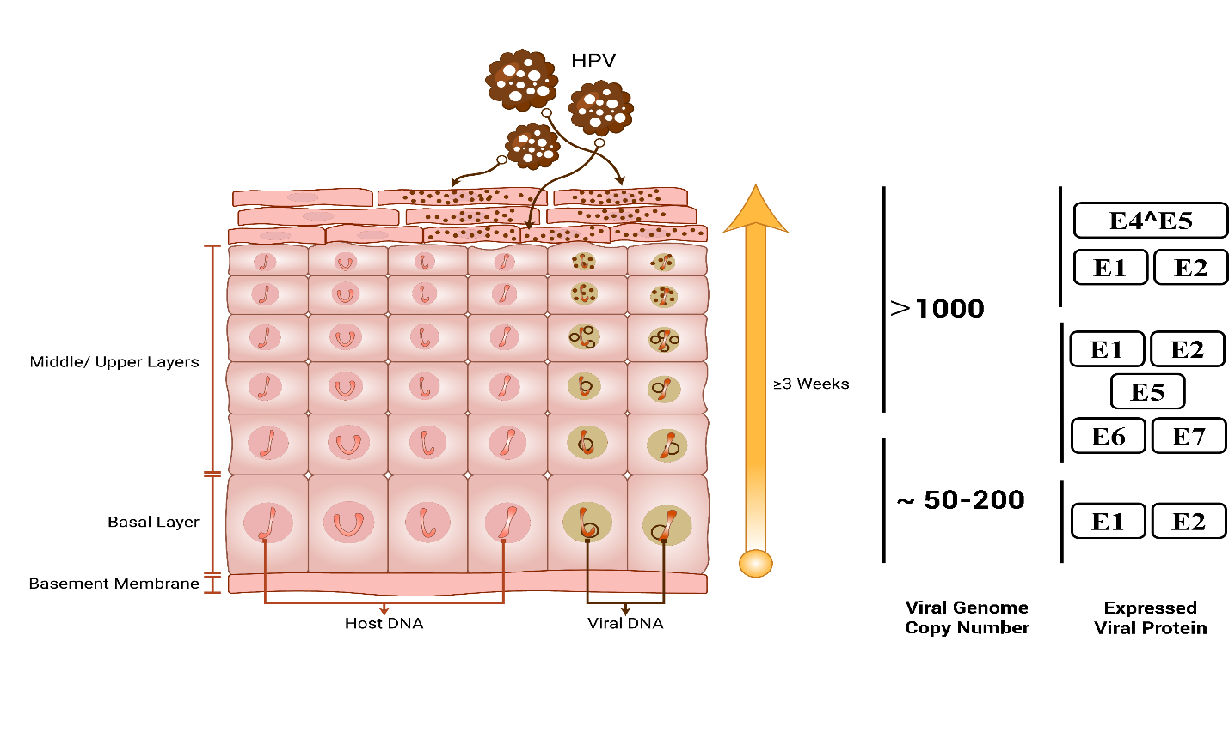term and persistent infection, HPV keeps low gene expression to reduce the chances of host immune detection. However, when the progeny cells move toward the epithelial surface and differentiate, viral genomes rapidly increase to 103, commencing the early and late gene expression and formation of virus particles. Therefore, numerical and structural chromosomal instability occurs. This instability and high oncogenic expression can lead to metastatic cancer development (**Figure 1.6**). (25,22) But the causation of cancer is not the main goal of HPV, rather, it’s a ‘rare byproduct’, (27) also referred to as “collateral damage” of infection (Nelson and Mirabello, 2023).

**Figure 1.6:** **Movement of HPV in stratified squamous epithelia during their life cycle**. [Reproduce with permission (Nelson and Mirabello, 2023)]

# 1.4.1.1.4 Molecular Events of HPV Associated HNSCC Development

The major early viral proteins, E5, E6, and E7, are solely responsible for causing HPV-associated head-neck cancer also known as HPV oncoproteins. These can drive the initiation, promotion, and development of metastatic cancer. E6 and E7 are the initial HPV oncoproteins that cause oncogenesis whereas E5 is the secondary oncoprotein with a supportive role in oncogenesis (de Martel et al., 2017b).

The primary task of E6 oncoprotein is to form a complex by binding with p53 and enhance the anti-apoptotic signal by degrading p53 in the 26S proteasome. It also interacts with XRCC1 and O6-methylguanosine-DNA-methyl transferase proteins, making them difficult to repair single-strand DNA break (SSB), enhanced mutation rate, and genomic instability (Araldi et al., 2018; Nelson and Mirabello, 2023; Vats et al., 2021). Along with this, E7 stimulates the phosphorylation of retinoblastoma protein (pRb) and this phosphorylation activates E2F-responsive genes, including A, D1, D2, D3, and E. As a result, it stimulates the cell cycle event, and signaling molecules, are associated with cell proliferation. This protein also affects the double-strand DNA break (DSB) repair by reducing the histone γ-H2 AX activity that also causes genomic instability. Besides this, both oncoproteins are associated with promoting replication and evading host immunity by interacting with several host proteins (Araldi et al., 2018; Nelson and Mirabello, 2023; Vats et al., 2021). The other oncoprotein E5, known as accessory oncoprotein, promotes epidermal growth factor receptor (EGFR) and epidermal growth factor (EGF)- mediated cellular signaling events. At the same time, this protein also plays a pivotal role in producing anti-apoptotic stimuli by binding with BAX, a pro-apoptotic protein, leading to BAX’s proteasomal degradation through E5-mediated ubiquitination. Therefore, EGF-mediated cellular signaling stimulates cell proliferation. Basically, HPV utilizes host machinery to express the early proteins that lead to the progression of metastatic cancer development via two basic mechanisms. Firstly, it enhances cellular signaling and promotes cell cycle events, resulting in abnormal cell proliferation. Concurrently, it halts the tumor suppressor activity by degrading the tumor suppressor gene (Araldi A diagram of a cell
et al., 2018).

**Figure 1.7: Mechanistic pathway of HPV-associated Head-Neck Squamous Cell Carcinoma**. The high-risk HPV integration facilitates the production of early-phase proteins, E6 and E7, which have a crucial role in HNSCC development. The E7 protein enhances the progression of the cell cycle by releasing E2F from the pRB-E2F complex, whereas E6 inhibits the apoptotic process through proteasomal degradation of p53, leading to abnormal cell proliferation and promotes the progression of HPV-associated HNSCC. [Reproduce with permission (Ghiani and Chiocca, 2022)]

# 1.4.2 HNSCC Arises Due to Non-Infective Causes

Along with the infectious agents, several non-infective potential risk factors, including smoking tobacco, smokeless tobacco, alcohol, betel quid, poor oral hygiene, and inadequate nutrition, also contribute to developing HNSCC. In addition, environmental pollutants and genetic mutation can also play a crucial role in causing this cancer. In fact, non-infective causes are more frequently associated with metastatic HNSCC than infectious agents (Johnson et al., 2020a). Around 85% of HNSCC cases occur due to habitual characteristics such as smoking or the consumption of tobacco products globally (Mahmutović et al., 2021). Geographically, habitual risk factors like alcohol and tobacco consumption are most predominant in some regions, somewhere chewing betel quid (the mixture of betel leaf, areca nut, and slaked lime with or without smokeless tobacco) is more common. Demographically, in the Asia region, chewing betel quid with areca nuts and smoking tobacco are the main reasons for HNSCC development (Johnson et al., 2020a).

# 1.4.2.1 Areca Nut-Associated HNSCC

Areca nuts are used as a psychoactive substance in rural areas of Southeast Asia. It is especially consumed with piper betel leaves; some flavoring agents are sometimes added. The extract materials of areca nut are composed of saccharides (26-47%), polyphenols (11-26%), fats (1.3-17%), various alkaloids (0.15-0.67%), and some crude fiber and rare tannins. Some studies show that the extracted materials act as potent tumor initiators and are able to produce premalignant lesions in the oral section, a large part of the head-neck region (Li et al., 2019). In 2004, the International Agency for Research on Cancer (IRAC) declared that the areca nut is a human carcinogenic material (“Dietary exposures – IARC,” n.d.).

An alkaloid named arecoline is found abundantly that plays a crucial role in developing carcinoma in the oral part of the head-neck **(Figure 1.8).** A long time chewing the betel nut can induce oral submucosal fibrosis, a premalignant disorder that causes squamous cell carcinoma in the oral region. In the transformation stages from submucosal fibrosis to squamous cell carcinoma multifactorial mechanisms are involved including, autophagy, cytotoxicity, genotoxicity, inflammation, tissue hypoxia, and epithelial-mesenchymal transition (EMT) which are also mediated by the arecoline (Li et al., 2019). The nut extract, arecoline raises the Reactive oxygen species (ROS) level in endothelial cells through mitochondrial enzymes which can cause significant damage to the cellular DNA, protein, and lipids. Similarly, in fibroblasts and keratinocytes, it enhances ROS production and activates several oncogenic signaling pathways such as Ras, ERK, EGFR, TGF-β mediated pathways, etc (Hung et al., 2011). Additionally, it is also associated with chromosomal or genetic damage and chromatid breakage which is also correlated with the DNA repair inhibitory mechanism and halting the p53 function (Li et al., 2019). Prolong habitual chewing of the areca nut activates the cellular stress response mechanism such as inducing cellular autophagy, generating ROS, and inhibiting tumor suppression through the extracted ingredients. Along with these, it also promotes malignant transformation by inducing tissue hypoxia which induces the epithelial-mesenchymal transition (EMT) process to stimulate A diagram of a diagram
the tumor progression (Ishida et al., 2013; Li et al., 2019).

**Figure 1.8: Areca nut-associated HNSCC development pathway.** [Reproduce with permission (Li et al., 2019)]

# 1.4.2.2 Tobacco and Alcohol-Associated HNSCC

Tobacco is another major risk factor for the progression of HNSCC. The use of both smoked tobacco and smokeless tobacco is increasing day by day in developed countries. It consists of more than 5000 chemicals while some are carcinogenic compounds such as aromatic amines, aldehydes, nitrosamines, polycyclic aromatic hydrocarbons, etc. where most of them are released during combustion, forming DNA adducts that lead to mutation and damage DNA in the oropharyngeal cell, resulting metastatic cancer development (Barsouk et al., 2023; Johnson et al., 2020b). A study reports that compared to a non-smoker, a chain smoker has a 5-25-fold higher risk of developing HNSCC (Morita et al., 1999).

On the other hand, alcohol consumption is another factor associated with HNSCC development which also exhibits a synergistic effect when combined with tobacco. But globally 4% of HNSCC cases have been observed to be caused solely by alcohol consumption among nonsmokers (Zandberg et al., 2016). However, alcohol might be known as the carcinogenic solvent that enhances the susceptibility of carcinogenic substances to mucosal tissues. Acetaldehyde is a metabolic compound produced from alcohol through the enzymatic activity of alcohol dehydrogenase which is known to mutagen and form DNA adducts (Barsouk et al., 2023; Brooks and Theruvathu, 2005). As a result, it causes head-neck cancer (Barsouk et al., 2023).

Additionally, the combined effects of alcohol and tobacco pose a significant threat to individuals who take both. This trend is rapidly increasing in developing countries, where it acts as a major contributor to the development of HNSCC. Globally, the consumption of alcohol and tobacco is responsible for 72% of HNSCC cases while about 35% of HNSCC occurred due to using both of these. Even, the combined effect of those has been shown to enhance the risk of HNSCC 40-fold recently (Barsouk et al., 2023; Zandberg et al., 2016).

# 1.4.2.3 Other risk factors associated with HNSCC

Along with the above major risk factors, HNSCC also occurs due to genetic predisposition and a few environmental risk factors. Individuals who suffer from Fanconi anemia have a higher risk of developing various malignancies and HNSCC is one of them. Additionally, environmental carcinogenic agents like asbestos or wood dust, low nutrition diet, poor oral hygiene, and chronic inflammation in the head-neck region or oral cavity are also responsible for developing metastatic HNSCC (Barsouk et al., 2023).

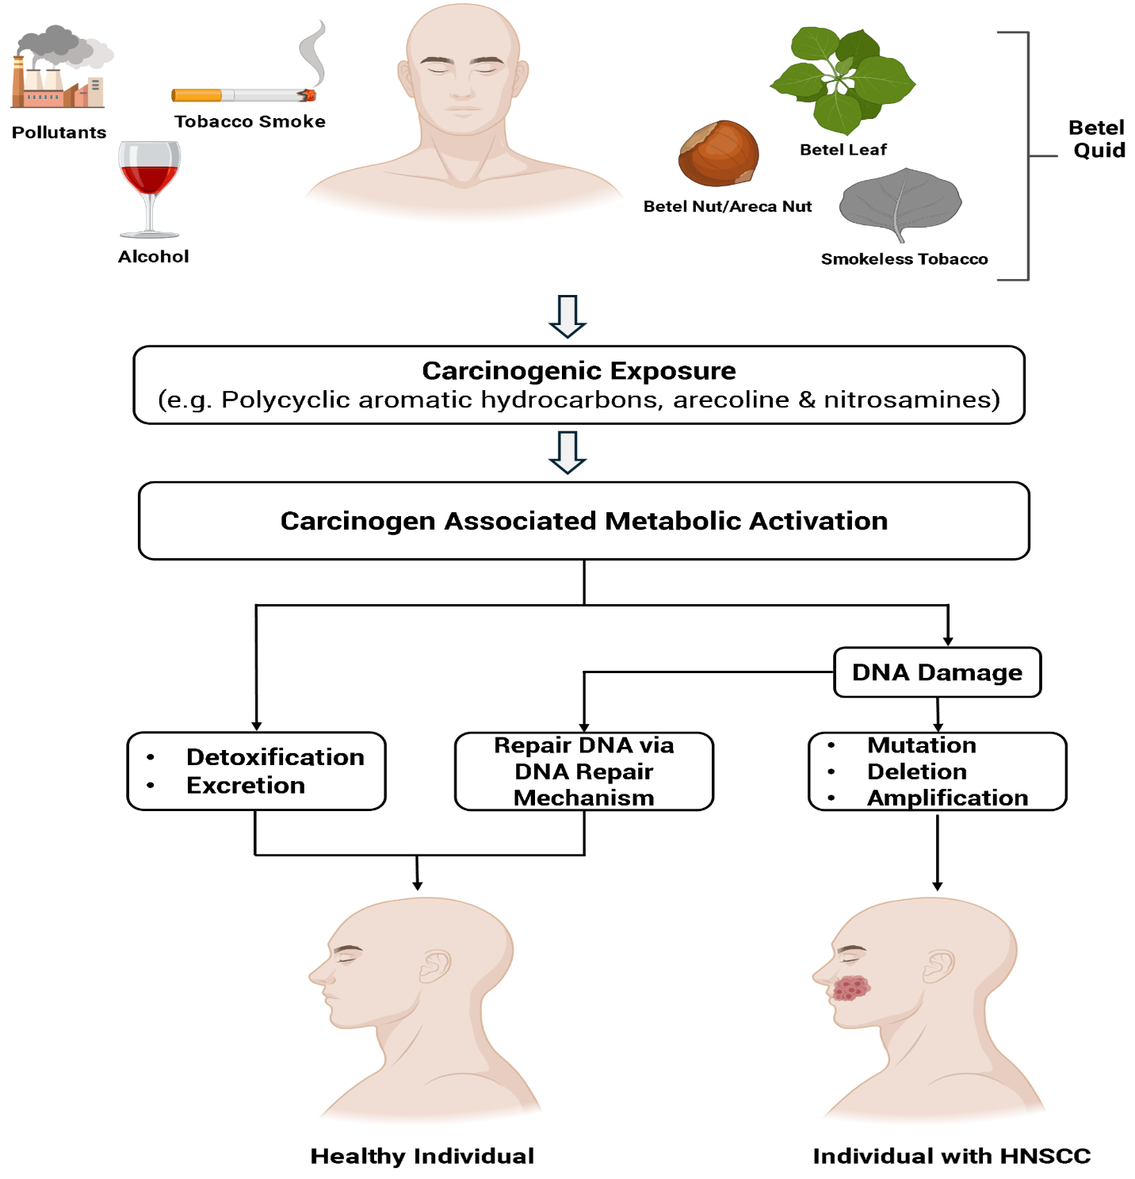**Figure 1.9: Non-infective factors cause the development of HNSCC.** [Reproduce with permission (Johnson et al., 2020c)]

# 1.5 Epidemiology of HNSCC in Bangladesh

Due to HNSCC, both the incident and mortality rates are increasing day by day, particularly in the Asian subcontinent where Bangladesh is one of them. According to GLOBOCAN data 2022, In Bangladesh, 16070 individuals were reported to be suffering from lip and oral cavity cancer. Additionally, 4438, 918, 8489, and 5975 individuals of both sexes were also affected by oropharyngeal, nasopharyngeal, hypopharyngeal, and laryngeal carcinoma respectively. Among them, 9440, 2792, 717, 3555, and 3740 individuals died due to these site-specific carcinomas (“Cancer Today,” n.d.). This high burden may be attributed to our geographical context, where habitual characteristics such as chewing betel quid and taking smoked and smokeless tobacco are most widespread, along with infective causes such as Human papillomavirus. On October 9, 2024, the International Agency for Research on Cancer (IRAC) reported that betel quid with tobacco consumption is responsible for 67% of oral cancer among women and 54% among men in Bangladesh (“Dietary exposures – IARC,” n.d.). Furthermore, HNSCC occurrence is also influenced by the age of individuals. Generally, the HNSCC occurs in an individual during the 6th to 7th decades of life. A recent study revealed that 50.8% of cases were found in young individuals ≤39 years old while the remaining causes occurred in those >39 years old. Among the HNSCC-positive individuals of ≤39 years, 50.5% were smokers and 83.7% were betel nut and tobacco chewers. In contrast, for individuals >39 years old, these percentages were 56.2%, 78.7%, and 83.7% respectively (Rahaman and Chinnikatti, 2020). As the HNSCC is increasing dramatically at young ages, there are probably some associations with HPV due to its sexual transmission. However, no recent study has been found to investigate HPV-associated HNSCC occurrence in Bangladesh. But a previous study reported that 21% of cases from 196 de-identified HNSCC samples were HPV positive where the more prevalent cancerous site was the oropharynx (~37%) and the lowest percentage was found in the larynx (~ 12.5%) which indicates the upcoming dominancy of HPV (Shaikh et al., 2017).

Along with the occurrence, the recurrence of HNSCC is also high in the local population. Although no recent studies have been conducted on the recurrence rate in Bangladesh, observations in BSMMU and other hospitals in Dhaka have provided insights into recurrence-related issues. A significant number of patients are present with recurrent HNSCC after taking chemotherapy and radiotherapy. A study reveals that approximately 60% of HNSCC patients experience recurrence after receiving HNSCC-associated treatments (Watermann et al., 2021). Additionally, a recent study reports that globally, 50.6% of recurrences occur within six months of completing treatment, while 88.6% occur within two years, suggesting the current treatments may inadvertently facilitate immune evasion (Haring et al., 2023). Therefore, target therapy and proper investigation are needed to identify the main causes of HNSCC. Proper treatment won’t be possible without knowing about the exact risk factors of HNSCC.

However, recent data indicate a significant rise in HNSCC occurrence and mortality rates in Bangladesh, which are predicted to continue increasing. It is assumed that these could increase by 2-2.5 times within 2045, (“Cancer Tomorrow,” n.d.) posing an alarming situation for our population. As HNSCC is a significant threat to us, it is necessary to reveal the present condition of HNSCC in Bangladesh, which factors are responsible for conducing this, and why the recurrence is high. So, to identify this, first of all, HNSCC diagnosis with its associated risk factors such as infective causes or non-infective causes is most important.

# 1.6 Molecular Approaches in HNSCC Diagnosis

Diagnosis of HNSCC is very important due to its notable influence on patient outcomes. Proper and early diagnosis plays a vital role in improving survival rates, reducing recurrence rates, and minimizing morbidity. Delayed identification often leads to the advanced stages of HNSCC, resulting in more aggressive tumor behavior and metastasis. Therefore, early detection is crucial for enhancing survivability, reducing mortality, and managing underlying risk factors strongly associated with HNSCC, including betel quid chewing, smoking, alcohol consumption, and HPV infections. Real-time detection of the causes of HNSCC can provide valuable insights into the functioning of these risk factors and help identify potential targets for therapy. Additionally, highly sensitive and accurate detection of HNSCC-associated risk factors can improve the quality of life for patients by enabling more personalized and targeted treatments, as well as reducing the overall mortality and recurrence rate of HNSCC.

There are several detection techniques based on the source of the sample. Tissue biopsy is the most effective specimen for the primary diagnosis of HNSCC and the detection of HNSCC-associated infectious agents compared to other sample types. It is used typically due to its detailed appraisal of cellular morphology and histopathology, which allows for tumor grading, staging, and molecular analysis. Therefore, histopathology, polymerase chain reaction (PCR) techniques including conventional PCR, RT-PCR, Nested PCR, etc, immunohistochemical staining, and in situ hybridization are commonly used in both HNSCC and its causes, especially any infectious association like HPV detection methods. Additionally, the genome sequencing technique is more sensitive and specific for identifying the actual causes (Venuti and Paolini, 2012).

# 1.6.1 Histopathology for HNSCC Detection

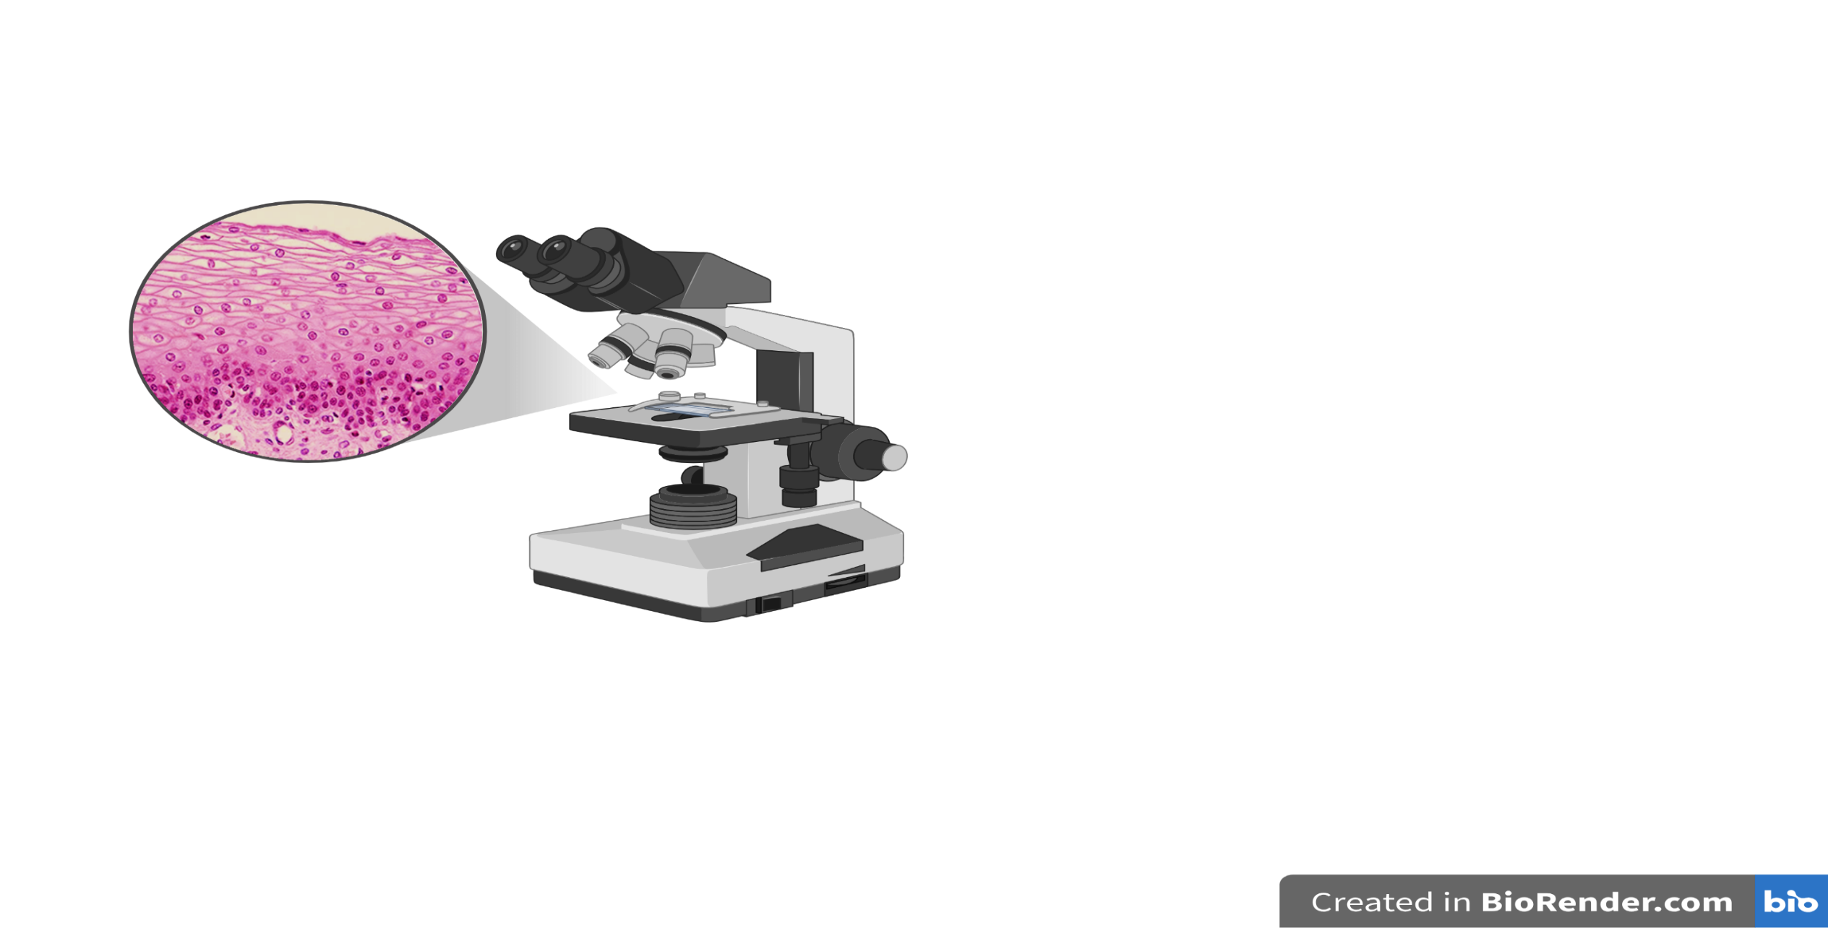Histopathology serves as the scientific and clinical basis for detecting, preventing, and treating head-neck cancer. It plays a vital role in guiding cancer management by classifying the actual patterns of cellular organization in tissue sections from biopsies or surgical specimens into definitive diagnoses. Though the morphological concepts of head-neck squamous cell cancer and premalignant evolution are being replaced by viral and molecular knowledge, histopathology remains indispensable. It is now utilized not only for HNSCC diagnosis but also for its associated infective risk factor detection (Shaikh et al., 2017). Histopathology serves as the most widely used clinical endpoint for assessing the efficacy of emerging HNSCC prevention techniques, which have a significant contribution to reducing the occurrence of head and neck cancer (Jenkins, 2007).

**Figure 1.10: Microscopic visualization of tissue for histopathological analysis.** [Plotted with Adobe Illustrator V.10.0.2]

# 1.6.2 Real-Time Polymerase Chain Reaction

Real-time PCR (RT-PCR) is a molecular technique used to amplify the target sequence with simultaneous real-time detection. Unlike conventional PCR, it does not require post-PCR analysis. It is widely used for PCR-based cancer detection and has become more popular in infectious agent diagnosis, especially for HPV detection, which has a major role in metastatic HNSCC development (Liao et al., 2013). Quantitative Real-Time PCR offers suitable sensitivity and specificity in virus detection compared to other diagnostic tools (Liao et al., 2013). Over the last decade, RT-PCR has become extensively utilized for measuring specific sequences within complex mixtures. For instance, it has been employed in genotyping, determining viral load in patients, and evaluating gene copy numbers in cancer tissue (Fraga et al., 2014a).

# 1.6.3 DNA Sequencing

Sequencing has rapidly advanced recently, as a leading role in providing intricate genomic features of any living organism. This is also used in disease, especially in cancer detection through mutational analysis, gene expression profile analysis, and oncogenic pathogen identification. Due to its inherently high throughput nature, it is now becoming more popular in biomedical sciences. The field of high-throughput DNA sequencing, known as next-generation sequencing (NGS), has seen rapid advancement with the ongoing commercialization of new methodologies. Depending on the platform used, sequencing technologies can vary in throughput from medium to high. For instance, Sanger sequencing is a relatively low to medium-throughput technology compared to the high-throughput capabilities of NGS platforms (Slatko et al., 2018).

# 1.6.3.1 Sanger Sequencing

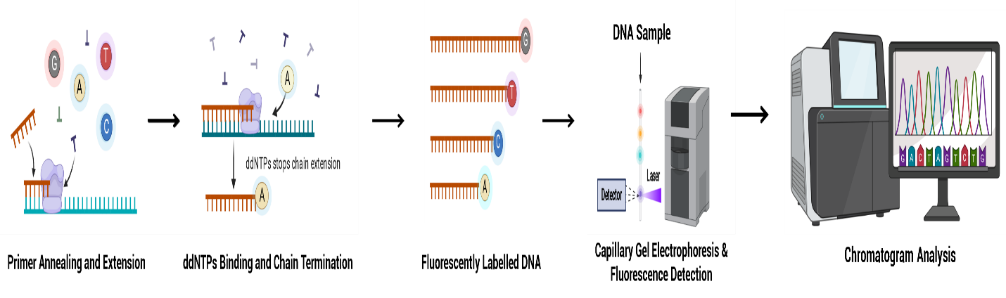Sanger Sequencing is a chain termination method that incorporates the selective fluorescent labeled ddNTPs (ddATP, ddCTP, ddGTP, or ddTTP) during complementary DNA synthesis from a single-stranded template. A mixture of dNTPs and ddNTPs creates extension products of varying lengths with the balanced ratio of dNTPs to ddNTPs to produce both long and short-extension products. The fluorescent-labeled ddNTPs terminate the elongation of the DNA strand at a specific base. Due to the fluorescent dye, the terminated fragments are colorful, and these fragments are separated by size through capillary electrophoresis where a laser acts like a scanner, reading the unique fluorophores on each fragment. The laser data is captured by photomultiplier tubes, producing an electropherogram that depicts the unique DNA sequence (Zhang et al., 2014).

**Figure 1.11: Principle of Sanger sequencing.** [Reproduce with permission (Zhang et al., 2014).]

# 1.6.4 Immunohistochemistry

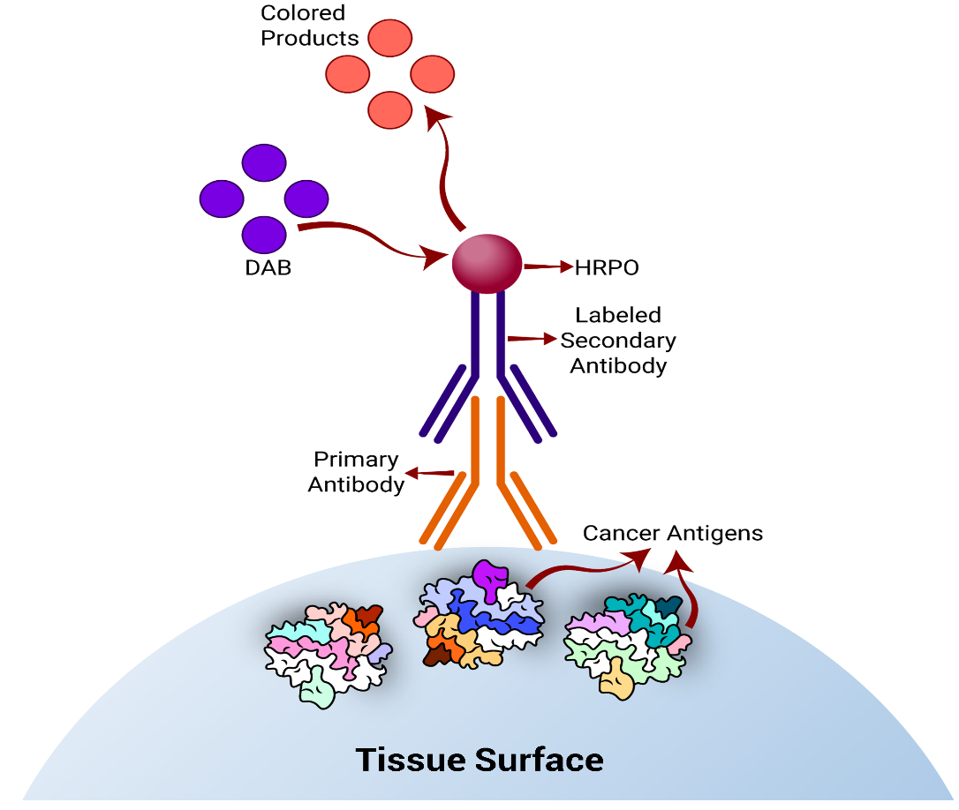Immunohistochemistry (IHC) is a powerful technique to show the expression of specific proteins in tissue samples and is most commonly used in cancer diagnosis to show the presence of cancer antigens, oncoproteins from both host and oncogenic pathogens, and the detection of associated biomarkers. It exploits the antigen and antibody bindings property to detect the presence of particular antigens and trace it in the tissue sample under the light microscope. It is usually performed in a paraffinized tissue section on a microtome to detect the host or pathogenic antigen like p16INK4a, pRb, p53, cyclin D1, etc. expression profile of HNSCC tissue samples and aid in neoplasm classification with the origination of metastatic tumor in the squamous cell (Magaki et al., 2019).

**Figure 1.12: Principle of immunohistochemistry (IHC).** The tissue surface containing cancer antigen (Ag) binds specifically to its corresponding antibody (Ab). A secondary Ab, labeled with horseradish peroxidase (HRPO) attaches to the primary Ab. The coloring products are generated when the substrate, 3,3’-Diaminobenzidine (DAB), reacts with HRPO, indicating the presence of cancer antigen in the tissue surface. [Plotted with Adobe Illustrator V.10.0.2]

Despite the advancement of the diagnostic field enabling early detection and therapeutic strategies, the occurrence rate of HNSCC has risen in recent years, accompanied by increasing recurrence rates, reflecting the significant gaps in our understanding of the intricate biology underlying HNSCC development and its progression. From this perspective, we assume that some critical factors are responsible for this threatening situation. Notably, the association of Human papillomavirus appears to be a prime risk factor for conducing this situation. Along with this, based on our geographical location, the habitual characteristic of betel quid chewing is probably another agent to exacerbate this issue over time. So, to comprehensively address the whole story about the rising incidence and mortality rate of HNSCC in Bangladesh, it is imperative to explore the fundamental origins of HNSCC development within our population.

# 1.7 Aim of the Study

Head Neck Squamous Cell Carcinoma is a significant public health concern in Bangladesh, affecting a significant portion of the population, particularly in middle-aged individuals and with growing concern for younger individuals. The dramatic increase in the HNSCC burden among these populations, coupled with its high recurrence rate, indicates cancer has risen due to factors that are not a concern yet, and the suitable therapeutics not to be provided to the HNSCC patient by considering this factor, that might be HPV. The lack of molecular studies on HPV-associated HNSCC in Bangladesh over the last 7 years raises a critical question within the scientific community about its association with HNSCC development and recurrence. In recent years, the Bangladesh government has taken several initiatives, to address the growing burden in our country. To accelerate this remarkable initiative, the scientific community must conduct more studies on HNSCC, its current status of occurrence, and the underlying causes of its development and recurrence.

So, the objectives of this study are,

1. To show the present scenario of Head Neck Squamous Cell Carcinoma (HNSCC) and identify its associated risk factors
2. Molecular detection of HPV status in HNSCC-affected tissue
3. Molecular profiling of HPV
4. Molecular detection of host protein expression
5. To identify the prime risk factor responsible for developing HNSCC

# 

# Chapter Two

# Materials and Methods

# 

# 2.1 Overview of the Study

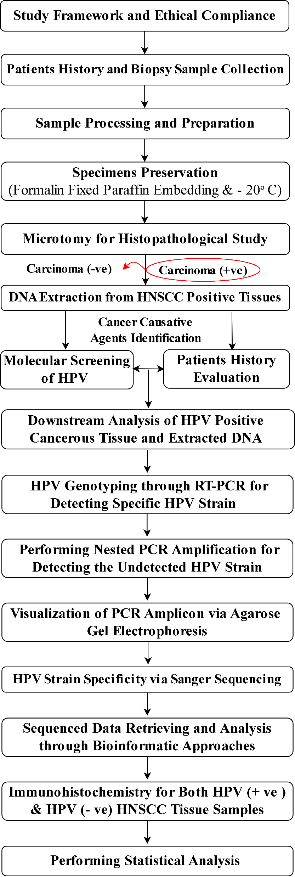The schematic diagram of the overall study is illustrated in **Figure 2.1**

**Figure 2.1: An overview of this study.** [Plotted with Adobe Illustrator V.10.0.2]

# 2.2 Preparing the Questionnaire

A substantial amount of literature was thoroughly reviewed to guide the development of a comprehensive questionnaire which was structured around five main key sections, namely- anthropometric information, socio-demographic details, health status-related data, habitual use of addictive substances related data, sample collection site and type of samples, and insight into the sexual history of patients.

* The anthropometric and socio-demographic section included the following features: age, sex, marital status, educational level, occupation and income status, housing situation, and smoking habit.
* Health status was taken to determine the patient's recent health status and comorbidity status. Sample collection site-related data provided information about which region of the head-neck samples were collected, including buccal mucosa, tongue, tonsil, oral cavity, neck, larynx, hypopharynx, etc.
* The other two, habitual characteristics of any addicted compound-related data and information about the sexual history of patients, are related to the patients with Head-Neck Squamous Cell Carcinoma (HNSCC). These sections aimed to get information about the etiological agents responsible for HNSCC.

# 2.3 Study Design

The study was designed as an observational study which was carried out in randomly collected tissue samples of the head-neck region. Where the 2 types of tissue samples, fresh tissue samples, and formalin-fixed paraffin-embedded (FFPE) tissue samples, were collected to evaluate the present condition of HNSCC and HPV-associated HNSCC.

# 2.4 Study Place

The study was conducted at the Department of Virology, Bangabandhu Sheikh Mujib Medical University (BSMMU). The study participants were recruited from the Department of Otorhinolaryngology and the Department of Pathology, BSMMU. All the laboratory procedures were performed at the Department of Virology, BSMMU, Shahbagh, Dhaka.

# 2.5 Study Population

The participants for this study were recruited from the Department of Otorhinolaryngology and the Department of Pathology at Bangabandhu Shiekh Mujib Medical University (BSMMU). The patients who came to the doctor with varying degrees of oral lesions, ranging from small to large, non-healing ulcers on the tongue, cheeks, and hard and soft palates were selected for this study. Additionally, patients who exhibited white, red, or dark patches, as well as persistent sores localized in the buccal region of the oral cavity were also selected. A total of 416 samples were randomly collected and included in this study by maintaining some specific criteria.

# 2.6 Selection Criteria

The inclusion and exclusion criteria of study participants are as follows-

* **Inclusions Criteria**

1. Age: adult (> 18 years)
2. Ulcerative lesions and sores at specific Head-Neck Subsites:

* Oral cavity - Borders of the tongue, gingiva, buccal mucosa, retromolar area, hard palate floor of the mouth, and vestibular fold
* Oropharynx - Base of the tongue, tonsil, soft palate, and pharyngeal walls
* Hypopharynx - Pyriform fossa and cricoid region
* Larynx – Supraglottic, vocal cord epiglottic, and aryepiglottic fold

1. Patients who provide informed consent for participation
2. Patients residing in Bangladesh

* **Exclusion Criteria:**

1. Age: Adult and children (< 18 years)
2. Ulcerative lesions and sores at the salivary glands and nasopharynx
3. Cancers of any part of the body other than the head-neck region
4. Previously diagnosed cases of HNSCC
5. Any chronic diseases, genetic diseases, acute/chronic infectious diseases, etc
6. Patients who did not provide informed consent for participation

# 2.7 Study Specimen

Fresh tissue and formalin-fixed paraffin-embedded (FFPE) tissue samples were collected.

# 2.8 Ethical Statement

This study received approval from the Institutional Review Board, BSMMU (Reference: BSMMU/2024/4667, Registration number:4667, Date: 29/04/24) **(Appendix I**) and also submitted on the clinicaltrial.gov (“ClinicalTrials.gov,” n.d.), **ClinicalTrials.gov ID: NCT06642324.** The entire study subjects were thoroughly appraised about the nature, purpose, and implication of the study, as well as the entire spectrum of benefits and risks of the study. Participants were assured of complete confidentiality and their right to withdraw from the study at any point without any obligation. The written informed consent was obtained from all participants voluntarily and the study subjects were taken free of duress and without exploiting any weakness.

# 2.9 Participant’s Consent

The information gathered in this study was kept as private as possible. Any reports or publications emerging from the study will not include any personal information. All steps of the study were carried out following the relevant guidelines and protocols. This study aided in the identification of Human papillomavirus-associated Head Neck Squamous Cell Carcinoma, contributing to the development of health management strategies for HNSCC-affected patients with awareness and sensitivity. Participants retained the right to seek clarification, withdraw, and inquire at any time.

# 2.10 Sampling and Data Collection

1. All the study participants were approached and if agreed, informed written consent **(Appendix II)** was obtained before data collection and then explained this study's overall procedure, potential risks, and benefits. Relevant history was collected and recorded in a preformed questionnaire **(Appendix III)** by interviewing the patient face to face.
2. Next, the lesion size, area of the lesion, and ulcerative region of patients were observed, and the lesion and ulcerative area were cleaned with an antiseptic solution.
3. According to the size of the sores and lesions punch biopsy tools were selected and punched biopsies were performed by an otolaryngologist. Then the cut specimens were carefully taken using forceps and transferred into 15 ml 0.9% normal saline and 10% formalin solutions containing tubes prepared by adding 100 ml 100% formalin into 900 ml distilled water.

# 2.11 Paraffin Embedding

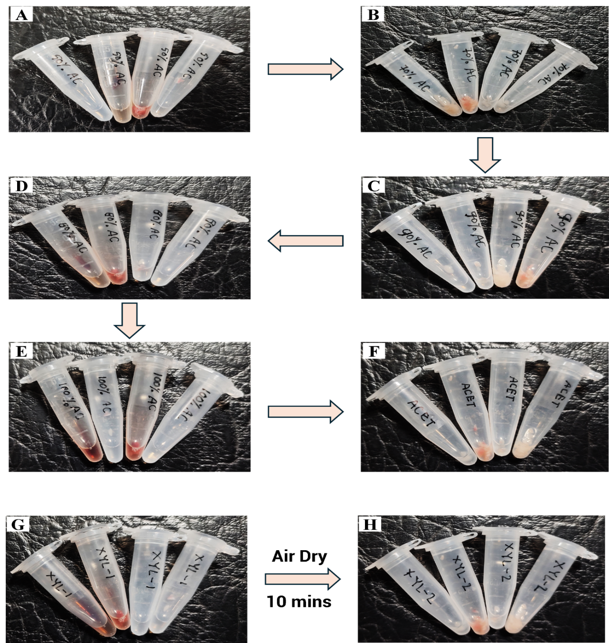The collected tissues in the 10% formalin solution were incubated overnight for grossing the tissue samples. The samples were dehydrated through a series of progressively higher concentrations of alcohol. Initially, the tissues were placed in a 50% alcohol solution for 60 minutes. Afterward, the samples were sequentially transferred to the solutions of 70%, 80%, 90%, and absolute alcohol-containing containers, spending 1 hour in each concentration. Then the tissues were kept in an acetone-containing box for 30 minutes **(Figure 2.2 A-F).**

**Figure 2.2: Dehydration of tissue samples through progressively higher concentrations of alcohol and clearing via xylene.** Tissue samples were immersed into (A) 50% alcohol, (B) 70% alcohol, (C) 80% alcohol, (D) 90% alcohol, (E) 100% alcohol sequentially for dehydrating and then for clearing the tissues were immersed in (F) Xylene-I solution, (G) Xylene-IIsolution (Fresh Xylene).

After completing the dehydration process, the tissues were placed into a xylene solution for 60 minutes and air-dried the sample for 10 minutes. Again, the samples were kept in fresh xylene solution for 30 minutes to clear the tissue samples properly **(Figure 2.2 G-H).**

Afterward, the solid paraffin was melted at 62º C using a paraffin bath (Tissue-Tek® VPTM, USA), and the tissues were immersed in melted/liquid paraffin for 3-4 hours to allow impregnation of the paraffin into the tissue samples. The metallic molds were lubricated with melted paraffin and the paraffin-impregnated tissues were placed in proper plane. The molds with the tissues were allowed to harden by keeping them in the ice chamber. The melted paraffin was poured into the hardened mold and kept in the ice chamber for 15 minutes. After hardening, the molds were removed, and the tissue blocks were trimmed properly to mount on a block holder.

# 2.12 Histopathological Study of Head-Neck Tissues

# 2.12.1 Microtomy

* Prepared tissue blocks were kept in the ice chamber of a refrigerator (Tissue-Tek® TECTM) for 60 minutes. Each block of tissue on the holder was fitted in the microtome machine (Leica Biosystems, Germany) and a sharpened microtome knife was used for cutting 5 sections from the block with 5-micron thickness, and the first two sections were removed. Ribbons of the sections were selected and placed into a water bath (Leedo, China) with a temperature of 50º C for floatation of the sections (**Figure 2.3 A-C).**
* The sections were then taken on glass slides and kept in the staining position in a slide holder for 10 minutes to drain out the water. Then the glass slides were allowed to dry at 80º C for 30 minutes in an oven (Dihan Scientific, Indonesia) (**Figure 2.3 D-F).**

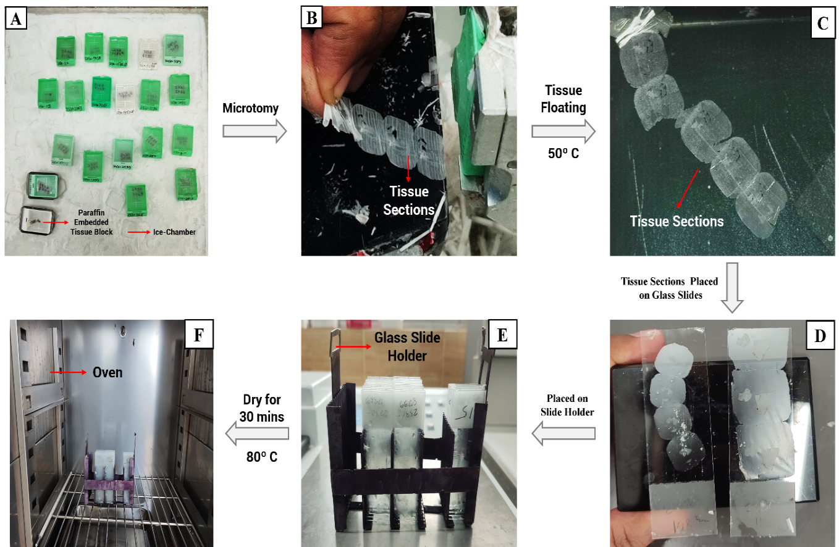**Figure 2.3: Tissue sectioning for staining and histopathological study**. (A) FFPE tissues were placed on the ice chamber, (B) tissue sectioning, (C) floating tissue on the warm water, (D) tissue on the glass slides, (E) the slides were placed on the glass slide holder, and (F) incubation80º C.

# 2.12.2 Hematoxylin and Eosin Staining Procedure

1. The dried glass slides with tissue samples were placed into a xylene solution for 5 minutes. Following this, the samples in a glass slide holder were rapidly dipped three to five times into three separate containers filled with fresh xylene solutions.
2. To rehydrate the samples, they were immersed in a series of alcohol solutions with progressively lower concentrations. At first, samples were dipped into absolute alcohol for 5 minutes. Followed by sequential immersion in 100%, 90%, 80%, 70%, and 50% alcohol solution for 2 minutes in each concentrated alcohol.
3. Afterward, the samples were prepared for staining while Harris Hematoxylin staining was performed first, and then Eosin staining was performed. So, initially, a Hematoxylin staining solution was prepared.

# 2.12.2.1 Hematoxylin Staining Solution Preparation

**Table 2.1: A list of required reagents for Hematoxylin solution preparation**

|  |  |
| --- | --- |
| **Reagent Name** | **Amount** |
| Hematoxylin | 5 gm |
| Potassium Aluminum Sulphate (KAL(SO4)2) | 100 gm |
| 95% Ethanol | 50 mL |
| (HgO) | 2.5 gm |
| 4% Glacial Acetic Acid (CH3COOH) | 40 mL |
| Distilled Water | 1000 mL |

* Firstly 5 g of hematoxylin powder was measured using a weighing machine (Shimadzu, Japan) and mixed into 50 mL 95% ethanol solution. The mixing solution was incubated for 30 minutes.
* Subsequently, 100 gm of Potassium Aluminum Sulphate (KAL(SO4)2) was measured and mixed into 1000 mL of distilled water. The solution was boiled until the KAL(SO4)2 was dissolved. After dissolving the solute, the solution was filtered and kept in a new volumetric flask.
* Afterward, both solutions were mixed properly and incubated for 5 minutes to cool the solutions. Then 2.5 gm Mercuric Oxide was weighed and mixed into the combining solution.
* Finally, 50 mL of 4% glacial acetic acid was prepared by mixing 2 mL of 100% glacial acetic acid with 48 mL of distilled water while 40 mL of 4% glacial acetic acid was added to the mixing solution.

1. After preparing the Hematoxylin solution, the glass slide holders containing the tissue samples were dipped in the hematoxylin staining solution for 5 minutes. Subsequently, the holders with the slides were rinsed in distilled water twice for 3 minutes each (**Figure 2.4 A).**
2. The rinsed slides were immersed for 10 seconds in 1% acetic alcohol solution, prepared with the combination of 1 mL HCL and 99 mL 70% alcohol, and then dipped into the ammonia water for 1 minute. Next, the samples were counter-stained with 1% watery solution of eosin for 2 minutes (**Figure 2.4 B).**

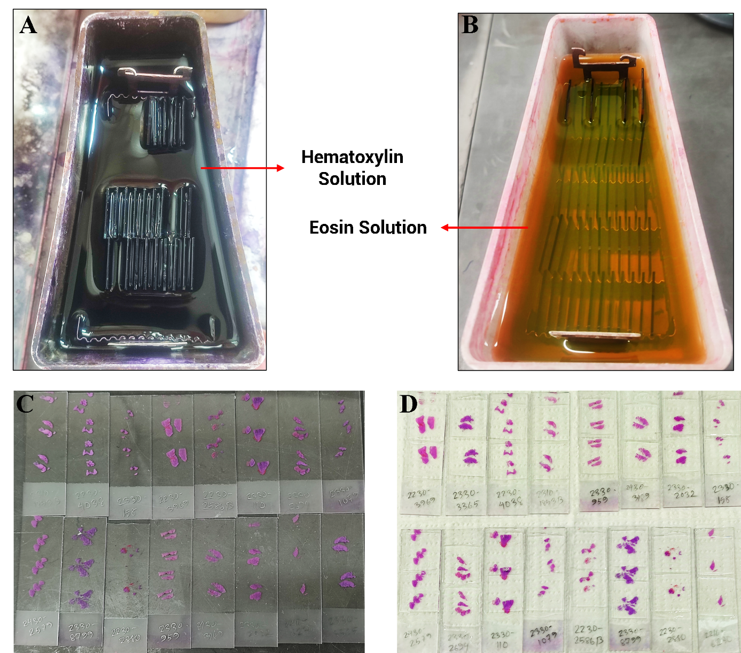**Figure 2.4: Slide preparation after Hematoxylin and Eosin staining.** Tissue-containing glass slides were immersed in (A) Hematoxylin solution and (B) Eosin solution. (C) Hematoxylin and Eosin-stained tissue on the glass slides, (D) coverslip-mounted glass slides.

1. For rehydrating the samples, the staining samples were submerged in a series of alcohol solutions with progressively higher concentrations**.** Initially, samples were immersed in 50% alcohol for 2 minutes. Then sequentially immersion in 70%, 80%, 90%, and absolute alcohol solution for 2 minutes in each concentrated alcohol.
2. The glass slides were then blotted (drying by absorbing) and cleared by using cotton gauze. (**Figure 2.4 C).**
3. After that, the glass slides were dipped into the xylene solution for 5 minutes to remove any dust or residual staining material from the surface, without affecting the tissue sections.
4. Afterward, cleared slides were mounted with 2 to 3 drops of Dibutylphthalate Polystyrene Xylene (DPX) through the coverslips and air-dried for 10 minutes. (**Figure 2.4 D).**
5. The coverslip-mounted tissues were analyzed under the microscope (Infitek, China) using 10x magnification. To obtain a more accurate view of the tissue structures, magnification was increased to 40x, ensuring a precise focus for optimal visualization.

# 2.13 Genomic DNA Extraction from Cancerous Tissue

Genomic DNA was extracted according to the manufacturer’s instructions from histopathologically confirmed HNSCC-positive tissue by using QIAamp® DNA FFPE Tissue Kit (Qiagen, Germany) for formalin fixed paraffin embedded tissues and QIAamp DNA Mini Kit (Qiagen, Germany) for fresh tissues. Both kit contents and reagent preparations are described in **Appendix IV.**

# 2.13.1 Extraction from Formalin Fixed Paraffin Embedded Cancerous Tissue Sections

1. First of all, scalpels were used to trim excess histopathologic carcinoma-positive paraffin-embedded sample block, and the samples were cut into 10 sections with 10 µm thick. 2 to 3 sections were discarded to avoid the contaminants of the sample surface that had been exposed to air. The remaining 8 sections were placed into a 1.5 microcentrifuge tube immediately after cutting the sections.
2. Secondly, the paraffin-removing reagent xylene was added to the microcentrifuge tubes two times. The first time, 1 ml of xylene was added to the samples.
3. After that, the lids were closed and vortexed vigorously for 15 seconds to dissolve the paraffin in the xylene solution. Then, it was incubated for 10 minutes at room temperature.
4. The dissolving paraffin was separated from the tissue samples by centrifuging the solution at 14000 rpm (20,000 x g) for 2 minutes at room temperature through a centrifuge machine (OHAUS Frontier™, Switzerland). Then the supernatant was removed by pipetting.
5. Again 0.5 ml xylene was added to the pellet containing microcentrifuge tubes and steps 3 and 4 were repeated to completely clean the tissue samples from paraffin and discard the supernatant for completely removing the dissolved paraffin.
6. As the ethanol extracts xylene from the sample, 1 ml 100% ethanol was added to the pellet and mixed via vertexing. Then, the solution was centrifuged at 14000 rpm (20,000 x g) for 2 minutes at room temperature and the supernatant was removed by pipetting. As the xylene disrupts to increase the DNA yield and the downstream assay, this step was performed two times in the same manner.
7. After that, the tubes were opened and incubated for 10 minutes at 37°C to evaporate all residual ethanol and the pellets were air-dried.
8. Each of the air-dried pellets was resuspended in 180 µl Buffer ATL. 20 µl proteinase K was added to each microcentrifuge tube and mixed by vortexing.
9. Then the mixture was incubated at 56°C for 1.30 hours and occasionally vortexed during incubation to disperse the completely lysed sample. Next, the mixture was incubated at 90°C for 1.15 - 1.30 hours to get more fragmented DNA from each tissue sample using a heat block (ESCO®, Singapore).
10. After incubation, the sample containing microcentrifuge tubes was cold, and briefly centrifuged the tubes to remove drops from the inside of the lid.
11. Next, 200 µl buffer AL was added to each tube and mixed thoroughly by vortexing. Subsequently, 200 µl ethanol (100%) was also added and mixed again thoroughly by vortexing. To remove drops from the inside of the lid, each of the tubes was briefly centrifuged.
12. Then the entire lysate was carefully transferred to the minelute column with a 2 ml collection tube without wetting the rim and centrifuged at 8000 rpm (6000 x g) for 1.30 minutes. After centrifugation, the column was placed in a clean 2 ml collection tube and the collection tube containing the flow-through was discarded.
13. After that, 500 µl buffer AW1 was added carefully to each of the tubes and centrifuged at 8000 rpm (6000 x g) for 1.30 minutes. After centrifugation, the column was placed in a clean 2 ml collection tube and the collection tube containing flow-through was discarded.
14. Subsequentially, 500 µl buffer AW2 was added carefully to each of the tubes without wetting the rim and centrifuged at 8000 rpm (6000 x g) for 1.30 minutes. After centrifugation, the column was placed in a new 2 ml collection tube and the collection tube containing flow-through was discarded. To dry the membrane completely, the column was centrifuged at 14,000 rpm (20,000 x g) for 3.30 minutes.
15. Afterward, the column was placed into a clean 1.5 ml microcentrifuge tube and the collection tube containing the flow-through was discarded. Then the 60 µl elution buffer, ATE was gently added to the center of the membrane and incubated for 5 minutes at room temperature.
16. Finally, the centrifugation occurred at 14,000 rpm (20,000 x g) for 1.30 minutes and the eluted DNA from each sample was collected in the microcentrifuge tubes and stored at -20° C.

# 2.13.2 Extraction from Freshly Collected Cancerous Tissue

1. At first, 25 mg of freshly collected histopathologic carcinoma-positive tissue samples were excised by using BP blades and minced the tissue samples. The small pieces of tissue samples were placed into 1.5 ml microcentrifuge tubes and 180 µl of buffer ATL was added to each sample containing tubes.
2. Secondly, 20 µl proteinase K was added and mixed by vortexing. Then the samples were incubated at 56° C for 3.30 hours (until the tissue was completely lysed) using a heat block. The samples were vortexed 3 times per hour during incubation to ensure efficient lysis and disperse the lysed samples.
3. After that, the microcentrifuge tubes containing samples were briefly centrifuged to remove drops from the inside of the lid. Then 200 µl buffer AL was added to the samples and mixed thoroughly by pulse-vortexing for 15 seconds.
4. The homogenously mixing solution was incubated at 70° C for 15 minutes and the tubes containing the solutions were briefly centrifuged to remove drops from inside the lid.
5. Next, 200 µl ethanol (100%) was added to the samples and mixed through pulse-vortexing for 15 s. After mixing, briefly centrifuge the tubes to remove drops from inside the lid.
6. After centrifugation, the entire mixture was carefully transferred to the minelute column with a 2 ml collection tube without wetting the rim and centrifuged at 8000 rpm (6000 x g) for 1.30 minutes. Then, the column was placed in a clean 2 ml collection tube and the collection tube containing filtrate was discarded.
7. After that, 500 µl buffer AW1 was added carefully to each of the tubes and centrifuged at 8000 rpm (6000 x g) for 1.30 minutes. After centrifugation, the column was placed in a clean 2 ml collection tube and the collection tube containing filtrate was discarded.
8. Subsequentially, 500 µl buffer AW2 was added carefully to each of the tubes without wetting the rim and centrifuged at 14,000 rpm (20,000 x g) for 3.30 minutes. After centrifugation, the column was placed in a new 2 ml collection tube and the collection tube containing the flow-through was discarded. To dry the membrane completely, the column was centrifuged at 14,000 rpm (20,000 x g) for 1.30 minutes.
9. Afterward, the column was placed into a clean 1.5 ml microcentrifuge tube and the collection tube containing the flow-through was discarded. Then the 100 µl elution buffer, AE was gently added to the center of the membrane and incubated for 5 minutes at room temperature.
10. Finally, the centrifugation occurred at 8000 rpm (6000 x g) for 1.30 minutes and the eluted DNA from each sample was collected in the microcentrifuge tubes and stored at -20° C.

# 2.14 Measurement of Extracted DNA Concentration and Purity

The extracted DNA was measured using a microvolume Ultraviolet (UV) spectrophotometer (NanoDrop 2000, Thermo Fisher Scientific Inc, Wilmington, DE. USA). The ratio of absorbance at 260 and 280 nm and absorbance spectrum were used to assess the purity of DNA. DNA samples with a 260/280 ratio between 1.8 and 2.0 were considered to have maximal purity.

# 2.15 Molecular Screening of HPV through RT-PCR

Genomic analysis was conducted through RT-PCR using an RT-PCR machine (Applied Biosystems Quant Studio 5 Real-Time PCR System, Thermo Fisher Scientific Inc, Wilmington, DE. USA) to determine the causes of HNSCC based on whether the infective causes were present or not. As the Human Papilloma Virus is the most prominent cause of HNSCC, the qualitative detection of the target (L1) gene of HPV was performed to show the presence or absence of this gene within two steps.

Firstly, the presence of the L1 gene in carcinoma-positive extracted DNA samples was determined using the NoeDx HPV 26 Screening PCR Kit (ARGEN Biotech, Türkiye), where 24 were high-risk and 2 were low-risk strains **(Appendix V).** Then, find out the responsible HPV strain by using the NoeDx HPV 14 Genotyping Kit (ARGEN Biotech, Türkiye) where all the strains were at high risk for causing cancer. Both the kit components are given in **Appendix V.**

# 2.15.1 HPV Screening through RT-PCR

* At first, all histopathological HNSCC positive samples and RT_PCR components, HPV Screening Master Mix, Positive Control, Negative Control, and Nuclease Free Water were thawed at room temperature except the Taq DNA polymerase (HPV Enzyme Mix). The HPV Enzyme Mix was kept on the ice box. After thawing all PCR components centrifuge was done briefly.
* The final volume of the master mix was obtained by multiplying single reaction volumes of HPV SMM, HPV Enzyme Mix, and Nuclease-Free Water by the total sample size. The number of clinical samples, negative controls, and positive controls were considered when calculating the total sample size. Each time the final master mix was prepared for 23 HNSCC positive samples, one positive, and one negative control.
* To prepare the master mix, the required amount of HPV SMM, HPV Enzyme Mix, and Nuclease Free Water was added for each sample to the master mix tube. After preparing the master mix, vortexed the tube gently and spun down briefly.
* Next, the 5 µl thawed DNA from each sample, negative control, and positive control were added into PCR reaction tubes. Afterward, 15 µl of the prepared master mix was added to this tube for each sample, and the solution was mixed thoroughly.

|  |  |
| --- | --- |
| **Components** | **Amount** |
| HPV SMM | 12 µl |
| HPV Enzyme Mix | 1 µl |
| Template DNA | 5 µl |
| Nuclease Free Water | 2 µl |
| **Final Volume** | **20 µl** |

**Table 2.2: Composition of the RT-PCR mixture for HPV screening**

* All PCR tubes were sealed and centrifuged at low speed for 30 seconds. Following that, the PCR tubes were placed into the thermal cycler’s well and 40 cycles of amplification were performed using the manufacturer’s instructions.

|  |  |  |  |
| --- | --- | --- | --- |
| **Steps** | **Temperature** | **Time** | **Number of Cycles** |
| Hot Start Polymerase activation | 95° C | 2 min | 1 |
| Denature | 95° C | 20 sec | 40 |
| Annealing | 60° C | 30 sec |
| Amplification | 60° C | 30 sec |

**Table 2.3: Amplification profile of real-time PCR**

* The fluorogenic data was collected at 60° C. FAM, VIC, and Cy 5 channels were selected for “High-risk HPV DNA”, “Low-risk HPV DNA”, and “RNase P gene” respectively.

# 2.15.2 Genotyping of HPV through RT-PCR

* Regarding HPV screening, initially, all the PCR components and HPV + ve HNSCC + ve samples were thawed at room temperature except the Taq DNA polymerase (HPV Enzyme Mix) and centrifuged briefly. Then the 5 master mixes were prepared using each of the 5 HPV Genotyping Master Mix (GMM), HPV Enzyme, and Nuclease Free Water in 5 separate master mix tubes for detecting the HPV strains.

**Table 2.4: Composition of the RT-PCR mixture for HPV genotyping**

|  |  |  |
| --- | --- | --- |
| **Genotyping Master Mix Tube** | **Components For Each Master Mix** | **Amount** |
| GMM1  GMM2  GMM3  GMM4  GMM5 | HPV GMM | 12 µl |
| HPV Enzyme Mix | 1 µl |
| Template DNA | 5 µl |
| Nuclease Free Water | 2 µl |
| **Final Volume** | 20 µl |

* After that, a total of 25 µl template DNA was taken from each sample those were both HPV + ve and HNSCC + ve by 5 µl and kept in 5 different PCR tubes. From each master mix,15 µl was added to these tubes gradually for each sample and each of the solutions was mixed thoroughly.
* All PCR tubes were sealed and centrifuged at low speed for 30 seconds, and 40 amplification cycles were performed according to the HPV Screening RT_PCR profile.
* The fluorogenic data was collected at 60° C. FAM, VIC, ROX, and Cy 5 channels were selected according to **Appendix VI.**

# 2.16 Strain Specificity of HPV through Sanger Sequencing

The specific strain from the cancerous tissue samples was identified by performing Sanger sequencing to increase specificity. From multiple HPV variants containing HNSCC samples, conventional Nested PCR amplification was performed targeting two specific sets of genes.

# 2.16.1 Primer Selection

Two specific sets of primers were selected to perform PCR amplification by reviewing the literature to target the L1 gene, a conserved region of HPV that varies from strain to strain. Specifically, the MY09 (F)/MY11 (R) primers (Macrogen, South Korea) were selected as the first set of primers, followed by the GP5+ (F)/GP6+ (R) primers (Macrogen, South Korea) as the second set (Fraga et al., 2014b; Liao et al., 2013).

**Table 2.5:** **List of the primer sets for PCR amplification of major capsid protein (L1 region) of HPV**

|  |  |  |  |
| --- | --- | --- | --- |
| **Primer Name** | **Sequence (5' – 3')** | **Annealing Temperature** | **Amplicon Size (bp)** |
| **MY09**  Forward Primer | CGT CCM ARR GGA WAC TGA TC | 55º C | 350 |
| **MY11**  Reverse Primer | GCM CAG GGW CAT AAY AAT GG | 55º C | 350 |
| **GP5+**  Forward Primer | TTT GTT ACT GTG GTA GAT ACT AC | 45º C | 140 |
| **GP6+**  Reverse Primer | GAA AAA TAA ACT GTA AAT CAT ATT C | 45º C | 140 |

**Degenerate Nucleotides -** M = A + C, R = A + G, W = A + T, Y = C + T

# 2.16.2 Primer Reconstitution

First, a 100 µM stock solution for each primer was prepared by adding 250 µL nuclease-free water to each of the primers. Then, the 100 µM stock solutions of primer were aliquoted into separate microcentrifuge tubes and diluted ten times to convert into a 10 µM working solution (**Table 2.6).**

|  |  |  |  |  |
| --- | --- | --- | --- | --- |
| **Primer Name** | **100 µM Stock Sol.**  **(Solute)** | **Nuclease free Water (Solvent)** | **Total Amount** | **Final Concentration** |
| **F:** MY09 | 20 µL | 180 µL | 200 µL | 10 µM |
| **R:** MY11 | 20 µL | 180 µL | 200 µL | 10 µM |
| **F:** GP5+ | 20 µL | 180 µL | 200 µL | 10 µM |
| **R:** GP6+ | 20 µL | 180 µL | 200 µL | 10 µM |

**Table 2.6: Preparation of 10 µM primer working solution**

# 2.16.3 Nested PCR for L1 Gene Amplification

# 2.16.3.1 First-Round PCR Amplification

* Initially, the primer and master mix (OneTaq Quick-Load 2X Master Mix, New England Biolabs Inc., USA) were retrieved from a -20º C freezer and allowed to defrost. Prior to use all reagents were shortly centrifuged at a low speed and the master mix was aliquoted carefully into the labeled microcentrifuge tube. Kit components are described in **Appendix VII**
* After that, HPV + HNSCC samples were added to each PCR tube. Then the needed quantity of aliquoted master mix, primers, and nuclease-free water was added to each PCR tube **(Table 2.7).**

|  |  |  |
| --- | --- | --- |
| **Components** | **Amount** | **Final Concentration** |
| Master Mix (2X) | 12.5 µL | 1X |
| Forward Primer **MY09** (10 µM) | 0.75 µL | 0.3 µM |
| Reverse Primer **MY11** (10 µM) | 0.75 µL | 0.3 µM |
| Nuclease-Free Water | 6.0 µL |  |
| Template DNA | 5.0 µL |  |
| **Total Volume** | **25.00 µL** |  |

**Table 2.7: Composition of first-round nested PCR mix**

* The PCR mixture was mixed thoroughly using a low-speed centrifuge. Following that, the PCR tubes were put into the thermal cycler well and 35 cycles of amplification were performed using a conventional amplification setting **(Table 2.8).** Each primer Tm value was used to adjust the annealing temperature.

**Table 2.8: First-round PCR (Nested-PCR) amplification profile**

|  |  |  |  |
| --- | --- | --- | --- |
| **Steps** | **Temperature** | **Time** | **Number of Cycles** |
| Initial denaturation | 94ºC | 30 s | **1** |
| Denaturation | 94ºC | 30 s | **33** |
| Annealing | 55ºC | 1 min |
| Extension | 68ºC | 1 min |
| Final extension | 68ºC | 5 mins | **1** |

# 2.16.3.2 PCR Amplification Products Visualization via Agarose Gel Electrophoresis

After completing the polymerase chain reaction, the 1st round of amplified products was visualized through agarose gel electrophoresis on 1.5% agarose gel.

# 2.16.3.2.1 Preparation of 10X Tris-Borate-EDTA (TBE) Buffer

To make 1000 ml 10X TBE buffer, 108 gm Tris base was dissolved in 800 ml sterile dH2O. Following that, the mixture will be stirred for 30 minutes. Then 55 g of boric acid and 9.3 g EDTA were added, and the volume was adjusted to 1000 ml by adding dH2O. The pH level was precisely regulated at 8.3. Finally, the mixture was stirred overnight.

|  |  |
| --- | --- |
| **Buffer Ingredients** | **Amount** |
| Tris Base | 108 g |
| Boric Acid | 55 g |
| EDTA | 5.84 g |
| dH2O | 1000 ml |
| **Total Volume** | **1000 ml** |

**Table 2.9:** **10X Tris-Borate-EDTA (TBE) buffer preparation**

# 2.16.3.2.2 Preparation of Agarose Gel

A measuring cylinder is used to measure 300 ml of 1 X TBE buffer, prepared by adding 30 ml of 10 X- TBE with 270 ml dH2O, which is then poured into a conical flask, where several amounts of agarose powder were added separately for performing different concentrated gel electrophoresis **(Table 2.10)**, carefully mixed, and placed in a microwave oven to melt. After 2-3 minutes, when the agarose powder had completely dissolved in the buffer, the measuring cylinder was placed into the magnetic stirrer, and ethidium bromide was added to the solution. Next, the solution was put into the gel tray where combs were used, having 20 teeth to create well and the bubbles were eliminated. Then the gels were allowed to cool until they formed a thick gel (**Figure 2.5 A-D).** The required apparatus for gel electrophoresis is given **in Appendix VII.**

|  |  |  |  |
| --- | --- | --- | --- |
| **1.5% Agarose Gel** | | **2% Agarose Gel** | |
| **Ingredients** | **Amounts** | **Ingredients** | **Amounts** |
| 10X_TBE Buffer | 30 µL | 10X_TBE Buffer | 30 µL |
| Agarose Powder | 4.5 g | Agarose Powder | 6 g |
| EDTA (0.5 M) | 22.5 µL | EDTA (0.5 M) | 22.5 µL |
| dH2O | 270 µL | dH2O | 270 µL |
| **Total Volume** | **300 µL** | **Total Volume** | **300 µL** |

**Table 2.10:** **Required reagents for 1.5% and 2% gel preparation agarose**

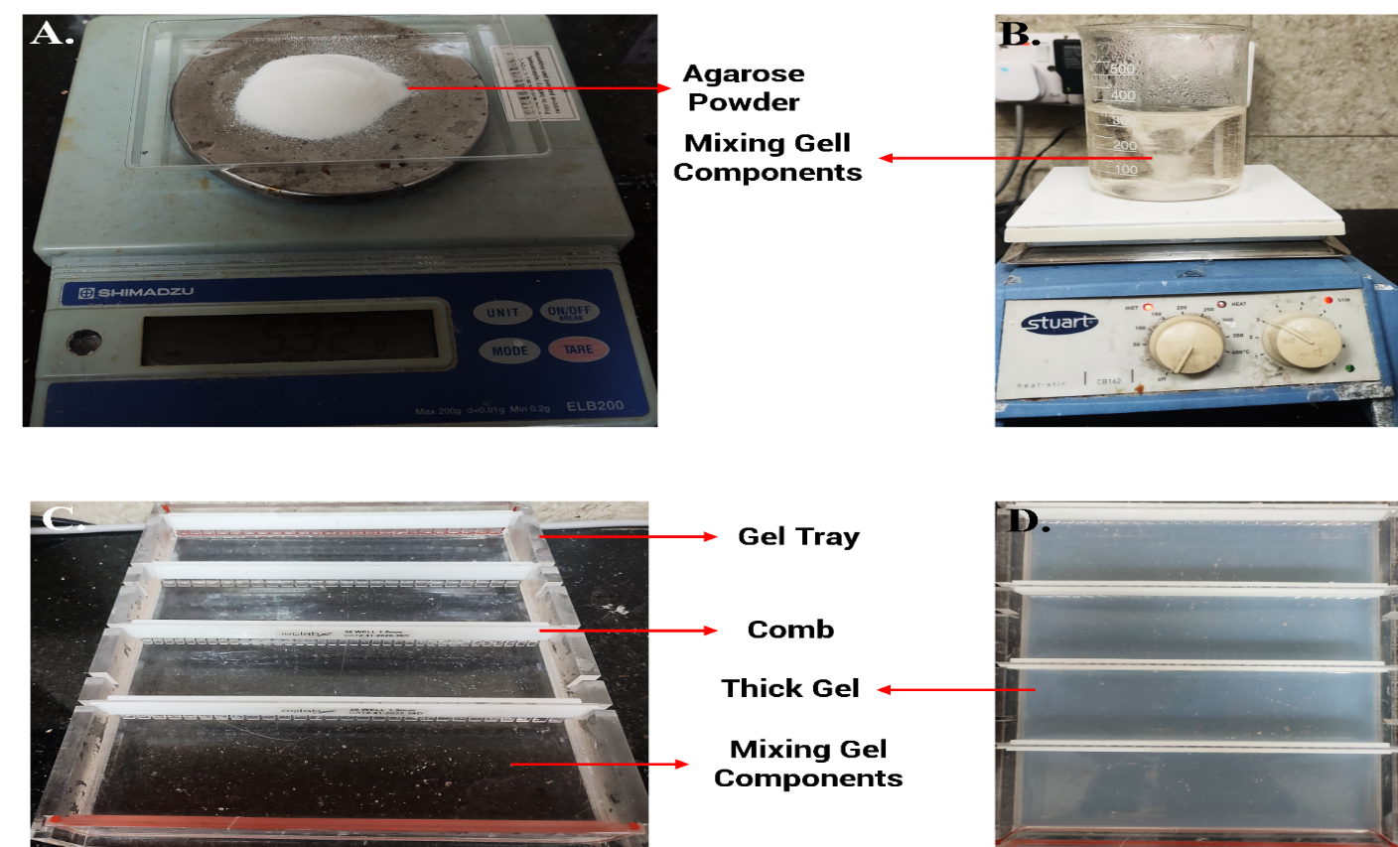**Figure 2.5: Agarose gel preparation.** (A) Weighing agarose powder, (B) mixing all components, and (C and D) preparing the agarose gel for electrophoresis

# 2.16.3.2.3 Procedure of Electrophoresis and Visualization of PCR Amplicon

1. The electrophoresis process was performed horizontally using a piece of gel equipment (My Run Cosmo Bio Co. Ltd, IMR-201). It was carried out in a 1.5% agarose (UltrapureTM Agarose, Invitrogen, USA) gel **(Table 2.10)** for the 1st round of PCR amplification products**.**
2. After removing the comb, the gel was placed into the electrophoresis tank, and a 1X TBE buffer was used to cover the gel completely.
3. Afterward, 8 µl of each amplified product from 1st of round PCR was loaded onto the agarose gel using a micropipette, and 10 µL of 100bp DNA ladder (Biolabs, New England) was also loaded to the specified well as a control **(Figure 2.6 A-B).**
4. The electrophoresis was performed at 120 volts for 90 minutes till the dye had migrated two-thirds of the distance in the gel. Subsequently, the bands of HPV DNA were observed using a UV transilluminator (UVPO, High-Performance Transilluminator, USA).

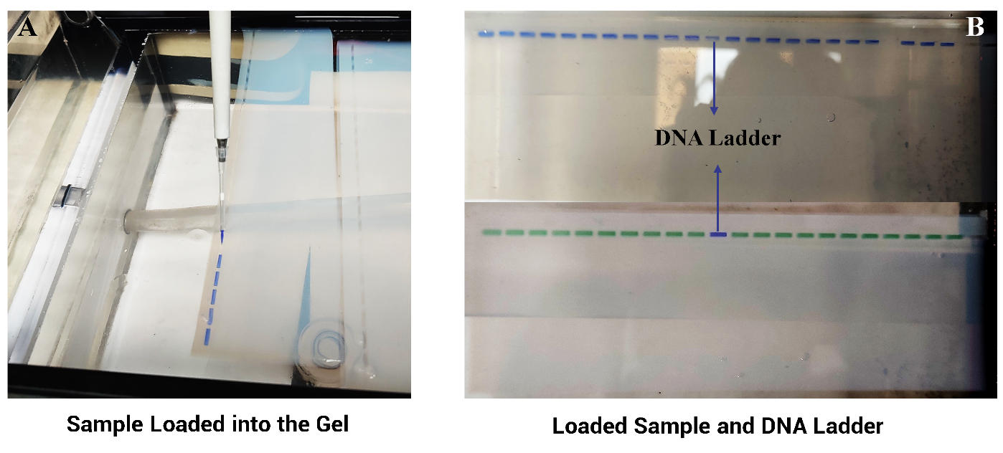**Figure 2.6: Sample DNA loaded into the gel.** Here, the blue and green color indicates the uses of different master mixes.

# 2.16.3.3 Second-round PCR Amplification of L1 gene

* In the 2nd round of amplification, the second set of primer and master mix (OneTaq Quick-Load 2X Master Mix, New England Biolabs Inc., USA) were retrieved from a -20º C freezer and allowed to defrost. All of the reagents were shortly centrifuged before using at a low speed and the master mix was aliquoted carefully.
* After that, amplified products from the 1st round of PCR were added to each PCR tube as a template. Then the required amount of aliquoted master mix, primers, and nuclease-free water were added to each PCR tube.

|  |  |  |
| --- | --- | --- |
| **Components** | **Amount** | **Final Concentration** |
| Master Mix (2X) | 12.5 µL | 1 X |
| Forward Primer **GP5+** (10 µM) | 0.75 µL | 0.3 µM |
| Reverse Primer **GP6+** (10 µM) | 0.75 µL | 0.3 µM |
| Nuclease-Free Water | 6.0 µL |  |
| Amplified Products (1st Round) | 5.0 µL |  |
| **Total Volume** | 1. **µL** |  |

**Table 2.11: Composition of First-Round Nested PCR Mix**

* The PCR mixture was mixed thoroughly using a low-speed centrifuge. Following that, the PCR tubes were put into the thermal cycler well and 35 cycles of amplification were performed using a conventional amplification setting **(Table 2.12).** Each primer Tm value was used to adjust the annealing temperature.

|  |  |  |  |
| --- | --- | --- | --- |
| **Steps** | **Temperature** | **Time** | **Number of Cycles** |
| Initial denaturation | 94ºC | 30 s | 1 |
| Denaturation | 94ºC | 30 s | 33 |
| Annealing | 45ºC | 30 s |
| Extension | 68ºC | 30 s |
| Final extension | 68ºC | 5 mins | 1 |

**Table 2.12: Second round PCR (Nested-PCR) amplification profile**

# 2.16.3.3.1 Visualization of 2nd Round PCR Amplification Products on Agarose Gel

1. After the PCR amplification, PCR products underwent electrophoresis on a 2% agarose gel, that was prepared during the previous gel electrophoresis process **(Table 2.10).** In this gel run, 10 µl of each amplified product from 2nd round PCR was loaded onto the agarose gel and 10 µL of 100bp DNA ladder (Biolabs, New England) was also loaded to the specified well as a control using a micropipette.
2. Electrophoresis was performed according to the previous manner with 120 volts applied until the dye migrated two-thirds of the distance in the gel. A UV transilluminator was used to visualize the presence or absence of the desired bands of HPV DNA.

# 2.16.4 Nucleotide Sequencing

The more prominent band-containing samples were selected. Subsequently, the PCR products of these samples were taken for sequencing. The sequencing step was carried out in the automated ABI 3500Xl genetic analyzer (Applied Biosystems, Foster City, USA).

# 2.16.4.1 PCR Product Purification (1st Purification Step)

Amplified PCR products with prominent DNA bands were purified with ExoSAP-IT Express (Applied Biosystems, USA) PCR product purification kit. The reagent was thawed on ice. For purification, 2 μL of ExoSAP-IT Express solution and 5 μL of post-PCR product were added. The reaction mix was incubated in a heat block at 37º C for 15 minutes and then at 80º C for 15 minutes. Finally, the purified products were stored at -20ºC.

# 2.16.4.2 Cycle Sequencing

The stored products were ready for cycle sequencing. Cycle sequencing was done using BigDyeTM Terminator v3.1 Cycle Sequencing Kit containing 5X Sequencing Buffer. The kit content of the ready reaction premix is shown in Appendix **VIII**. The kit and primers were completely thawed and maintained on ice before starting. The tubes were vortexed for 2-3 seconds and centrifuged briefly. The following reaction setup was used for cycle sequencing.

**Table 2.13: Required ingredients of cycle sequencing reaction mix for Sanger sequencing**

|  |  |  |
| --- | --- | --- |
| **Component** | **Forward Reaction (µl)** | **Reverse Reaction (µl)** |
| 5X Sequencing Buffer | 1.75 µl | 1.75 µl |
| BigDyeTM Terminator | 0.5 µl | 0.5 µl |
| Forward primer (5 pmol) | 0.5 µl |  |
| Reverse primer (5 pmol) |  | 0.5 µl |
| 1st Purified PCR product | 1 µl | 1 µl |
| Nuclease-free H2O | 6.25 µl | 6.25 µl |
| **Total Volume** | **10 µl** | **10 µl** |

The reaction tubes were vortexed for 2-3 seconds and then centrifuged at 1000 ×g for 10 seconds. The reaction tubes were placed in a thermal cycler for cycle sequencing using the following cycling conditions **(Table 2.14).**

**Table 2.14: Thermal cycling profile for cycle sequencing reaction**

|  |  |  |  |  |  |  |  |
| --- | --- | --- | --- | --- | --- | --- | --- |
| **Parameter** | **Cycle** | | | | | | |
| **Incubation**  **(1 cycle)** | **35 cycles** | | | | | **Hold**  **(1 cycle)** |
| **Denature** | | **Anneal** | | **Extend** |
| **Ramp rate** | - | 1º C/ second | | | | | - |
| **Temperature** | 96º C | 96º C | 50 ºC | | 60º C | | 4º C  Until ready  to purify |
| **Time (mm: ss)** | 03:00 | 00:10 | 00:05 | | 04:00 | |

# 2.16.4.3 Purification of Cycle Sequencing Product (2nd Purification Step)

* After performing the cycle sequencing steps, the individual DNA amplified products were purified using ethanol/sodium acetate precipitation. At first, 1 µl 3M sodium acetate, 1 µl EDTA, and 25 µl 100% ethanol were added into each PCR tube holding individual cycle sequencing product and kept in a magnetic rack for 3 minutes and then incubated at -20º C for 15 mins. The tubes were centrifuged at 4º C at 13000 rpm (18,000x g) for 15 minutes and the supernatants were discarded.
* Afterward, 30 µl of 70% ethanol was added and centrifuged at 13000 rpm (18,000x g) for 15 minutes followed by incubation at 37º C for 5 minutes. 10 µl of highly de-ionized (Hi-Di) formamide was added to the tube and briefly vortexed. The solution was centrifuged before denaturation at 95ºC for 5 minutes followed immediately by placing it on ice for 2 minutes.
* Finally, the products were placed on a sequencing plate for a short spin-down before proceeding to capillary electrophoresis. Cycle sequencing products were purified using a BigDye XTerminator purification kit (PPLIED Biosystems, USA).

# 2.16.4.4 Capillary Electrophoresis

Capillary electrophoresis was done by using 10 µl clear solution in the ABI 3500 Genetic Analyzer (Applied Biosystems, USA). BDx_Std_Seq_50_POP7_Z module was used for the run. The generated chromatograms were saved for further analysis.

# 2.17 Bioinformatics Analysis

# 2.17.1 Chromatogram Analysis

The generated Chromatograms were visualized and analyzed through BioEdit Sequence Alignment Editor v7.7.1. Noise present at the beginning or end of both forward and reverse sequences was subsequently removed. The consensus sequences of each sample, containing the L1 gene, were retrieved by aligning the edited forward and reverse sequences (“BioEdit Download - Research software utility for creating and editing biological sequences,” n.d.).

# 2.17.2 Phylogenetic Tree Construction

The retrieved partial query sequences of the HPV L1 gene were analyzed and compared using the Nucleotide BLAST program (“Nucleotide BLAST: Search nucleotide databases using a nucleotide query,” n.d.). Molecular phylogeny and sequence alignment were evaluated using MEGA 11 (“Home,” n.d.), an integrated tool for conducting automated and manual sequence alignment, inferring phylogenetic trees, estimating rates of molecular evolution, inferring ancestral sequences, and testing evolutionary hypotheses. The TREEVIEW program was used to construct the phylogenetic tree.

# 2.17.3 Mutational Analysis

The retrieved nucleotide sequences of the gene were then aligned with the reference sequence and mutation analysis was performed by using EMBOSS NEEDLE software (“EMBOSS Needle < EMBL-EBI,” n.d.) to identify any point mutations and other variations.

# 2.18 Immunohistochemistry for both HPV Positive and HPV Negative HNSCC Tissue Sample

* Regarding the previous microtomy procedure, HPV-positive and carcinoma-positive sample blocks were sliced with 5-micron thickness and taken these sections on histogrip-coated glass slides. The slides were incubated overnight at 37ºC in the incubator.
* Next, the slides were placed into a hot air oven for deparaffinization at 62º C for 1 hour. Then the slides were soaked in Xyline I, II, and III for 5 minutes of each solution.
* After that, the samples were rehydrated in a series of decreasing propanol solutions (100%, 90%, 80%,70%) for 5 minutes of each solution and then immersed in distilled water for 2-3 minutes.
* For antigenic retrieving (unmask the antigenic epitopes from undesired crosslinking), firstly, the slides were placed in a preheated antigen retrieval solution in the water bath (Dako, PT-Link, Greece) at 95 ℃ for 30 minutes. The slides were then cooled at room temperature for 10 minutes in a Coplin jar and washed via 20 times diluted washing buffer, prepared by adding 50 ml 20X washing buffer (EnVision Flex, Dako, Greece) with 950 ml distilled water (**Figure 2.7 A-C).**

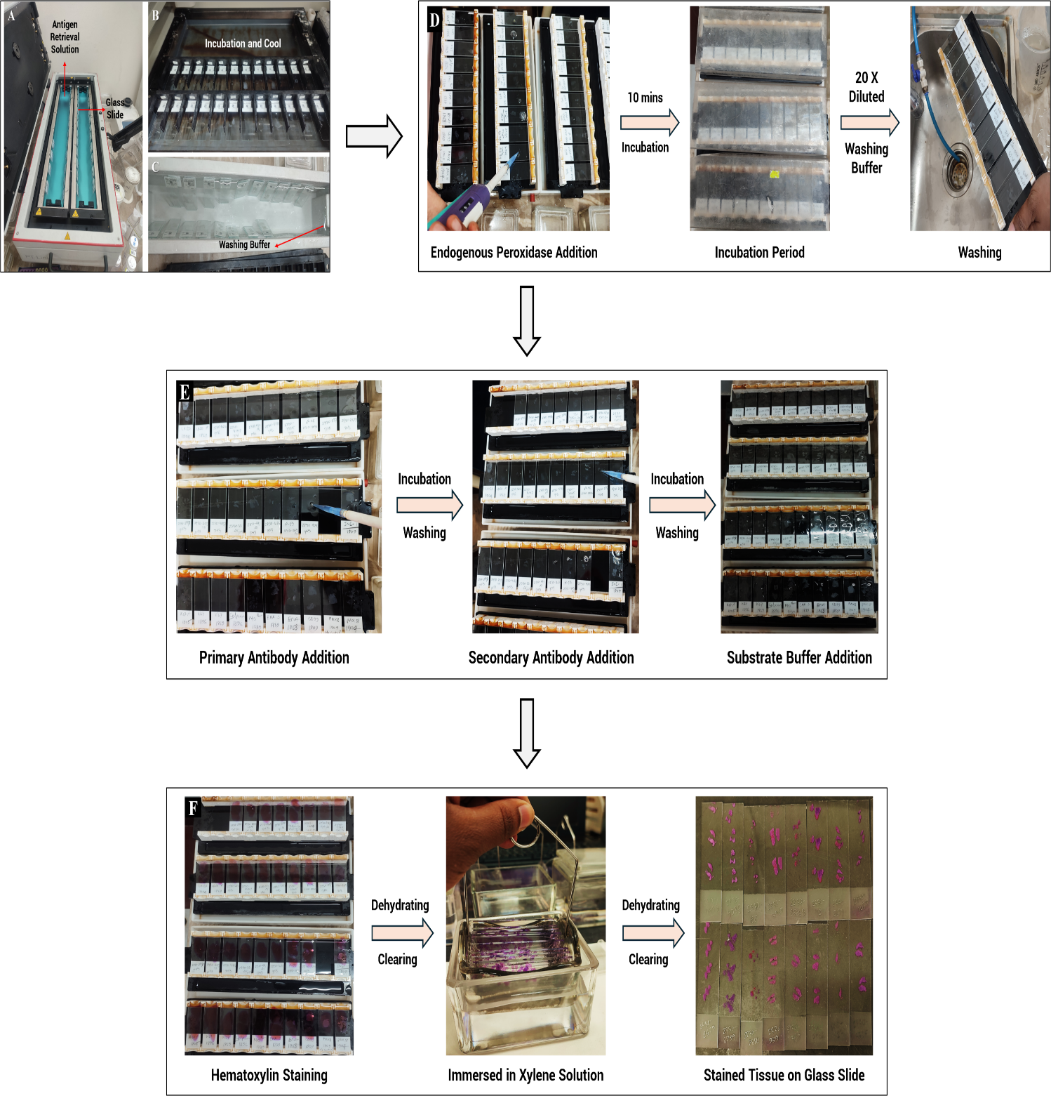**Figure 2.7: Slide preparation for immunohistochemistry.** (A) Antigenic retrieving using preheated antigen retrieval solution in the water bath, (B-C) cooling the glass slides and washing, via washing buffer, (D) addition of endogenous peroxidase for blocking unwanted bonding, incubation, and washing the slides, (E) addition of primary antibody, secondary antibody, and substrate buffer sequentially, (F) staining the glass slides using hematoxylin solution, clearing via xylene immersion and overnight dehydrating the stained tissues.

* Secondly, 200 µL blocking endogenous peroxidase was added to each of the slides and incubated for 10 minutes by keeping the slides in a moist box. By using 20 times diluted washing buffer, the slides were washed after the incubation period (**Figure 2.7 D).**
* Thirdly, 200 µL primary antibody-containing solutions including p16, p53, and Cyclin D1 (Dako, Greece) were added to the samples and incubated at room temperature for 30 minutes. To remove the unbounded antibody, the samples were washed using the washing buffer and again incubated for 30 minutes after adding 200 µL secondary antibody solution, bounded with peroxidase polymer. Gradually the slides were washed using the washing buffer (**Figure 2.7 E).**
* Subsequently, 200 µL liquid substrate buffer solution was added over the tissue section, kept for 10 minutes in a dark place, and washed via de-ionized water immediately after incubation (**Figure 2.7 E).**
* Afterward, 3-4 drops of Mayer's Hematoxylin staining solution were added to the tissue surface and slides were kept for 2 minutes for counterstaining. The slides were then rinsed with distilled water and dehydrated in ascending alcohol solutions (70%, 80%, 90%, and 100%) for 5 minutes of each solution (**Figure 2.7 F).**
* After dehydrating the samples, these were immersed in fresh xylene solution for 5 minutes to remove any dust or residual staining material from the tissue surface. The cleared slides were mounted with DPX through the coverslips and air-dried for 10 minutes (**Figure 2.7 F).**
* Finally, the coverslip-mounted tissues were analyzed under the microscope using 40x magnification. To obtain a more accurate view of the tissue structures, magnification was increased to 40x, ensuring a precise focus for optimal visualization.

# 2.19 Statistical and Machine Learning Analysis

* The analyses were performed using Python v3.10.12 and utilizing some libraries and dependencies including matplotlib v3.10.0, upsetplot v0.9.0, pandas v2.2.2, scipy v1.13.1, and os which facilitated data manipulation, statistical analysis, visualization, and efficient file handling. For analyzing the age distribution, a T-test was conducted using the stats module from the scipy library.
* Addictions of betel quid chewing, smoking tobacco, smokeless tobacco, consuming alcohol, familial history, and HPV status (possible reasons for causing cancer) were selected as features for classifying both positive and negative cancer cases by using Machine Learning (ML) models. We aimed to identify the most significant factor that contributes to the development of cancer within our dataset.
* The dataset was split into 80% training and 20% testing subsets. Fifteen ML models, including, Ridge Classifier, Linear Discriminant Analysis, Logistic Regression (LR), Ada Boost Classifier, Extreme Gradient Boosting, Random Forest Classifier, Decision Tree Classifier, Gradient Boosting Classifier, Extra Trees Classifier, K Neighbors Classifier, Light Gradient Boosting Machine, SVM - Linear Kernel, Naive Bayes, Quadratic Discriminant Analysis, and Dummy Classifier were compared to identify the best-fitted model, followed by cross-validation and hyperparameter tuning to optimize performance. A feature importance plot, ranked the features based on their importance scores, reflecting their ability to classify samples effectively. The model's performance on the datasets was evaluated by using an Are Under the Curve (AUC) plot for visualization. We utilized Scikit-Learn (v1.4.2), along with its dependencies, including Pandas (v2.1.4), SciPy (v1.11.4), Joblib (v1.3.2), Sktime (v0.26.0), and Pmdarima (v2.0.4), among other.

# Chapter Three

# Results

# 3.1 Preparatory Steps for Sample Collection

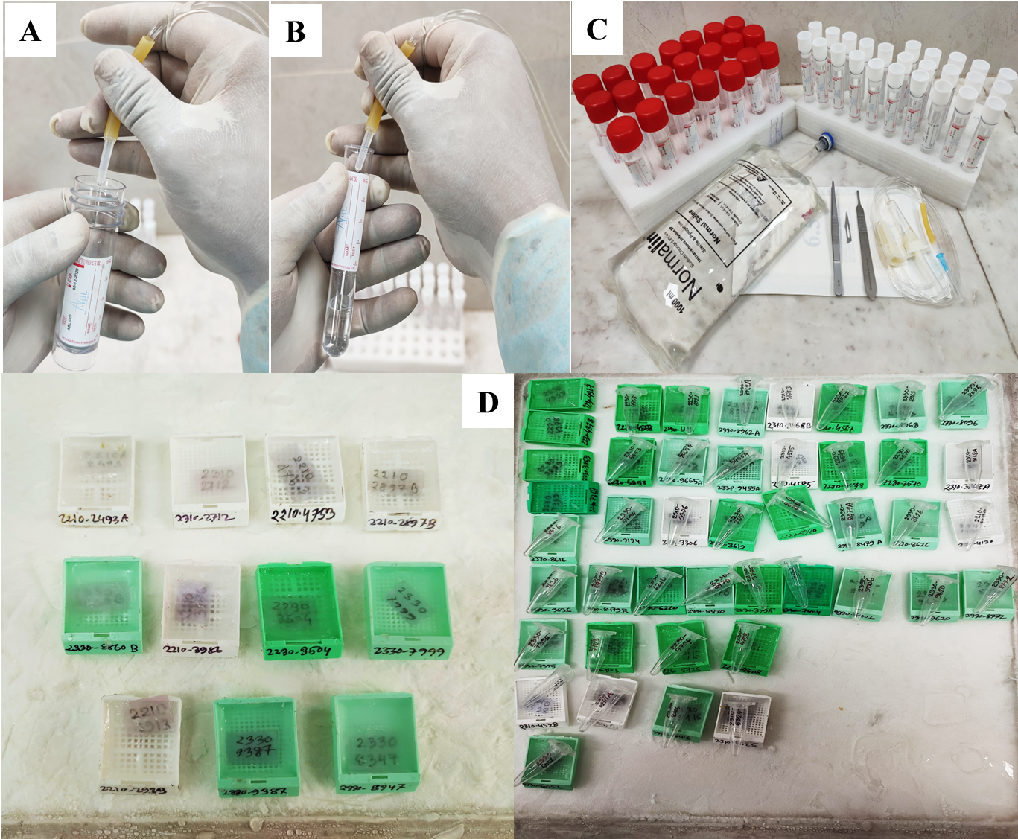The study commenced with the careful preparation of 0.9% sterile normal saline and 10% formalin solutions (**Figure 3.1 A-C**) for collecting the fresh tissue biopsy samples from the patients, where paraffin-embedded tissue blocks were prepared for previously collected tissue samples by cooling the tissue surface in an ice chamber. (**Figure 3.1 A-C**)

**Figure 3.1: Pre-sampling procedure.** (A) The tube contains 0.9% normal saline. (B) Contains a 10% formalin solution for preserving the tissue sample. (C) Equipment for tissue biopsy and excised tissue collection. (D) Paraffin-embedded tissue in paraffin blocks.

# 3.2 Specimen Collection

The specimens from the ulcerative lesion or sore-containing region of the head-neck were excised using sterilized punch biopsy tools (**Figure 3.2 A-B**). Depending on the lesion size, around 5-7 mm measured tissue samples were collected that were further processed (**Figure 3.2 C**) and preserved in two separate tubes containing formalin solution and normal saline (**Figure 3.2 C**).

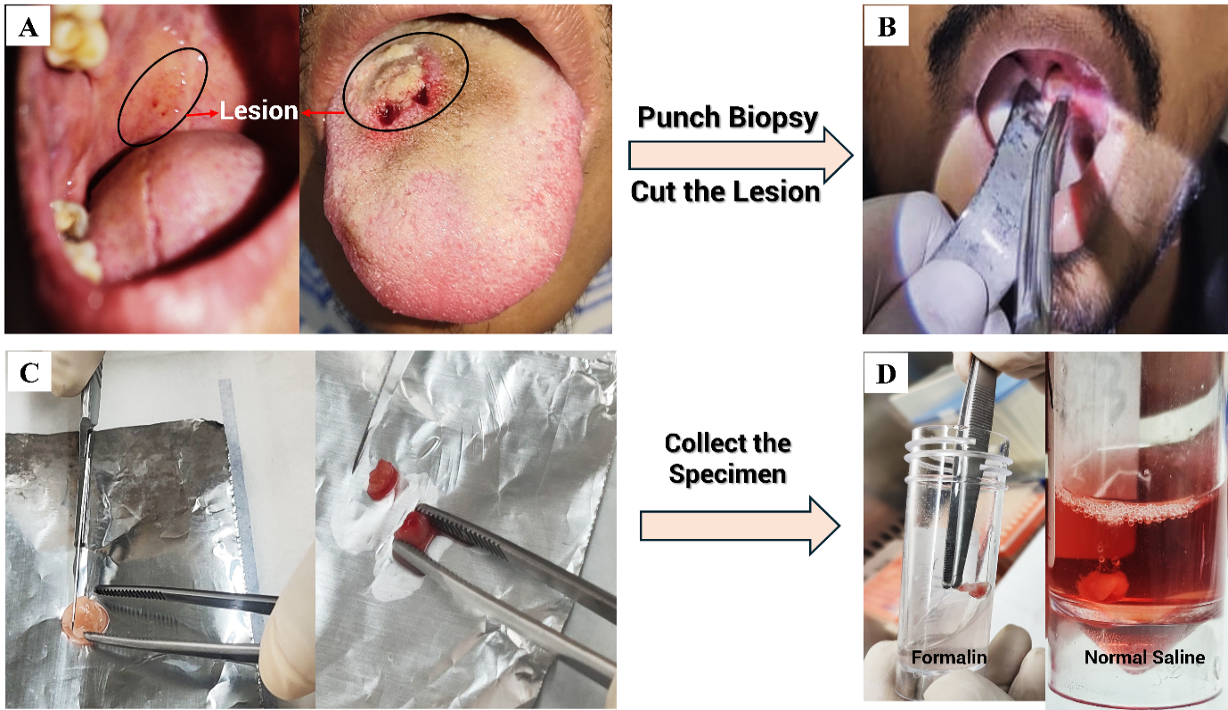**Figure 3.2: Punch biopsy for tissue sampling and preservation.** (A) Sore-like structure in retromolar trigon of the oral cavity (left picture) and ulcerative lesion in the tongue. (B) Cut the ulcerative lesion using a biopsy punch. (C, D) Cut the collected samples into two pieces and transfer them into two different solutions for preservation and continuing further analysis.

# 3.3 Overview of Sample Collection

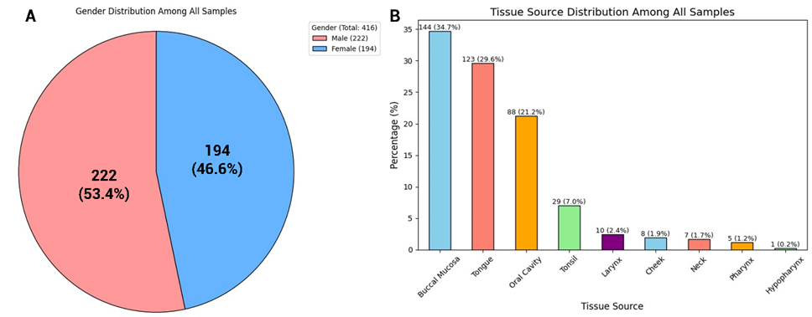A total of 416 tissue samples were collected where 222 were male and 194 were female. Among these, 144 were taken from buccal mucosa, 123 were tongue, 88 were oral cavities, 29 weretonsils, and others were from the larynx, cheek, neck, pharynx, and hypopharynx.

**Figure 3.3: Sample distribution by gender and source of the collected tissue.** (A) Gender distribution among all samples, (B) Tissue collection site of all samples.

# 3.4 Tissue Embedded in Paraffin Block

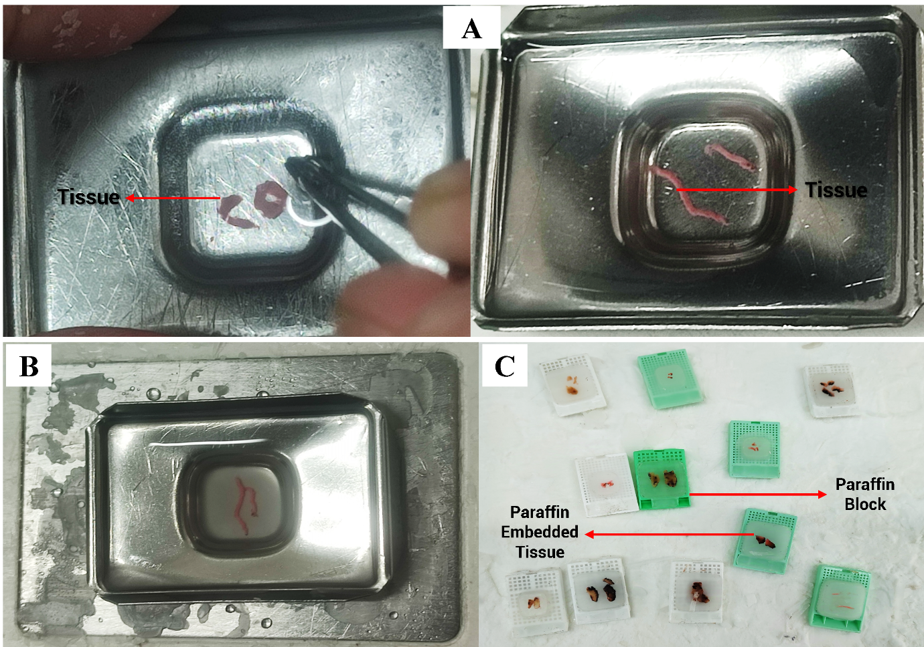Proper sectioning for histopathological study and for providing long-term stability to perform several downstream assays, the freshly collected small tissue specimens were embedded in wax or paraffin. The paraffin-impregnated excised tissues were placed into the center of the metallic mold. The mold was transferred into a paraffin block and immersed in melted paraffin. (**Figure 3.4 A-B**). The prepared paraffin-embedded tissues were properly solidified by keeping them in an ice chamber, as shown in **Figure 3.4 C**.

**Figure 3.4: Formalin Fixed Paraffin Embedded head-neck tissue block preparation.** (A) Small, excised tissues are immersed in the melted paraffin. (B) The metal mold with the excised tissue is placed on the ice chamber. (C) Paraffin-embedded tissues in paraffin block.

# 3.5 Histopathological Analysis

The basic morphological features between healthy and cancerous tissues were evaluated using Hematoxylin and Eosin stain. This histopathology study of a healthy individual tissue sample contains normal cellular architecture, an organized cellular shape, granulated cytoplasm in the squamous cell, and small uniform nuclei, but no invasion pattern is seen (**Figure 3.5 A**). Compared to these, others show some abnormal characteristics including cellular disorganization, abnormal shape, cellular dislocation, and enlarged hyperchromatic nuclei that indicate them as 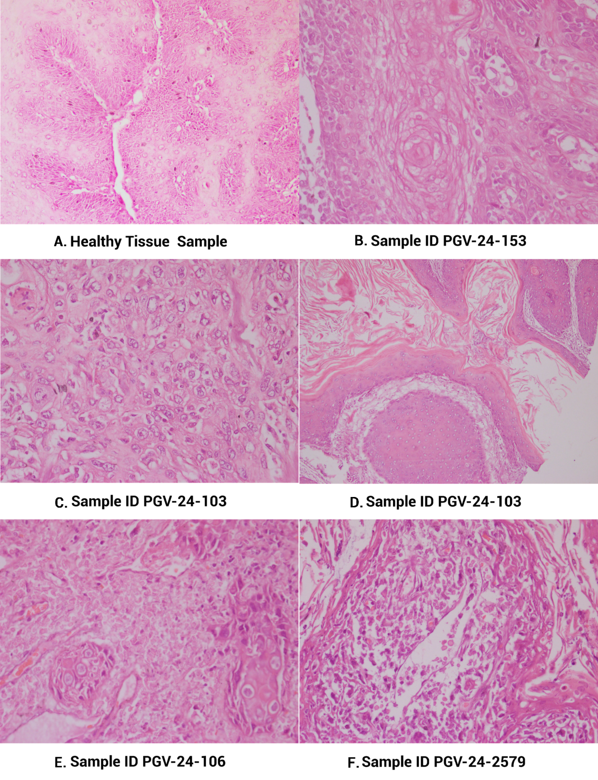cancerous tissue. (**Figure 3.5 B-F**). Giant cells are also visualized in **Figure 3.5 E.**

**Figure 3.5: Histopathological analysis of head-neck tissues through Hematoxylin and Eosin staining.** (A) Normal cellular shape and small uniform nuclei, (B-F) abnormal cellular shape, inappropriate cellular orientation, and hyperchromatic nuclei in the squamous cell.

# 3.6 Socio-Demographic Profile of Study Cohort

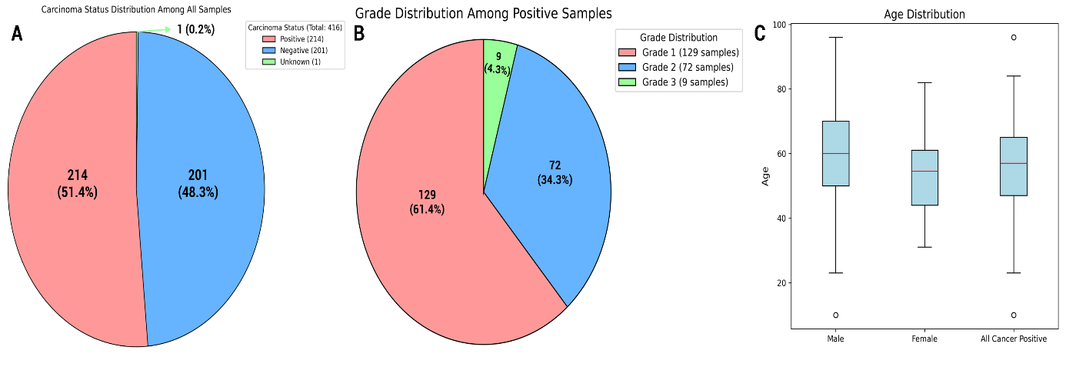A total of 214 (51.4%) histopathologically Head-Neck Squamous Cell (HNSCC) patients were identified from 416 participants where 61.4%, 34.3%, and 4.3% were classified as grade 1, grade 2, and grade 3 respectively. The mean age of the HNSCC-affected patients was 56.29, while the mean age of male individuals was 59.03 and females was 52.82 (**Figure 3.6 A-C)**. Among these patients, 111 (51.9%) were male and 103 (48.1%) were female.81 (37.9%) HNSCC patients had no formal education, 66 (30.8 %) were literate, and the comparatively lowest number of educated people were affected by HNSCC. In addition, 12 (5.6%) individuals were upper class. In contrast, 103 (48.1 %) and 99 (46.3%) belong to the middle and lower socioeconomic classes respectively. However, the collected tissues of HNSCC samples were collected from different sites of head-neck regions that are tabulated in **Table 3.1.**

**Figure 3.6: Head-Neck Squamous Cell Carcinoma (HNSCC) status distribution with grading among all collected tissue samples.** (A) Carcinoma Status distribution from all samples, (B) grading of head-neck cancer, (C) age distribution among all HNSCC-positive samples.

|  |  |
| --- | --- |
| **Variables** | **HNSCC Patients (N = 214) (%)** |
| **Mean Age** | |
| Age | 56.29 |
| Male | 59.03 |
| Female | 52.82 |
| **Gender** | |
| Male | 111 (51.9) |
| Female | 103 (48.1) |
| **Educational Level** | |
| Illiterate | 81 (37.9) |
| Literate | 66 (30.8) |
| Primary - SSC | 33 (15.4) |
| HSC | 22 (10.3) |
| Above | 12 (5. 6) |
| **Socio-Economic Status** | |
| Upper Class | 12 (5.6) |
| Middle Class | 103 (48.1) |
| Lower Class | 99 (46.3) |
| **Primary site of Tumor (Origin of HNSCC)** | |
| Buccal Mucosa | 100 (46.7) |
| Tongue | 70 (32.7) |
| Oral Cavity | 24 (11.2) |
| Tonsil | 10(4.7) |
| Cheek | 7 (3.3) |
| Larynx | 2 (0.9) |
| Neck | 1 (0.5) |

**Table 3.1: Socio-demographic profile and clinical characteristics of study participants (N = 214)**

# 3.7 Addiction Profiles and Familial History of HNSCC Patients

Among the habitual risk factors 97 (45.3%) individuals were habituated to betel quid chewing, 90 (42.1%) to smoked tobacco, 30 (14%) to smokeless tobacco, and 17 (7.9%) to alcohol. However, 30 (23.8%) individuals were not associated with any of those addictions. Along with this, 30 (14%) of patients were habituated to both betel quid chewing and smoking while the lowest, 2 (0.9%) combination was visualized for smokeless tobacco and alcohol **(Figure: 3.7 A)**.

Besides this, the familial history shows that 125 (72.7 %) individuals have no familial history of

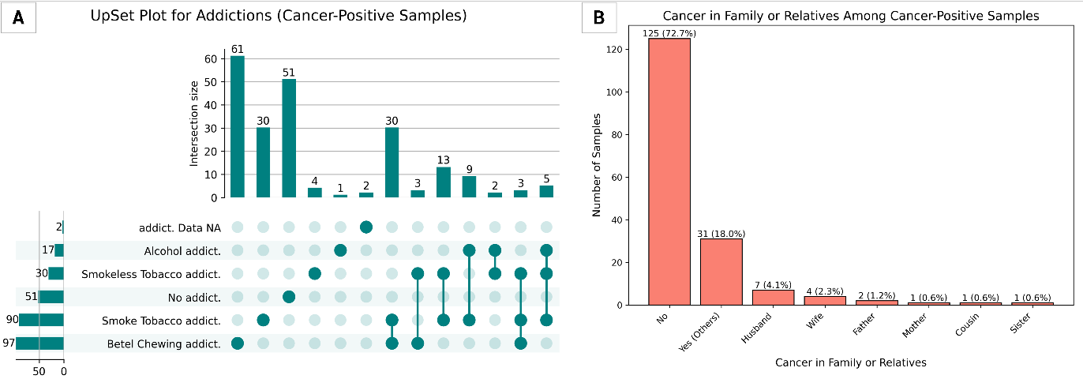cancer, but a low number of individuals have **(Figure: 3.7 B)**.

**Figure: 3.7: Habitual risk factors and familial history evaluation of HNSCC patients**. (A) Habitual addiction, (B) Cancerous status of family and other relatives of HNSCC-positive individuals.

# 3.8 Extracted DNA from Cancerous Tissue

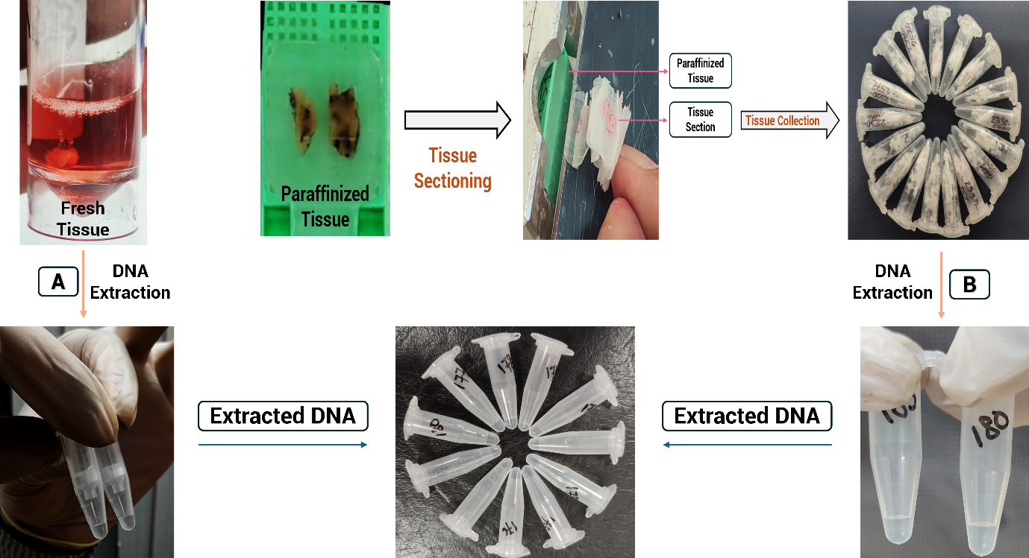To assess the current status of the infective risk factor - HPV-associated HNSCC, and address the immense interest, especially regarding the 23.8% of the population without any addiction history and the cases of some young individuals, DNA was extracted from a total of 225 samples. Among these, 214 were histopathologically confirmed HNSCC-affected patient tissues, where 11 were from young patient tissue samples that were preserved in normal saline (**Figure 3.8 A)** and microcentrifuge tube (FFPE Tissue) at room temperature (**Figure 3.8 B).**

**Figure 3.8: DNA Extraction from HNSCC positive tissue.** (A) DNA extraction from freshly collected head-neck tissues. (B) Specimen collection and DNA extraction from precisely sectioning paraffin-embedded tissues.

# 3.9 Molecular Profiling of Human Papillomavirus

The HPV status from the extracted samples with its specific genotype was also detected by analyzing real-time PCR data.

# 3.9.1 HPV Screening

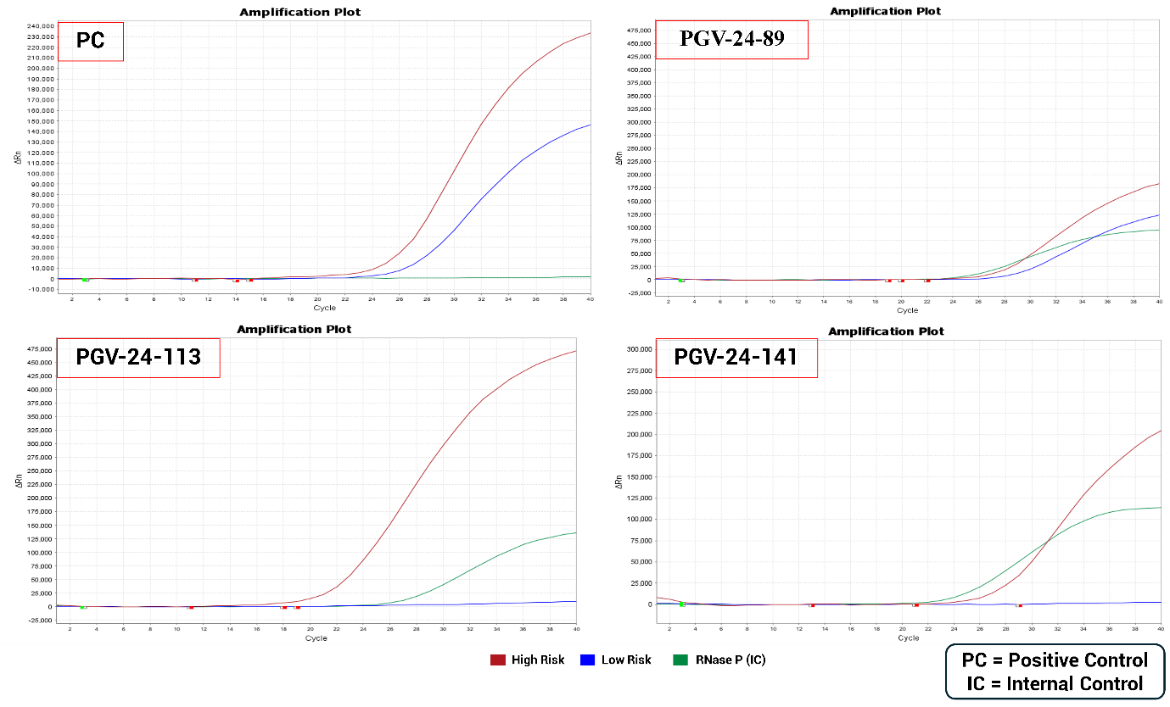A total of 61 samples were detected as an HPV-positive sample from all of the extracted DNA. Among them, from the HNSCC-positive samples, HPV was detected in 53 samples and others were detected in non-HNSCC samples **(Appendix IX). Figure 3.9** represents three specific samples containing high-risk HPV genomic material while low-risk HPV is present in one sample (PGV-24-89). However, **Figure 3.9** does not indicate any information about HPV genotypes.

**Figure 3.9: HPV status in the HNSCC-positive tissue sample. (PGV-24-)** indicates the sample ID. The number of amplification cycles is represented on the X-axis, while the Y-axis indicates the changes in fluorescence signal during amplification, presented as ΔRn.

# 3.9.2 HPV Genotyping

From the detected 60 HPV-positive samples, HPV strains were identified in 38 samples **(Appendix IX)**. While the remaining samples showed a positive response during HPV screening, no peaks were observed in these samples. Among these 38 identified samples, multiple strains were detected in a few samples. All relevant information is present in **Appendix IX.**

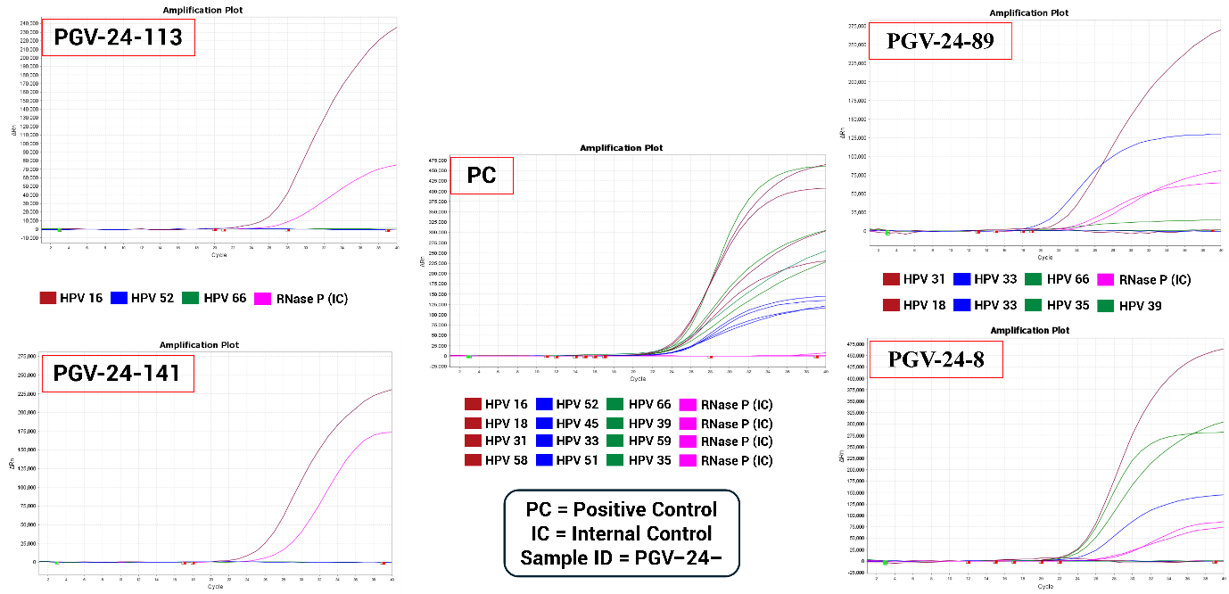**Figure 3.10** presents the HPV profiling status of four patient samples. Among these, two samples contain HPV 16 genomic DNA while multiple strains are present in the other two samples. Specifically, Sample No. 89 contains both HPV 31 and 33, whereas Sample no 8 includes four strains: HPV 18, 33, 35, and 39.

**Figure 3.10: Genotyping of HPV from head-neck cancerous tissue samples.** For a single sample, four types of positive controls **(PC)** are evaluated where each of the PC contains three HPV strains and one internal control (IC). All PCs are presented in a single figure. **PGV-24-113** and **PGV-24-141** share a single legend, whereas **PGV-24-89** and **PGV-24-8** share two distinct legends sequentially due to the presence of different HPV genotypes in the samples. For better understanding, strain-specific legends are used only, while others are not included in the figure. Here, the X-axis represents the number of amplification cycles, while the Y-axis indicates the changes in fluorescence (**ΔRn**) signal during the amplification process.

# 3.10 HPV Strain Specificity through Sanger Sequencing

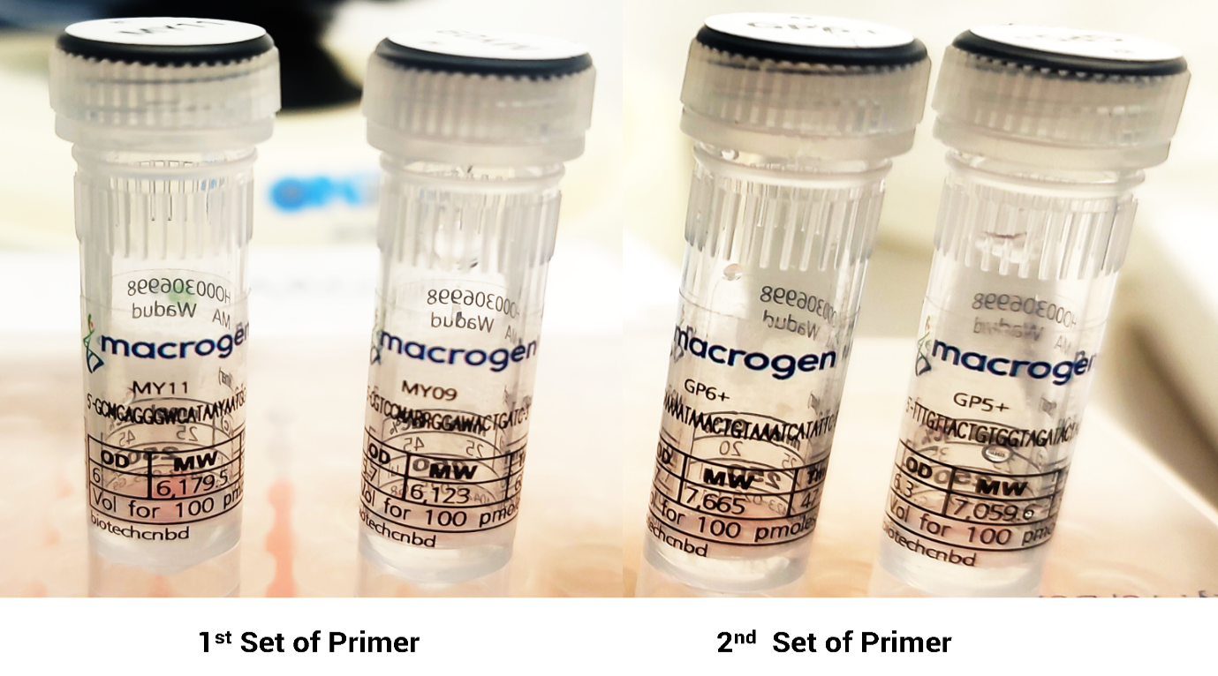As 22 samples remained undetected with no strain-specific information, two different sets of primers, MY9-MY11 and GP5+-GP6+, of the L1 gene of HPV were targeted for performing nested PCR to amplify the strain-specific L1 region by using degenerated nucleotide (**Figure 3.11).** To obtain accurate information about these strains and validate the PCR result, Sanger sequencing was performed.

**Figure 3.11: Two distinct sets of primers of the HPV L1 gene.** In the 1st set of primers, MY9 and MY11 act as forward and reverse primers respectively. For the 2nd set, GP5+ acts as forward, and GP6+ acts as reverse primer.

# 3.10.1 Performing Nested PCR and Gel Electrophoresis

After primer reconstitution, the master mix was prepared by adding the 1st set of primers and transferred to the PCR tube containing the HPV-positive HNSCC DNA sample as shown in **Figure 3.12 A.**

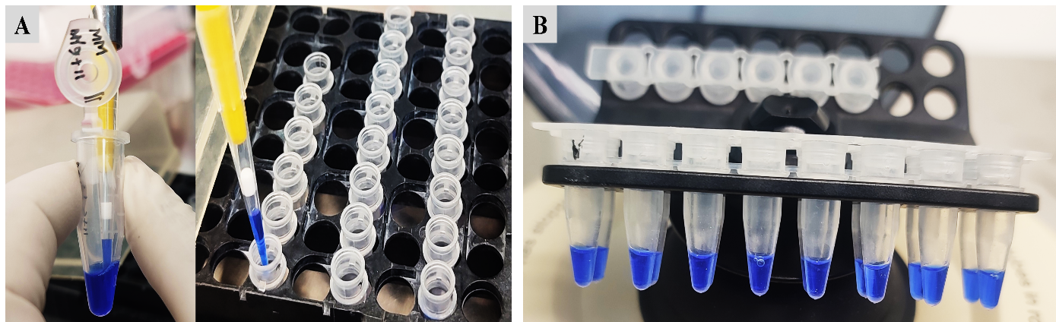**Figure 3.12:** **Prepared Solution for 1st round PCR.** (A) 1st round PCR master mix preparation. (B) Prepared 1st round PCR master mix for the PCR run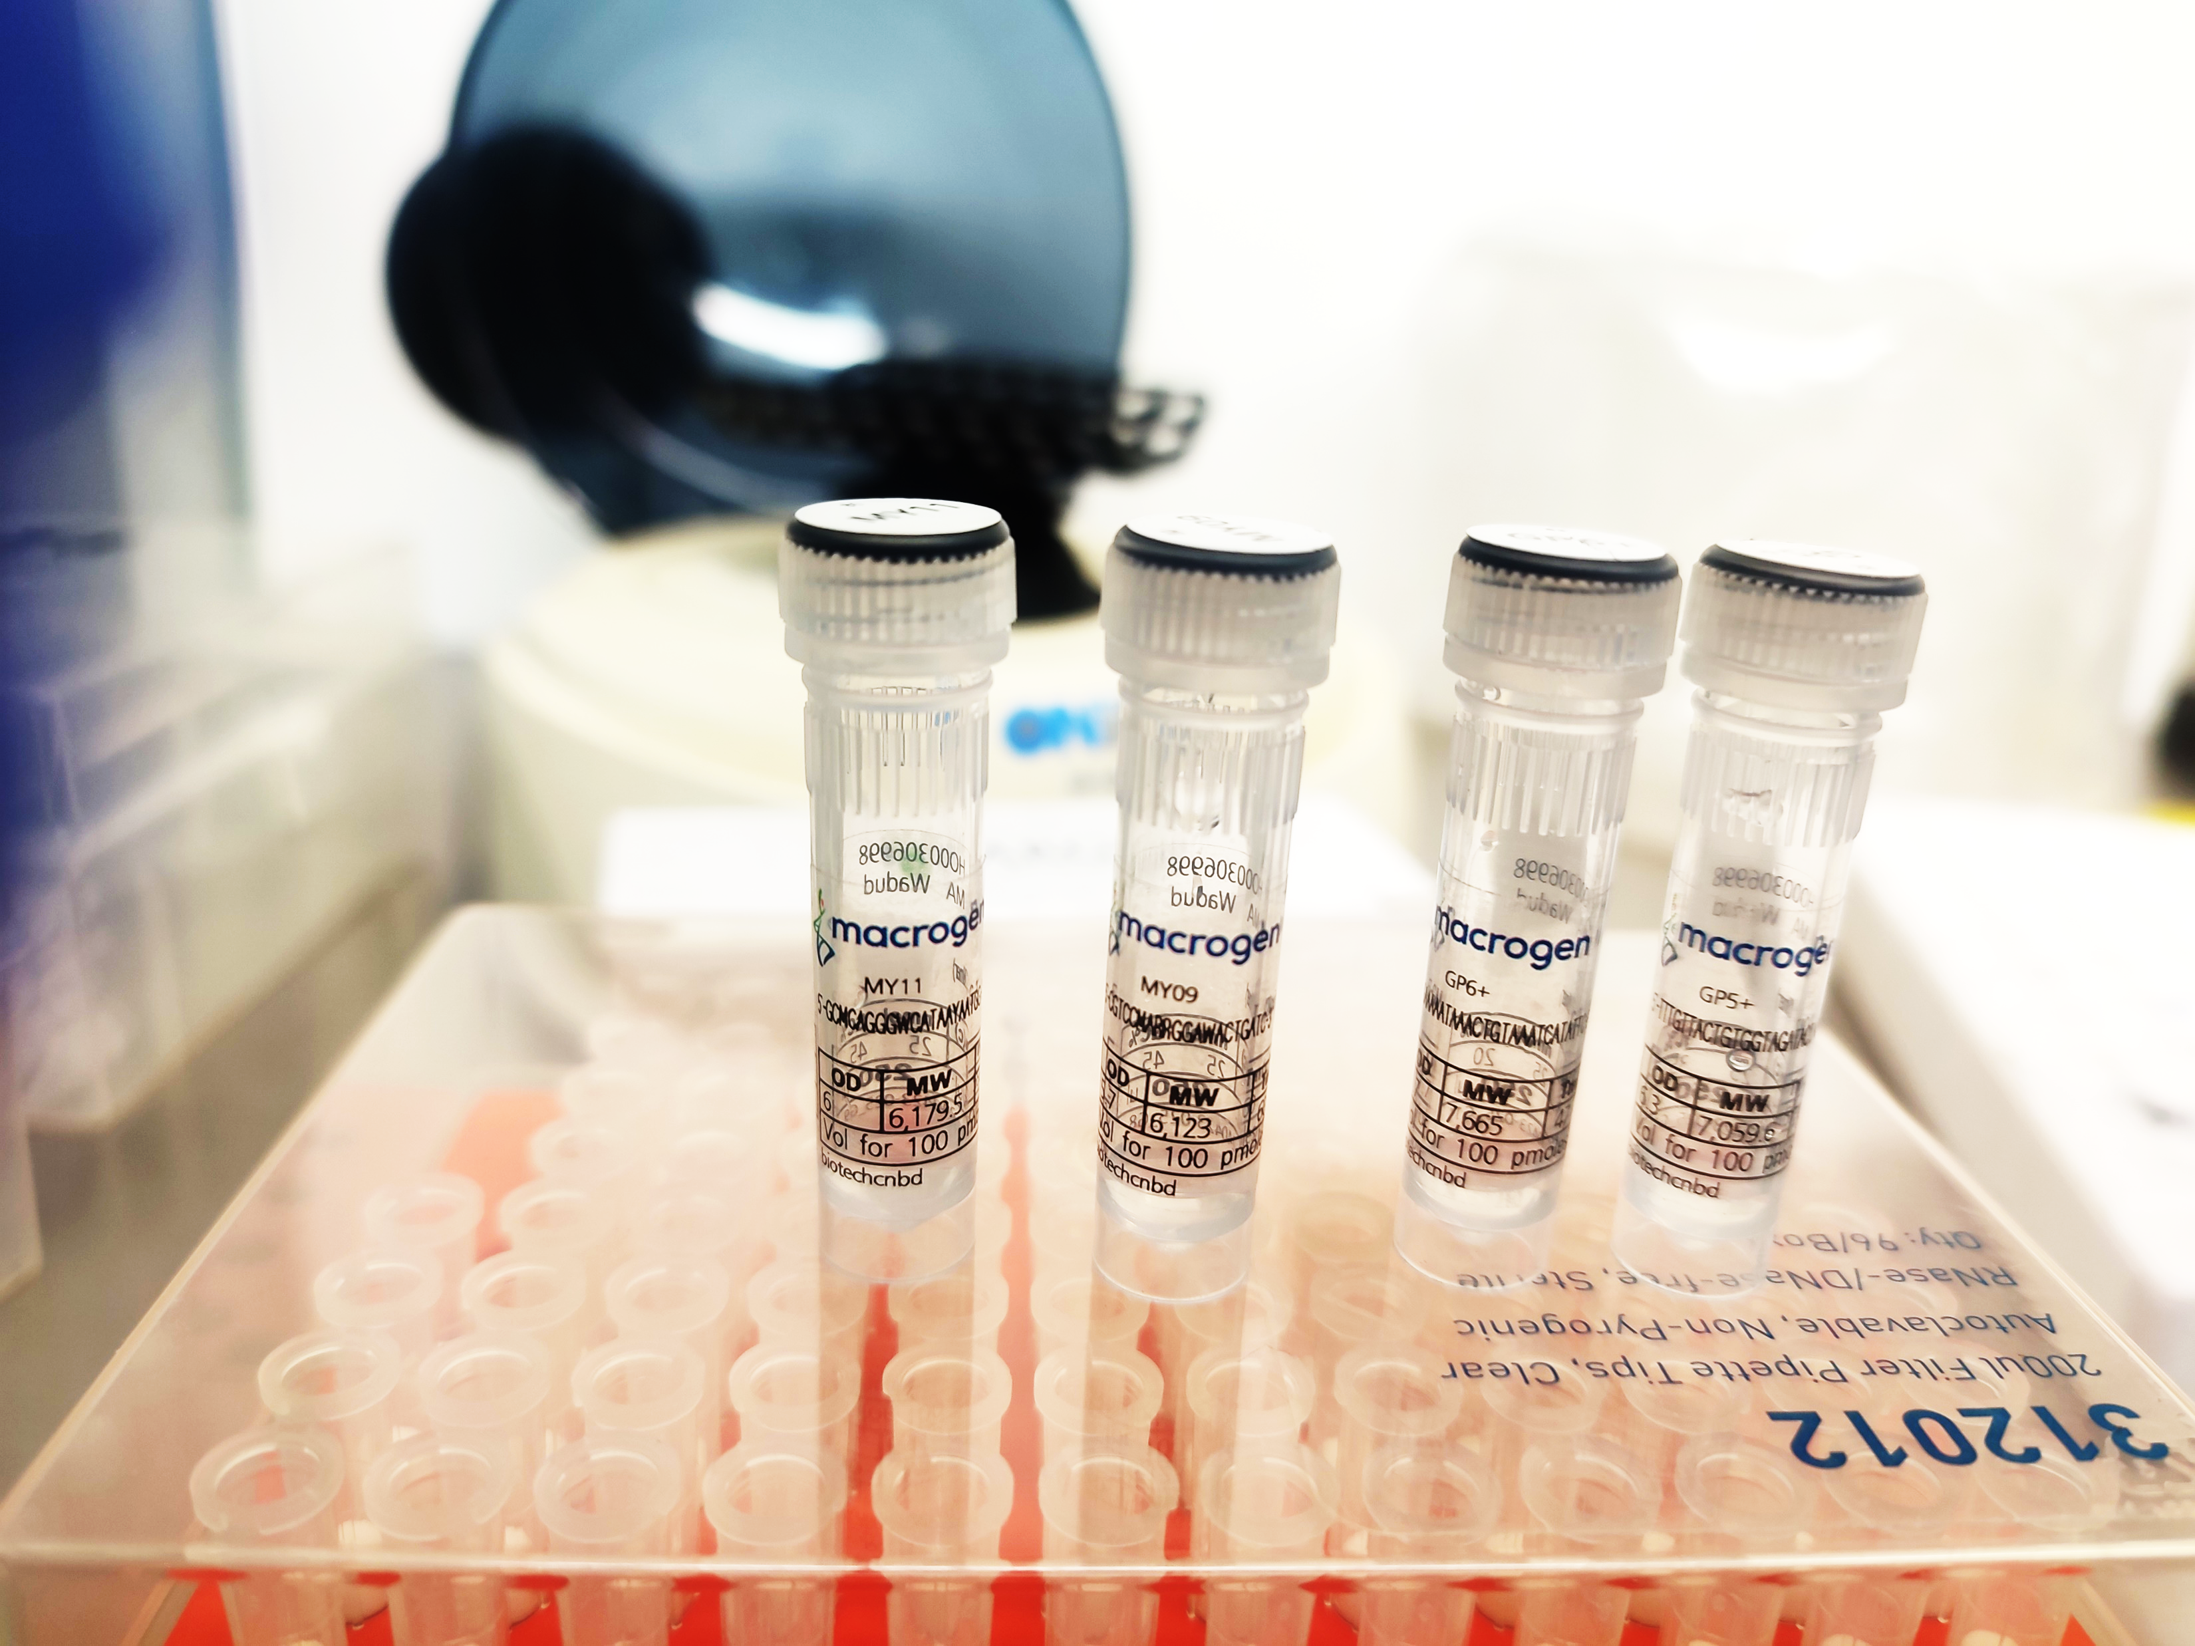.

# 3.10.2 Visualization of 1st Round Amplified Product

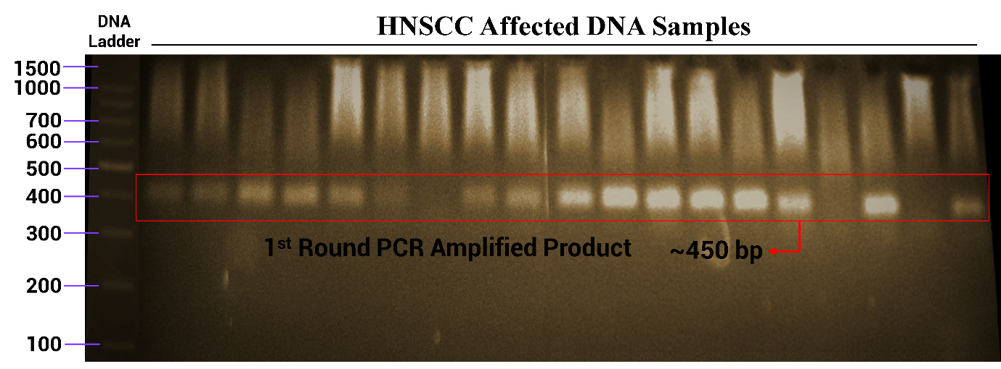After completing the PCR run, the 1st round of PCR amplified products was visualized in 1.5% agarose gel. Except for a few samples, gel bands were shown for a maximum number of samples. All the bands are shown in a single line, nearer about 450 base pairs compared to the DNA ladder.

**Figure 3.13: Gel electrophoresis band of 1st round PCR amplified product**. (a) The first well contains a 100bp DNA ladder sequence. Here, 100bp is the lowest base pair while 1500bp is the highest base pair band. 500bp is the most prominent band compared to other bands on ethidium bromide-stained agarose gels. (b) All the bands are shown in a single linear line near about 450 bp and there are no bands shown in negative control which contain TBE buffer only. There are some prominent bands and some of the bands are moderately prominent. No bands are visualized in a few samples containing wells.

# 3.10.3 Prepared Solution for 2nd Round PCR

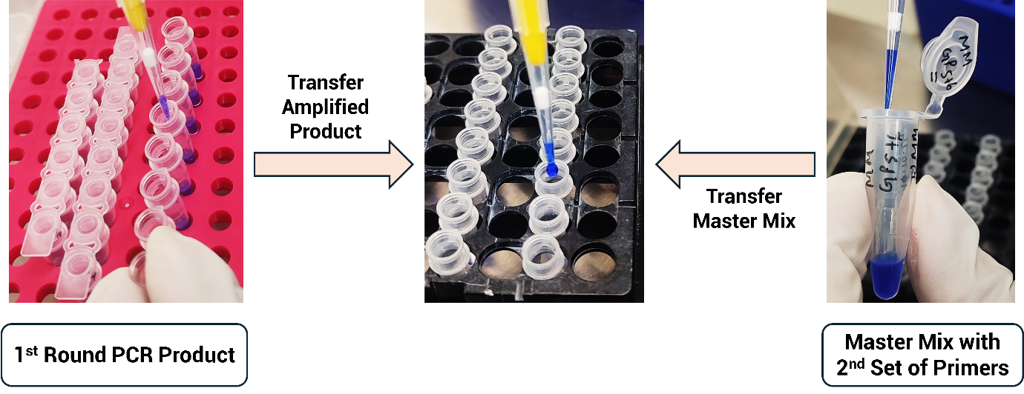Samples from 1st round PCR amplified product showing the band in agarose gel were transferred to perform 2nd round PCR where the new master mix was prepared by adding 2nd set of primers. (**Figure 3.14)**

**Figure 3.14: Preparation of 2nd round PCR mix.**

# 3.10.4 Visualization of 2nd Round Amplified Product

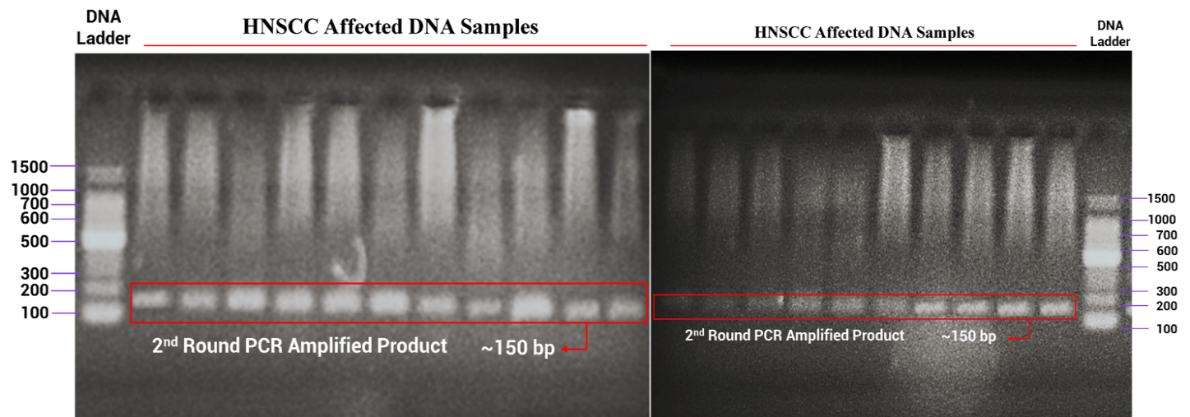The 2nd round PCR amplified product bands were visualized near about 150 base pairs compared to the ladder sequence where the maximum bands were prominent, and few bands were less prominent.

**Figure 3.15: Gel electrophoresis band of 1st round PCR amplified product**. (a) Both the first and last well contain a 100bp DNA ladder sequence. Here, 100bp is the lowest base pair while 1500bp is the highest base pair band. 500bp is the most prominent band compared to other bands. (b) All the bands are shown in a single linear line near about 150 bp. Maximum bands are more prominent while a few are less prominent bands.

# 3.10.5 Retrieve the Nucleotide Sequence of the L1 Gene

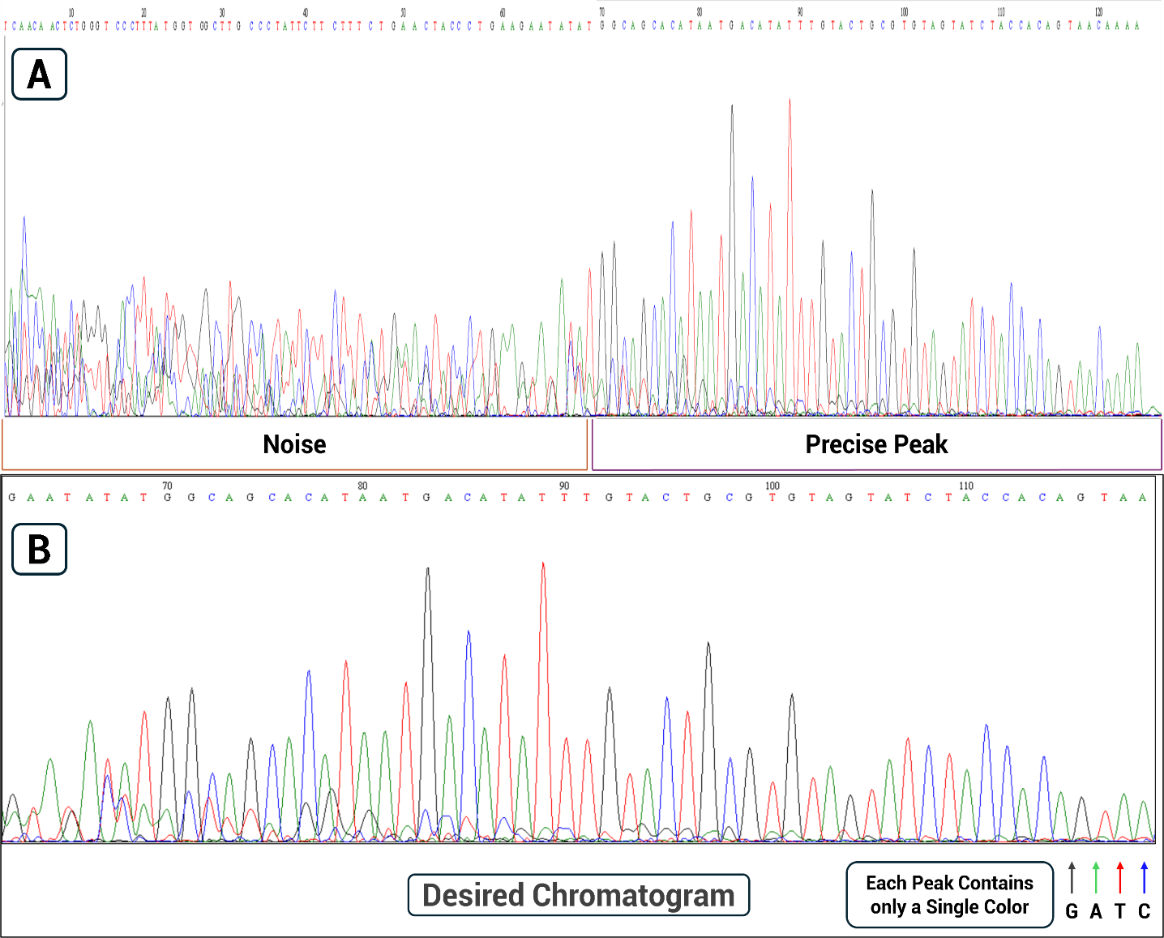After getting the desired band from gel electrophoresis, sanger sequencing was performed to get the partial sequence of the L1 gene and confirmed the HPV genotype both detected and undetected. The actual sequence of the L1 gene was retrieved by analyzing the raw chromatogram data (**Figure 3.16 A**). The analyzed peaks are eventually distributed across the chromatogram (**Figure 3.16 A**) and five sequence data are tabulated in **Table 3.2.** where the red color indicates point mutations. All sequenced data are available in **Appendix X.**

**Figure 3.16: Chromatogram analysis from Sanger sequencing data.** (A) Raw chromatogram data containing both noise and precise nucleotide information. (B) Analyzed data with the desired chromatogram.

**Table 3.2: Consensus sequences of the HPV L1 gene detected from different HNSCC samples.**

|  |  |
| --- | --- |
| **No of Sequence** | **Consensus Sequence** |
| **Query Sequence 1** | AGGAGTACCTACGACATGGGGAGGAATATGATTTACAGTTTATTTTTCATTTGTTACTGTGGTAGATACTACACGCAGTACAAATATGTCATTATGT |
| **Query Sequence 2** | TACTAACTTTAAAGAGTACCTACGACATGGGGAGGAATATGATTTACAGTTTATTTTTCATTTTGTTACTGTGGTAGATACTACACGCAGTACAAATATGTCATTATGTGCTGC |
| **Query Sequence 3** | AAAAATACTAACTTTAAGGAGTACCTACGACATGGGGAGGAATATGATTTACAGTTTATTTTTCATTTGTTACTGTGGTAGATACTACACGCAGTACAAATATGTCATTATGCGCTGCC |
| **Query Sequence 4** | ATACTAACTTTAAGGAGTACCTACGACATGGGGAGGAATATGATTTACAGTTTATTTTTCATTGTTACTGTGGTAGATACTACACGCAGTACAAATATGTCATTATGTGCTGCC |
| **Query Sequence 5** | TCTACTTTCAGGAAACTACATATAAAAATACTAACTTTAAGGAGTACCTACGACATGGGGAGGAATATGATTTACAGTTTATTTTTCA |

# 3.11 BLAST Search

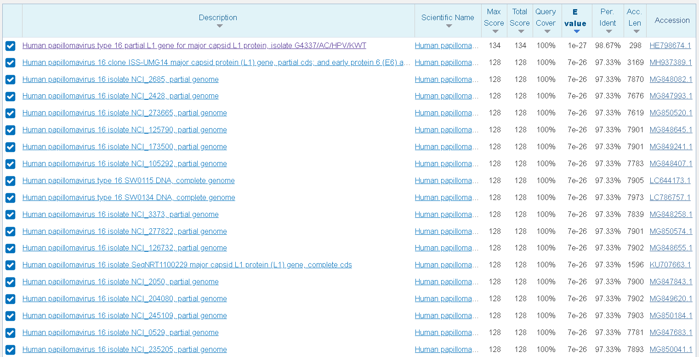Analyzed consensus sequences were the different strains of HPV that were confirmed by nucleotide BLAST searching.

**Figure 3.17: Confirmation of HPV strain via nucleotide BLAST searching.**

# 3.12 Immunohistochemical Analysis

The differential expression of the host (patient’s) proteins was visualized using immunohistochemical principles. The tissue sample of a healthy individual showed a high expression of pRb (Retinoblastoma protein) protein and no expression of cyclin D1. (**Figure 3.18 A**). Compared to the healthy control, the desired expressions were visualized in both HPV-positive HNSCC (**Figure 3.18 B-C)** and HPV-negative HNSCC samples (**Figure 3.18 D).**

Along with the expression of pRb and cyclin D1, two other HNSCC-associated host proteins, p16INK4a and p53, were also analyzed in **Figure 3.19.** No expression of p16INK4a was observed in healthy tissue samples, while moderately low expression of p53 was detected in the healthy tissue samples **Figure 3.19 A.** Compared to the healthy control, the desired protein expressions were visualized in both HPV-positive HNSCC (**Figure 3.19 B-C)** and HPV-negative HNSCC samples (**Figure 3.19 D).**

**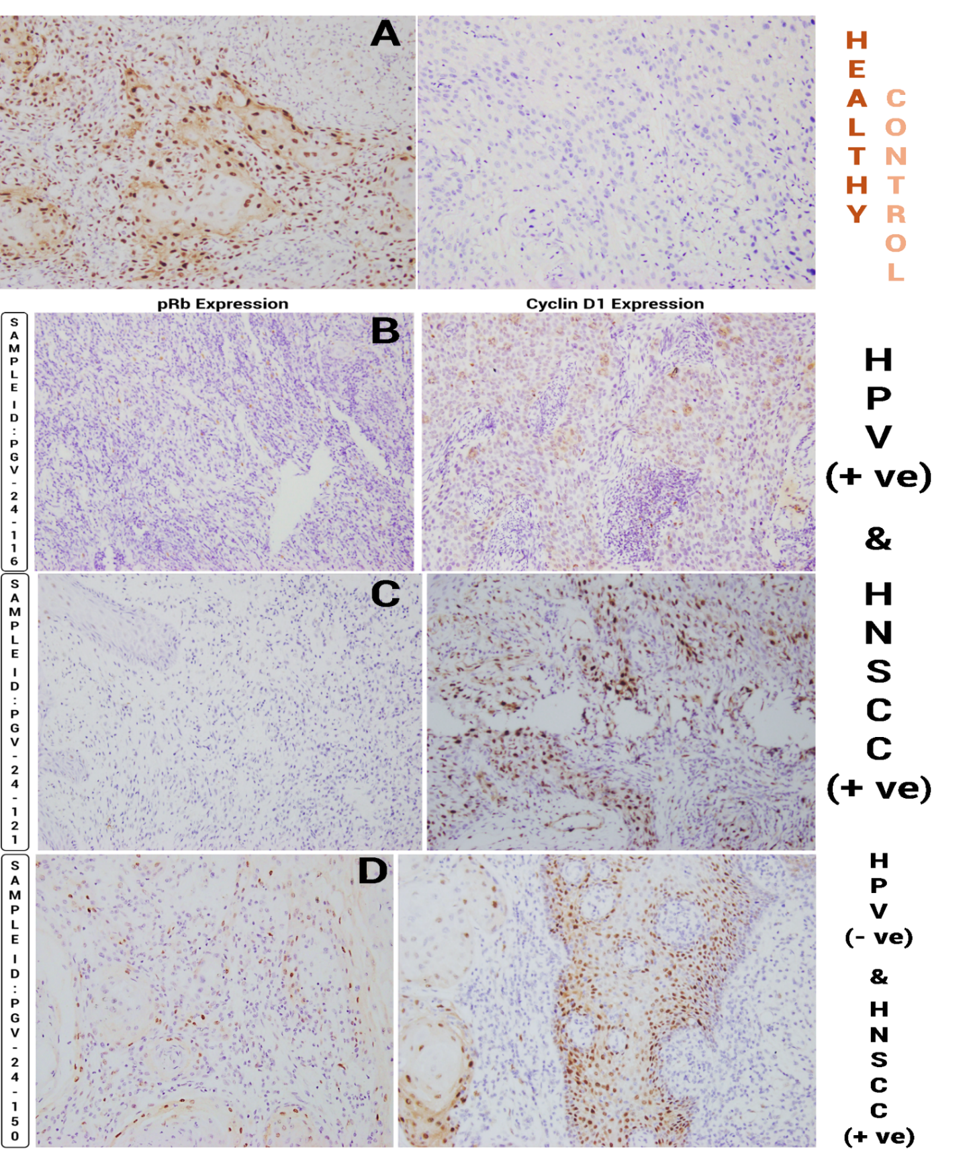****Figure 3.18: Immunohistochemical analysis of** **pRb and cyclin D1 protein in head-neck tissue.** pRb and cyclin D1 expression profiles were visualized in healthy control (A), HPV-Positive HNSCC affected patient tissue samples (B-C), and only HNSCC affected patient tissue samples (D).

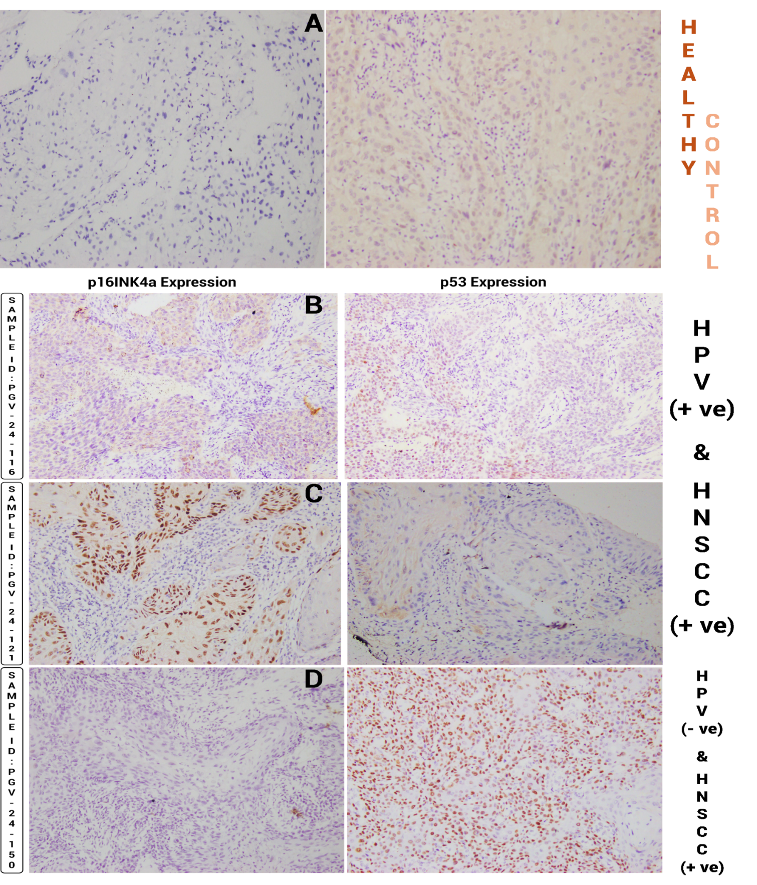**Figure 3.19: Immunohistochemical analysis of** **p16INK4a and p53 protein in head-neck tissue.** p16INK4a and p53 expression profile was visualized in healthy control (HPV-Negative and HNSCC Negative) (A), HPV-Positive HNSCC affected patients tissue samples (B-C), and only HNSCC affected patient tissue samples (D).

# 3.13 Correlation Between Host Protein Expressions in HPV-Positive HNSCC Sample

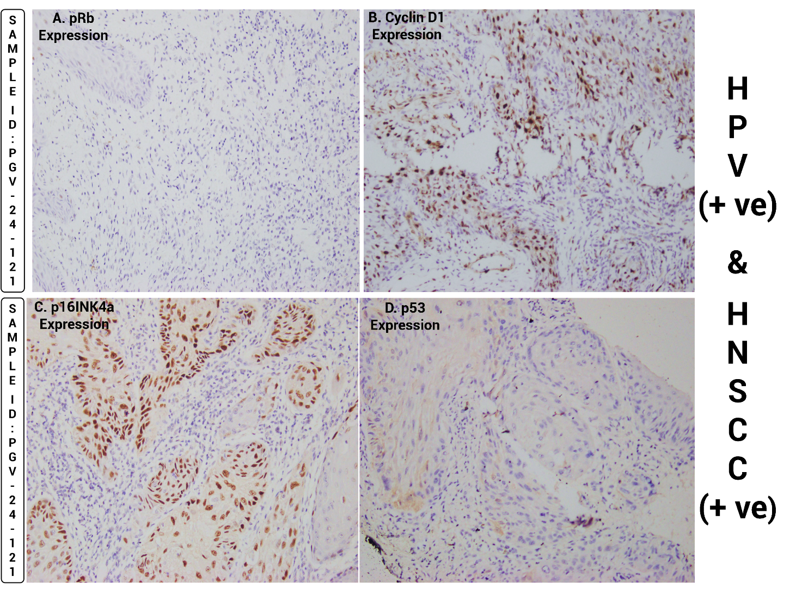The low expression of pRb can trigger the high expression of p16INK4a that facilitated moderately expressed cyclin D1moderately and the other host protein, p53 shows a low expression that is visualized in HPV-positive HNSCC samples (**Figure 3.20**), indicating the causation of HNSCC via HPV.

**Figure 3.20: Host protein expression analysis in HPV-positive HNSCC sample.** (A) A small number of brownish-colored dots indicate low pRb expression. (B and C) In contrast, a moderate and large number indicate the moderate expression of cyclin D1 and high expression of p16INK4a. (D) Low expression of p53.

# 3.14 Socio-Demographic Profile of HPV-associated HNSCC Patients

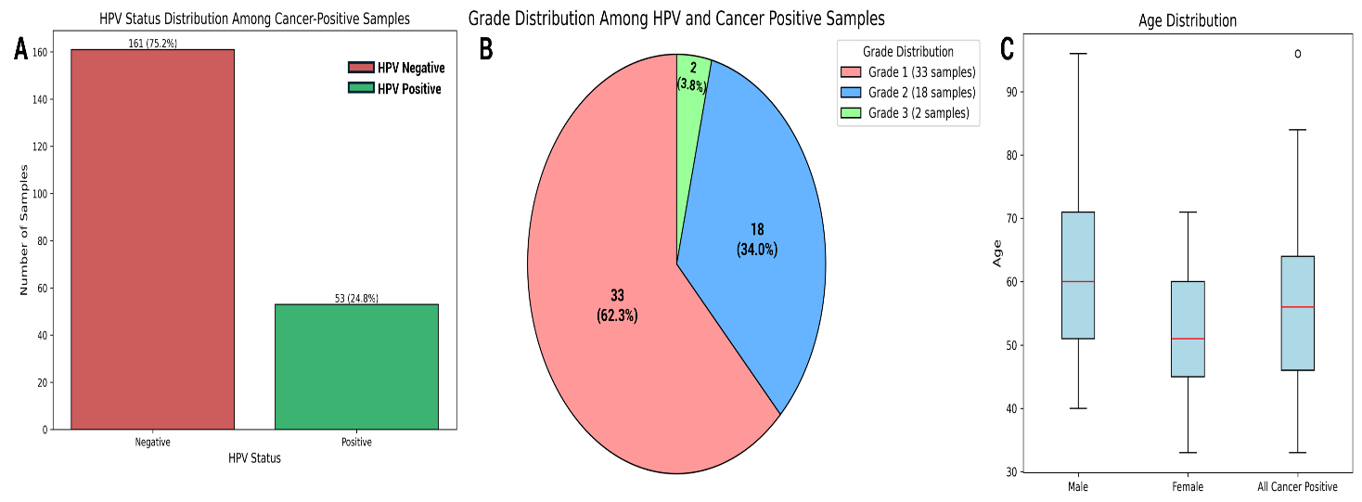Analyzing all the biological data, 53 (24.8%) of HNSCC samples were HPV positive which was the main causal factor in developing this carcinoma **Figure 3.21 A.** Among these HPV-positive HNSCC, 33 (62.3%), 18 (34%), and 2 (3.8%) were classified as grade 1, grade 2, and grade 3 respectively **Figure 3.21 B.** The mean age of the HPV-associated HNSCC patients was 56.1 while specifically the males and females were 62.1 and 51.5 **Figure 3.21 C.** However, the maximum number of HPV was detected in buccal mucosa 33 (62.2%) and tongue 16 (30.2 %). The remaining was detected in other sites of head-neck regions. Among these people, oral sexual history was found in 56.6% of patients. **(Table 3.4)**

**Figure 3.21: Distribution of HPV-positive HNSCC status with grading and age among all HNSCC-positive samples**. (A) HPV status distribution among all HNSCC-positive samples, (B) Grading of HPV-positive HNSCC, (C) Age distribution profile of HPV-associated HNSCC patients.

|  |  |
| --- | --- |
| **Variables** | **HPV (+ve) HNSCC Patients (N = 53) (%)** |
| **Mean Age (Years)** | |
| Age | 56.1 |
| Male | 62.1 |
| Female | 51.5 |
| **Gender** | |
| Male | 23 (43.4) |
| Female | 30 (56.6) |
| **Education** | |
| Illiterate | 14 (26.4) |
| Literate | 16 (30.2) |
| Primary - SSC | 11 (20.8) |
| HSC | 8 (15.1) |
| Above | 3 (5.7) |
| **Socio Economic Status** | |
| Upper Class | 4 (7.5) |
| Middle Class | 35 (66) |
| Lower Class | 14 (26.4) |
| **Primary Tumor Site (Origin of HNSCC)** | |
| Buccal Mucosa | 33(62.2) |
| Tongue | 16 (30.2) |
| Oral Cavity | 1 (1.9) |
| Tonsil | 1 (1.9) |
| Cheek | 2 (3.8) |
| **Marital Status** | |
| Married | 53 (100) |
| Unmarried | 0 (0) |
| **Sexual History (Oral)** | |
| Yes | 30 (56.6) |
| Unknown | 23 (43.4) |

**Table 3.3: Socio-demographic profile and clinical characteristics of HPV-positive HNSCC patients (N = 53)**

# 3.15 Addiction Profiles and Familial History of HPV associated HNSCC Patients

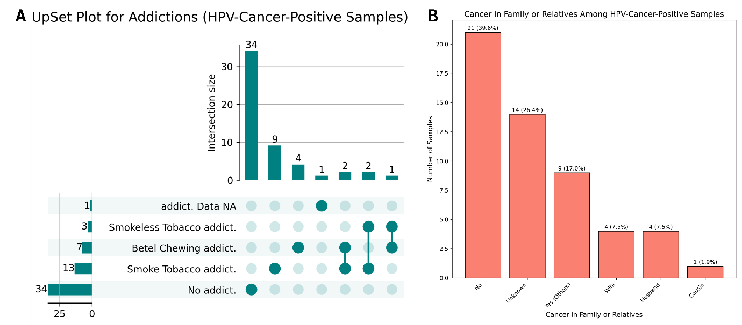A large number 34(64.2 %) of patients were not addicted while 13 (24.5%) were habituated to smoking. The combination of addictions was also shown in 2 (3.8%) of patients **(Figure 3.22).** On the other side, 39.6% of patients have no familial cancerous history where a low number of familial histories were found.

**Figure: 3.22: Habitual risk factors and familial history evaluation of HPV positive HNSCC patients**. (A) Habitual addiction, (B) Cancerous status of family and other relatives of HPV-associated HNSCC individuals.

# 3.16 High-Risk Factor Evaluation and Validation of ML Classifier Model in HNSCC

Among the 15 models, The Linear Discrimination Analysis (LDA) was selected as the best-fitted model based on the performance matrices (AUC: 0.86, Recall: 0.8206, and F1: 0.8148) mentioned in **Appendix XI**. ‘HPV status’ ranked at the top of the importance plot of the selected model, acts as a significant influencer in causing head-neck squamous cell carcinoma compared to other risk factors in our dataset where betel quid chewing addict is the second most important influencer. The others are also associated with causing HNSCC but those are showing comparatively low importance scores.

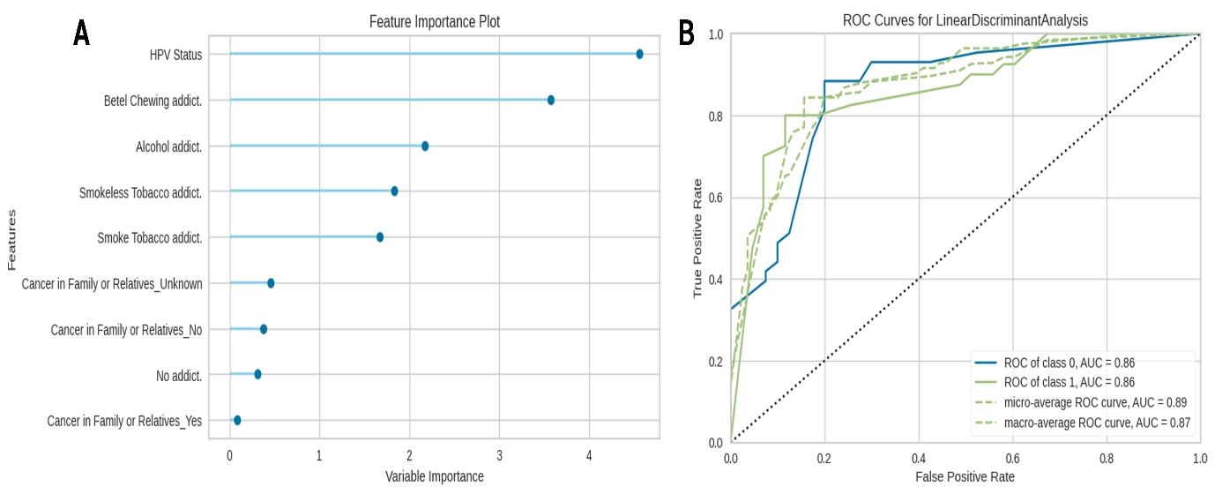**Figure 3.23: Predictive risk factor assessment for developing Head-Neck Squamous Cell Carcinoma.** (A) Feature importance plot of LDA model, ranking the features based on their importance score (B) ROC Curve representing the accuracy of the model with the AUC values for both classes. ‘0’ represents positive cancer cases and ‘1’ represents negative cancer cases.

# Chapter Four

# Discussion

# 4.1 Discussion

Head Neck Squamous Cell Carcinoma (HNSCC) from the squamous epithelial cells is known for its aggressive and frequent occurrence. The development of HNSCC-associated malignant tumors occurs across several regions of the head-neck and is more frequent in the oral part (Akhter et al., 2013) while other regions are also included. Globally, the HNSCC has emerged as a major public health concern due to its high incidences, mortality, and frequent recurrence rates and also in several Asian countries where Bangladesh (“Cancer Today,” n.d.) is gaining attention due to the increasing number of HNSCC cases among the middle-aged and younger populations. The habitual characteristics, along with infectious and noninfectious factors, specific to our geographical location, contribute to the high prevalence of HNSCC (“Dietary exposures – IARC,” n.d.). Furthermore, the lack of adequate information and understanding of the intricate biology, and risk factors associated with HNSCC progression has exacerbated the recurrence of this disease.

Based on our geographical location, betel chewing is a unique habitual characteristic that is deeply rooted in the cultures and lifestyles of the middle-aged and older population, along with smoking. The combination of extracted compound, arecoline from the betel nut (a major component of betel quid) and nitrosamines from *Nicotiana-rustica* in betel quid is playing a crucial role in HNSCC development compared to other elements and are the major carcinogenic agents responsible for developing malignancy (Lai et al., 2000; Li et al., 2019). On the other hand, among the younger population, smoking, alcohol, and both smoke and smokeless tobacco consumption and the immense interest in causal sexual relationships are increasing dramatically (“Preliminary Report on GATS Bangladesh 2017.pdf,” n.d.). These demographic characteristics are the major risk factors for the development of metastatic cancer. Although various factors mentioned above can develop HNSCC.

Betel nut, the major ingredient of betel quid chewing remains a unique risk factor in Asia regions, specifically in Bangladesh (Johnson et al., 2020b). The combination of extracted compounds like arecoline from the betel nut and nitrosamines from *Nicotiana-rustica* in betel quid plays a critical role in HNSCC development compared to other components and are the major carcinogenic agents responsible for developing malignancy (Lai et al., 2000; Li et al., 2019).

However, an important factor that remains underexplored in the context of Bangladesh is the association of Human Papillomavirus (HPV) with HNSCC. While the medical community is aware of this association, HPV detection tests are prescribed for HNSCC-affected individuals. To our knowledge, there are only two published studies that were conducted before 2017 about the HPV association in HNSCC in Bangladesh, creating a substantial information gap regarding its contribution to HNSCC development. So, from the perspective of Bangladesh, the prolonged use of betel quid and the lack of information about the viral association of HNSCC might be alarming risk factors for developing malignant HNSCC. As a result, despite the rise of awareness, administering chemotherapy, and completing proper diagnosis, the occurrence and recurrence rate of HNSCC continues to rise. The main focus of this study was to address this gap and know about the occurrence of HPV-associated HNSCC.

Epidemiological and clinical studies with molecular evidence imply the vital role of high-risk HPV in the etiopathogenesis of HNSCC. Though other viruses are also linked to HNSCC development, especially in nasopharyngeal carcinoma, HPV is more prevalent and affects most of the regions and subregions of the head-neck (Borsetto et al., 2020; Mahmutović et al., 2021). Notably, HPV-associated HNSCC cases are rising in developed nations, whereas non-infective causes are decreasing. However, due to the lack of extensive data on HPV-associated disease, the exact scenario of Bangladesh remains unclear. But the cases of HPV-associated HNSCC development have been reported by analyzing the small amount of data.

As a developing country, Bangladeshi people are influenced by both positive and negative sides of Western culture like reduced use of betel quid but enhanced smoking and unethical sexual behavior. Though there is no concrete evidence supporting the statement of changing sexual behavior, it's required to investigate this issue to obtain the actual information about HNSCC occurrence in our country. Since the primary mode of HPV transmission is sexual contact or close skin-to-skin contact, it spreads readily and often asymptomatically during sexual activity. As HPV spreads without any noticeable symptoms and the associated disease may take 5-10 years to manifest (Smith et al., 2017b), it’s easy to overlook HPV as a cause of HNSCC. Hence, implementing sensitive detection methods is crucial for the diagnosis of HPV-associated HNSCC in its early stages. It is important to use a controlled and highly sensitive detection system for detecting HPV in patient samples. Tissue samples are more commonly used for detecting both carcinoma and HPV status by analyzing cellular morphology and spatial status and obtaining a high amount of DNA for molecular analysis. Additionally, PCR-based assays and immunohistochemistry are widely recognized techniques for identifying HPV status.

To complete the aforementioned study, initially, 416 tissue samples were randomly collected from the patients containing the sores or the ulcerative lesions in the head neck region **(Figure 3.2)** where222 (53.4%) samples were collected from the male and 194 (46.6%) from female participants **(Figure 3.3 A).** All the patients were over 18 years old. From these, some tissues were embedded via paraffin that were collected 3 months ago from commencing the molecular analysis. Among these samples, a maximum of 144, 123, and 88 tissues were collected from the buccal cavity, tongue, and oral cavity where the moderate amount was from the tonsil, larynx, cheek, pharynx, and others (**Figure 3.3 B).** Subsequently, for performing histopathological analysis all excised samples were collected from the previously preserved formalin solutions **(Figure 3.2 D)** and embedded via paraffin for proper tissue sectioning **(Figure 3.4)**. Three precisely sliced FFPE tissues **(Figure 2.3 B)** were then underwent Hematoxylin and Eosin staining for histopathological analysis **(Figure 2.4)** and analyzed under the microscope **(Figure 3.5)**. The tissue given in **Figure 3.5 A** contains the normal cellular structure and appropriate cellular shape with a small uniform nucleus. In addition to these, all cells are well organized where no invasive nature is seen which indicates it’s a healthy tissue. Compared to this, **Figures 3.5 B and E** show the abnormal shape and orientation with hyperchromatic nuclei around the squamous tissue. From these, the cellular and tissue appearance are clearly visualized. Though the cellular shape and organization are well understood in **Figure 3.5 A,** in **Figure 3.5 B,** these are understood moderately, and a giant cell is also visualized. These characteristics indicate the sample is a well-differentiated tumor.In contrast,the various irregular cellular shape, scattered cellular organization, and abnormal mitotic proliferation with densely pink-colored hyperchromatic nuclei are shown in **Figure 3.5 C and F.** Additionally, compared to the normal cell the large cellular shape and enlarged nucleolus are also observed in **Figure 3.5 C** whereas the cellular organization and shape are moderately understood in **Figure 3.5 F** which represents as moderately differentiated tumor. Besides this, there is poorly differentiated cellular, and no proper nuclear appearance is shown in **Figure 3.5 D,** indicating a poorly differentiated tumor. Additionally, scattered cellular and nuclear localization is also observed in this tissue (**Figure 3.5 D).**

By analyzing the stained tissue, we got 51.4% cancerous tissues where 51.9% males and 48.1% females were head-neck squamous cell carcinoma positive where the median age of HNSCC-positive patients was 56.29. (**Figure 3.6 A and C).** The prevalence of HNSCC was high in the buccal mucosa (46.7%) tongue (32.7%) and oral cavity (11.2%) while it was low for other regions (**Table 3.1).** However, A maximum of affected individuals were illiterate whereas a moderate number were literate and well-educated, and we observed that a large number came from middle- and lower-class families (**Table 3.1).** By evaluating the patient’s history, it is shown that many people had habitual addiction to betel quid chewing, smoking, and uptake of smokeless tobacco and alcohol. Multiple addiction features were also observed in these individuals, but we got a moderate number of patients who were not involved in any addiction, (**Figure 3.7 A).** Besides this, familial history was also evaluated, and we found that 72.7% of patients have no familial cancer (**Figure 3.7 B).** These evaluations indicate it might be possible that a large number of HNSCCs occur due to habitual risk factors but 23.8% of non-addicted 72.7 % of patients who had no genomic predisposition, have raised the question about the hidden agents of HNSCC which might be HPV. So, to get the answer to our hypothesis and solve the rising questions about the risk factors, molecular analyses were conducted.

The DNA from all histopathologically confirmed HNSCC tissue was extracted (**Figure 3.8)** where maximum samples contained high-quality DNA, and a few had low quality **(Appendix XII)**. The reason for this low quality was not used RNase during the extraction procedure in some samples. Using this DNA, RT-PCR was conducted to detect the presence of HPV DNA where 61 samples were detected as HPV-positive samples where high-risk HPV was detected in all samples, and low-risk HPV was detected in 7 samples. Compared to positive control, maximum Ct values were shown between the 20 to 28 cycles. The successful amplification of high-risk HPV was observed in all samples where two sigmoid shape curves were visualized in the sample ID **PGV-24-89** wheretheblue colorcurvebegins to rise around the cycle 28-30, indicating a high Ct value compared to PC. These high Ct values imply the low viral load of low-risk HPV. The amplification of internal control confirms the validity of sample quality. (**Figure 3.9)** For genotyping, HPV-detected DNA extracted samples again undergo the RT-PCR. 94.3% of samples contained HPV 16 genomic DNA, whereas multiple strains of HPV including HPV 16, 18, 31, 33, 35, 39, and low risk were also present in a few samples. Compared to control, HPV 16 strains positivity was shown in the two-sample ID PGV-24-113, and 141 while multiple strains including HPV 31 and 33 are present in sample ID PGV-24-89 and HPV 18, 33, 35,39 DNA are present in id PGV-24-8 (**Figure 3.10**). Among 61 samples, HPV strains were identified in 38, where multiple strains are present in ~34% sample. The remaining samples were undetected. Detecting the undetected HPV strains and validating the PCR results, sanger sequencing was conducted to retrieve the sequence of the L1 gene. The L1 gene is a major capsid protein of HPV whose nucleotide sequence varies from strain to strain (Depuydt et al., 2007) and is more widely used in the laboratory for detecting HPV as an amplification target. Due to its stability in the fixed tissue compared to other genes, it acts as a well-recognized target of HPV for PCR reactions (Shaikh et al., 2017). However, for conducting sequencing, initially nested PCR was performed using two sets of primers of the L1 gene (**Figure 3.11).**  The amplified products of 1st round PCR were visualized in 1.5% agarose gel. The desired brands of amplicon products were found near the 450-base pair. Some prominent bands were visualized in some of the samples containing well, while some bands were moderately prominent indicating the presence of the HPV genomic DNA in a moderate amount. Two less prominent bands were observed which suggests the presence of a very low amount of HPV DNA and no bands were observed in a few wells containing samples, indicating the absence of the HPV DNA in the sample (**Figure 3.13).** Based on the confirmed gel band, first-round amplified products were used to perform 2nd round PCR where a different set of primers was used (**Figure 3.14).** Then the PCR-amplified products were visualized in 2% of the agarose gel where maximum bands were prominent, and some were moderately prominent. However, compared to the 100 bp DNA ladder, all the bands were visualized in nearly 150 base pairs which was similar to our desired product size (**Figure 3.15).** In both cases, the smear was visualized which means the poor quality of viral DNA or it may be degraded during the extraction process. However, Sanger sequencing was performed from all the amplified HPV DNA samples, which were confirmed via gel electrophoresis band. The generated chromatograms after sequencing were analyzed (**Figure 3.16 A)** and the nucleotide sequences were retrieved (**Figure 3.16 B)**. The nucleotide sequence similarity of all sequencing samples was checked via nucleotide BLAST searching **(Figure 3.17)** and found similarities among HPV 16, 18, 31, 33, and 35, strains of the L1 gene **(Appendix IX).** However, based on the aforementioned molecular technique from DNA extraction to nucleotide sequencing, we were sure about the presence of HPV in head-neck squamous cell carcinoma samples. However, the presence of HPV does not indicate that it was the factor or only the sole factor that caused cancer. As we have some participants who have been affected by HNSCC with habitual risk factors and also HPV, so, for ensuring the involvement of HPV as an oncogenic agent in these samples, immunohistochemistry was performed. Though the presence of viral proteins, E6 and E7, are mainly responsible for causing HNSCC, these are not commonly used in immunohistochemical detection due to their low availability and sensitivity, and low expression level in host tissues. For this, the host protein expressions in tissue samples were observed that are regulated through HPV E6 and E7 proteins (Shaikh et al., 2017; Smeets et al., 2007). In this technique, the expression intensity of the 4 major host proteins including p16, pRb, cyclin D, and p53 was visualized for HPV DNA positive HNSCC, 2 HPV negative HNSCC samples, and one healthy individual sample. The different expressions of pRb and Cyclin D1, p16INK4a, and p53proteins were observed in **Figure 3.18** and **Figure 3.19** respectively. In the healthy control, there was high expression of pRb whereas low expression was visualized in Cyclin D1 (**Figure 3.18 A).** Compared to healthy control, no pRb expression was visualized in HPV and HNSCC-positive samples (**Figure 3.18 B-C)** while low expression was seen in the HPV-negative but HNSCC-positive sample (**Figure 3.18 D).** In addition, low to moderate expression of Cyclin D1 was observed in HPV-positive and HNSCC-positive samples whereas high expression of Cyclin D1 was shown in HPV-negative HNSCC-positive samples (**Figure 3.18 B-D)**. Along with this, **Figure 3.19** visualizes the different expressions of p16INK4a and p53. Compared to the healthy control (**Figure 3.19 A),** moderate to high expression ofp16INK4a was observed in HPV and HNSCC-positive samples (**Figure 3.19 B-C)** where nop16INK4a was shown in HPV negative-HNSCC positive sample (**Figure 3.19 D).** The moderate to low p53 expression was visualized in HPV and HNSCC-positive samples(**Figure 3.19 B-C),** but the high p53 expression was seen in HPV-negative HNSCC-positive samples(**Figure 3.19 D).** These immunohistochemical results explain the association of HPV with the development of HNSCC and give a correlation between viral proteins (E6 and E7) and host proteins (**Figure 3.20)**. The viral E7 protein binds with the pRb region of the E2F-pRB complex and occurs pRb degradation. As a result, released E2F promotes cell cycle events and enhances DNA replication in the G1/S phase, leading to abnormal cell proliferation by dysregulating the cell cycle. In response to this, to control the abnormal condition of the cell cycle, p16INK4a **-** a cyclin-dependent kinase inhibitor, was upregulated and inhibited the function of Cyclin D1 via disrupting the protein. Due to this, no pRb, low to moderate cyclin D1, and moderate to high p16INK4a expression were visualized in HPV-positive HNSCC-positive samples. On the other side, the E6 protein attached to the p53 and degraded it through proteasomal degradation. In our study, low to moderate expression of p53 was also visualized in some HPV and HNSCC-positive samples which might be the causes of p53 gene mutations due to other HNSCC associate factors that were observed in HPV-negative HNSCC samples (Pinkiewicz et al., 2022; Shaikh et al., 2017). Besides these, the results of IHC also explain the HPV-negative HNSCC development where a reduced level of pRb indicates the mutation of the pRb gene, resulting in dysregulation of the cell cycle and increasing the expression of cyclin D1. Additionally, the overexpression of p53 compared to the control suggests the mutation of p53 and no expression of p16, which is the poor prognosis marker of HNSCC indicating the development and progression of HPV-negative HNSCC (Hashmi et al., 2018).

Ultimately, in 24.8 % of samples, HNSCC occurred due to HPV where the mean age of the population is 56.1 (**Figure 3.21).** Compared to males the occurrence of HPV-associated HNSCC in females was high and most individuals came from middle-class families. A large number of carcinomas occur in the oral region of the patients who have oral sexual history **(Table 3.3)** and most of the patients had no addiction and no familial cancerous history (**Figure: 3.22).** Though the percentages of HPV associated with HNSCC were low, the possibility of causing HNSCC due to HPV is too high compared to other factors. Based on the performance evaluation matrices, the selected model LDA ranked HPV on top of the importance plot, indicating HPV infection as the main reason for developing HNSCC among other factors (**Figure 3.23).**

The overall findings of this study validate our assumptions. According to our results, the present status of HNSCC in Bangladesh is high compared to other studies (Karim et al., 2022) where betel quid, smoked tobacco, and HPV are identified as the major contributing factors among adult individuals. Among the HNSCC patients, multiple HPV strains were detected in one-third of the samples, all of which showed a high similarity with the Japanese strain (**Appendix XIII)**. However, some point mutations were observed in the L1 gene **(Appendix XIV)** that might be capable of the alteration of the viral major capsid protein, potentially facilitating easier viral entry into the host body and maintaining the viral life cycle through immune evasion. Consequently, this could lead to the development of HNSCC (Buck et al., 2013). The differential expression of the host proteins including p16, pRb, cyclin D1, and p53 in our HPV-positive HNSCC samples confirms the causation of HNSCC due to HPV which strongly validates our assumption.

Worldwide, 30% of HNSCCs are caused due to HPV which varies on the site of origin of a tumor and geographical location. The previous two studies in Bangladesh reported that 3% and 21% of samples were HPV positive within 36 and 174 samples respectively (Akhter et al., 2013; Shaikh et al., 2017) whereas, in ours, 24.8% of HPV was detected in 214 samples. Additionally, 37% of HPV was detected in the oropharynx and 12.5% were in the larynx (Shaikh et al., 2017) but in our study, we found 94.3% of HPV in the oral region. Compared to other HPV-associated HNSCC studies in Southeast Asia, and Eastern Asia, our findings exhibit a slightly lower frequency in HPV-associated HNSCC but a higher frequency in Bangladesh which is the strongest influencer that develops HNSCC gradually. However, most of the studies reported that high-risk HPV 16 and 18 are the responsible strains that develop HNSCC while HPV 16 prevalence was high. In our study, we found HPV 16 in maximum cases but HPV 18, 33, and 35 were also detected at a moderate rate. The vital findings of this study reveal that HPV is the hidden destructive factor in our country that increases the occurrence of HPV-associated HNSCC. Due to limited studies about HPV-associated HNSCC, the medical community could not provide proper suggestions and treatment for this. Consequently, the spread of HPV occurs unwittingly, and the given treatment is not working properly, leading to high recurrence and mortality.

# 4.2 Limitations

There are several limitations in this study which are moderate sample size with a small number of anatomic subsites which does not reflect the scenario of the whole country. Information about sexual relationships from all individuals could not sought respecting the social and cultural belief. Besides, some samples, especially FFPE tissue samples, were excluded due to poor-quality DNA, and due to budget limitations, the expression of any viral protein was not evaluated. Despite these limitations, this study shows the way to novel research opportunities, which also grows an immense enthusiasm to reveal the mechanistic pathway of HPV 18, 31, and 33, associated HNSCCs and developing population-specific therapeutics, becoming beneficial for both the scientific community and future researchers.

# Chapter Five

# Conclusion and Future Aspects

# 5.1 Concluding Remarks and Future Aspects

This study provides a fundamental insight into the associated risk factors for Head Neck Squamous Cell Carcinoma (HNSCC) development in Bangladesh. Along with the habitual non-infective risk factors such as betel quid and smoking, HPV plays a pivotal role in developing 26% of HNSCC in this study. Although the percentage is lower compared to habitual risk factors, it is increasing gradually and has a detrimental impact on our population, consequently contributing to rising incidence and mortality rates of HNSCC. The 41.5% increasing rate of other variants in HNSCC development poses an emerging threat to our population and the scientific community. Moreover, the outcomes of this study have a significant positive impact on reducing both the HNSCC occurrence and recurrence through early diagnosis.

This study reflects an area of active research in the field of HPV-mediated HNSCC. It can be used for gathering knowledge about the development of HNSCC via the combined effect of infective and non-infective causes and multiple HPV strains except HPV16, indicating a new dimension of HPV-associated research. In the future, this study might be expanded to develop population-specific therapeutics by analyzing differentially expressed genes through comprehensive transcriptomic analysis between HNSCC and HPV-positive HNSCC patients in the geographical context.

# Chapter Six

# References

1. Akhter, M., Ali, L., Hassan, Z., Khan, I., 2013. Association of Human Papilloma Virus Infection and Oral Squamous Cell Carcinoma in Bangladesh. J Health Popul Nutr 31, 65–69. <https://doi.org/10.3329/JHPN.V31I1.14750>
2. American, S., America, N., American, S., 1996. Fundamental Understandings. Sci Am 275, 61–61. <https://doi.org/10.1038/scientificamerican0996-61>
3. Araldi, R.P., Sant’Ana, T.A., Módolo, D.G., de Melo, T.C., Spadacci-Morena, D.D., de Cassia Stocco, R., Cerutti, J.M., de Souza, E.B., 2018. The human papillomavirus (HPV)-related cancer biology: An overview. Biomedicine and Pharmacotherapy 106, 1537–1556. <https://doi.org/10.1016/j.biopha.2018.06.149>
4. Barsouk, Adam, Aluru, J.S., Rawla, P., Saginala, K., Barsouk, Alexander, 2023. Epidemiology, Risk Factors, and Prevention of Head and Neck Squamous Cell Carcinoma. Medical Sciences 11, 42. <https://doi.org/10.3390/medsci11020042>
5. Borsetto, D., Fussey, J., Fabris, L., Bandolin, L., Gaudioso, P., Phillips, V., Polesel, J., Boscolo-Rizzo, P., 2020. HCV infection and the risk of head and neck cancer: A meta-analysis. Oral Oncol 109, 104869–104869. <https://doi.org/10.1016/J.ORALONCOLOGY.2020.104869>
6. Brooks, P.J., Theruvathu, J.A., 2005. DNA adducts from acetaldehyde: implications for alcohol-related carcinogenesis. Alcohol 35, 187–193. <https://doi.org/10.1016/J.ALCOHOL.2005.03.009>
7. Buck, C.B., Day, P.M., Trus, B.L., 2013. The papillomavirus major capsid protein L1. Virology 445, 169–174. <https://doi.org/10.1016/j.virol.2013.05.038>
8. Cancer Over Time [www. All cancer statitics], n.d. URL https://gco.iarc.fr/overtime/en (accessed 1.10.25).
9. Cancer Today [www. Asian cancer statistics], n.d. URL https://gco.iarc.fr/today/en (accessed 1.10.25a).
10. Cancer Today [www. Incident/mortality], n.d. URL https://gco.iarc.fr/today/en/dataviz/maps-heatmap?mode=population&key=cum_risk&cancers=3 (accessed 1.10.25b).
11. Cancer for Today [Presents Cancer Statistics] n.d. URL <https://gco.iarc.fr/today/en>(accessed 1.11.25c).
12. Cancer Tomorrow [CFuture], n.d. URL <https://gco.iarc.fr/tomorrow/en/dataviz/isotype> (accessed 1.11.25).
13. Carrillo-Infante, C., Abbadessa, G., Bagella, L., Giordano, A., 2007. Viral infections as a cause of cancer (Review). Int J Oncol 30, 1521–1528. <https://doi.org/10.3892/ijo.30.6.1521>
14. Chiesa-Estomba, C.M., Barillari, M.R., Mayo-Yáñez, M., Maniaci, A., Fakhry, N., Cammaroto, G., Ayad, T., Lechien, J.R., 2023. Non-Squamous Cell Carcinoma of the Larynx: A State-of-the-Art Review. Journal of Personalized Medicine 2023, Vol. 13, Page 1084 13, 1084. <https://doi.org/10.3390/JPM13071084>
15. Chin, D., Boyle, G.M., Porceddu, S., Theile, D.R., Parsons, P.G., Coman, W.B., 2006. Head and neck cancer: past, present and future. Expert Rev Anticancer Ther 6, 1111–1118. <https://doi.org/10.1586/14737140.6.7.1111>
16. de Martel, C., Plummer, M., Vignat, J., Franceschi, S., 2017a. Worldwide burden of cancer attributable to HPV by site, country, and HPV type. Int J Cancer 141, 664–670. <https://doi.org/10.1002/IJC.30716>
17. de Martel, C., Plummer, M., Vignat, J., Franceschi, S., 2017b. Worldwide burden of cancer attributable to HPV by site, country, and HPV type. Int J Cancer 141, 664–670. <https://doi.org/10.1002/IJC.30716>
18. Depuydt, C.E., Boulet, G.A.V., Horvath, C.A.J., Benoy, I.H., Vereecken, A.J., Bogers, J.J., 2007. Comparison of MY09/11 consensus PCR and type-specific PCRs in the detection of oncogenic HPV types. J Cell Mol Med 11, 881–891. <https://doi.org/10.1111/j.1582-4934.2007.00073.x>
19. Dietary exposures – IARC [WWW Document], n.d. URL https://www.iarc.who.int/risk-factor/dietary-exposures/ (accessed 1.11.25).
20. Dunne, E.F., Park, I.U., 2013. HPV and HPV-associated diseases. Infect Dis Clin North Am 27, 765–778. <https://doi.org/10.1016/j.idc.2013.09.001>
21. EMBOSS Needle < EMBL-EBI [WWW Document], n.d. URL https://www.ebi.ac.uk/jdispatcher/psa/emboss_needle (accessed 1.11.25).
22. Fraga, D., Meulia, T., Fenster, S., 2014a. Real-Time PCR. Curr Protoc Essent Lab Tech 8, 10.3.1-10.3.40. <https://doi.org/10.1002/9780470089941.ET1003S08>
23. Fraga, D., Meulia, T., Fenster, S., 2014b. Real-Time PCR, Current Protocols in Essential Laboratory Techniques. <https://doi.org/10.1002/9780470089941.et1003s08>
24. Ghiani, L., Chiocca, S., 2022. High Risk-Human Papillomavirus in HNSCC: Present and Future Challenges for Epigenetic Therapies. International Journal of Molecular Sciences 2022, Vol. 23, Page 3483 23, 3483. <https://doi.org/10.3390/IJMS23073483>
25. GLOBOCAN 2020: New Global Cancer Data | UICC [WWW Document], n.d. URL https://www.uicc.org/news/globocan-2020-global-cancer-data (accessed 1.10.25).
26. Graham, S. V., 2010. Human papillomavirus: Gene expression, regulation and prospects for novel diagnostic methods and antiviral therapies. Future Microbiol 5, 1493–1506. <https://doi.org/10.2217/fmb.10.107>
27. Haring, C.T., Kana, L.A., Dermody, S.M., Brummel, C., McHugh, J.B., Casper, K.A., Chinn, S.B., Malloy, K.M., Mierzwa, M., Prince, M.E.P., Rosko, A.J., Shah, J., Stucken, C.L., Shuman, A.G., Brenner, J.C., Spector, M.E., Worden, F.P., Swiecicki, P.L., 2023. Patterns of recurrence in head and neck squamous cell carcinoma to inform personalized surveillance protocols. Cancer 129, 2817–2827. <https://doi.org/10.1002/cncr.34823>
28. Hashmi, A.A., Hussain, Z.F., Hashmi, S.K., Irfan, M., Khan, E.Y., Faridi, N., Khan, A., Edhi, M.M., 2018. Immunohistochemical overexpression of p53 in head and neck Squamous cell carcinoma: Clinical and prognostic significance. BMC Res Notes 11, 1–5. <https://doi.org/10.1186/S13104-018-3547-7/TABLES/3>
29. Head and neck cancers - Symptoms and causes - Mayo Clinic [WWW Document], n.d. URL https://www.mayoclinic.org/diseases-conditions/head-and-neck-cancers/symptoms-causes/syc-20354171 (accessed 1.10.25).
30. Home [WWW Document], n.d. URL https://www.megasoftware.net/ (accessed 1.11.25).
31. Hung, T.C., Huang, L.W., Su, S.J., Hsieh, B.S., Cheng, H.L., Hu, Y.C., Chen, Y.H., Hwang, C.C., Chang, K.L., 2011. Hemeoxygenase-1 expression in response to arecoline-induced oxidative stress in human umbilical vein endothelial cells. Int J Cardiol 151, 187–194. <https://doi.org/10.1016/j.ijcard.2010.05.015>
32. ICD-10 Version:2019 [WWW Document], n.d. URL https://icd.who.int/browse10/2019/en (accessed 1.10.25).
33. Ishida, T., Hijioka, H., Kume, K., Miyawaki, A., Nakamura, N., 2013. Notch signaling induces EMT in OSCC cell lines in a hypoxic environment. Oncol Lett 6, 1201. <https://doi.org/10.3892/OL.2013.1549>
34. Jenkins, D., 2007. Histopathology and cytopathology of cervical cancer. Dis Markers 23, 199–212. <https://doi.org/10.1155/2007/874795>
35. Johnson, D.E., Burtness, B., Leemans, C.R., Lui, V.W.Y., Bauman, J.E., Grandis, J.R., 2020a. Head and neck squamous cell carcinoma. Nature Reviews Disease Primers 2020 6:1 6, 1–22. <https://doi.org/10.1038/s41572-020-00224-3>
36. Johnson, D.E., Burtness, B., Leemans, C.R., Lui, V.W.Y., Bauman, J.E., Grandis, J.R., 2020b. Head and neck squamous cell carcinoma. Nature Reviews Disease Primers 2020 6:1 6, 1–22. <https://doi.org/10.1038/s41572-020-00224-3>
37. Johnson, D.E., Burtness, B., Leemans, C.R., Lui, V.W.Y., Bauman, J.E., Grandis, J.R., 2020c. Head and neck squamous cell carcinoma. Nature Reviews Disease Primers 2020 6:1 6, 1–22. <https://doi.org/10.1038/s41572-020-00224-3>
38. Karim, M.A., Mahmud, M.K., Khan, M.S.R., Zafar, M.H., Ali, M., 2022. Demographic Distribution of Head-Neck Carcinoma of ENT Oncology Department of NICRH in 2020. Bangladesh Journal of Otorhinolaryngology 28, 68–77. <https://doi.org/10.3329/bjo.v28i1.60827>
39. Lai, S., Lai, H., Page, J.B., McCoy, C.B., 2000. The association between cigarette smoking and drug abuse in the United States. J Addict Dis 19, 11–24. <https://doi.org/10.1300/J069V19N04_02>
40. Li, Y.C., Cheng, A.J., Lee, L.Y., Huang, Y.C., Chang, J.T.C., 2019. Multifaceted mechanisms of areca nuts in oral carcinogenesis: The molecular pathology from precancerous condition to malignant transformation. J Cancer 10, 4054–4062. <https://doi.org/10.7150/jca.29765>
41. Liao, Y., Zhou, Y., Guo, Q., Xie, X., Luo, E., Li, J., Li, Q., 2013. Simultaneous detection, genotyping, and quantification of human papillomaviruses by multicolor real-time PCR and melting curve analysis. J Clin Microbiol 51, 429–435. <https://doi.org/10.1128/JCM.02115-12>
42. Magaki, S., Hojat, S.A., Wei, B., So, A., Yong, W.H., 2019. An introduction to the performance of immunohistochemistry. Methods in Molecular Biology 1897, 289–298. <https://doi.org/10.1007/978-1-4939-8935-5_25>
43. Mahmutović, L., Bilajac, E., Hromić-Jahjefendić, A., 2021. Meet the insidious players: Review of viral infections in head and neck cancer etiology with an update on clinical trials. Microorganisms 9. <https://doi.org/10.3390/microorganisms9051001>
44. McBride, A.A., 2017. Mechanisms and strategies of papillomavirus replication. Biol Chem 398, 919–927. <https://doi.org/10.1515/hsz-2017-0113>
45. Moody, C.A., Laimins, L.A., 2010. Human papillomavirus oncoproteins: Pathways to transformation. Nat Rev Cancer 10, 550–560. <https://doi.org/10.1038/nrc2886>
46. Morita, S., Yano, M., Tsujinaka, T., Akiyama, Y., Taniguchi, M., Kaneko, K., Miki, H., Fujii, T., Yoshino, K., Kusuoka, H., Monden, M., 1999. Genetic polymorphisms of drug-metabolizing enzymes and susceptibility to head-and-neck squamous-cell carcinoma. Int J Cancer 80, 685–688. [https://doi.org/10.1002/(SICI)1097-0215(19990301)80:5<685::AID-IJC9>3.0.CO;2-W](https://doi.org/10.1002/(SICI)1097-0215(19990301)80:5%3c685::AID-IJC9%3e3.0.CO;2-W)
47. Nelson, C.W., Mirabello, L., 2023. Human papillomavirus genomics: Understanding carcinogenicity. Tumour Virus Res 15, 200258. <https://doi.org/10.1016/j.tvr.2023.200258>
48. Non-sexual HPV transmission and role of vaccination for a better future (Review) [WWW Document], n.d. URL https://www.spandidos-publications.com/10.3892/etm.2020.9316 (accessed 1.11.25).
49. Nucleotide BLAST: Search nucleotide databases using a nucleotide query n.d. URL https://blast.ncbi.nlm.nih.gov/Blast.cgi?PROGRAM=blastn&PAGE_TYPE=BlastSearch&LINK_LOC=blasthome (accessed 1.11.25).
50. Papillomaviridae, n.d. URL https://web.stanford.edu/group/virus/papilloma/2008/index.html (accessed 1.10.25).
51. Pinkiewicz, M., Dorobisz, K., Zatoński, T., 2022. Human Papillomavirus-Associated Head and Neck Cancers. Where are We Now? A Systematic Review. Cancer Manag Res 14, 3313–3324. <https://doi.org/10.2147/CMAR.S379173>
52. Preliminary Report on GATS Bangladesh 2017.pdf, n.d.
53. Rahaman, H.N.A., Chinnikatti, S.K., 2020. “Head and Neck Squamous Cell Carcinoma in Young Adults Patients: A Hospital-Based Study.” Saudi Journal of Medical and Pharmaceutical Sciences Abbreviated Key Title: Saudi J Med Pharm Sci ISSN. <https://doi.org/10.36348/sjmps.2020.v06i02.005>
54. Shaikh, M.H., Khan, A.I., Sadat, A., Chowdhury, A.H., Jinnah, S.A., Gopalan, V., Lam, A.K., Clarke, D.T.W., McMillan, N.A.J., Johnson, N.W., 2017. Prevalence and types of high-risk human papillomaviruses in head and neck cancers from Bangladesh. BMC Cancer 17, 1–11. <https://doi.org/10.1186/s12885-017-3789-0>
55. Slatko, B.E., Gardner, A.F., Ausubel, F.M., 2018. Overview of Next-Generation Sequencing Technologies. Curr Protoc Mol Biol 122, e59. <https://doi.org/10.1002/CPMB.59>
56. Smeets, S.J., Hesselink, A.T., Speel, E.J.M., Haesevoets, A., Snijders, P.J.F., Pawlita, M., Meijer, C.J.L.M., Braakhuis, B.J.M., Leemans, C.R., Brakenhoff, R.H., 2007. A novel algorithm for reliable detection of human papillomavirus in paraffin embedded head and neck cancer specimen. Int J Cancer 121, 2465–2472. <https://doi.org/10.1002/IJC.22980>
57. Smith, T.J., Mendez, A., Donald, C., Nagel, T.H., 2017a. HPV-associated oropharyngeal squamous cell carcinoma. J Am Acad Physician Assist 30, 14–19. <https://doi.org/10.1097/01.JAA.0000510985.76167.ED>
58. Smith, T.J., Mendez, A., Donald, C., Nagel, T.H., 2017b. HPV-associated oropharyngeal squamous cell carcinoma. J Am Acad Physician Assist 30, 14–19. <https://doi.org/10.1097/01.JAA.0000510985.76167.ED>
59. Squamous Cell Carcinoma | Front Range Dermatology [WWW Document], n.d. URL https://www.frontrangedermatology.net/squamous-cell-carcinoma/ (accessed 1.10.25).
60. State of cancer care in Bangladesh | The Daily Star [WWW Document], n.d. URL https://www.thedailystar.net/supplements/world-cancer-day-2022/news/state-cancer-care-bangladesh-2953926 (accessed 1.10.25).
61. Sun, Z., Sun, X., Chen, Z., Du, J., Wu, Y., 2022. Head and Neck Squamous Cell Carcinoma: Risk Factors, Molecular Alterations, Immunology and Peptide Vaccines. Int J Pept Res Ther 28, 1–18. <https://doi.org/10.1007/S10989-021-10334-5/TABLES/2>
62. Syrjänen, S., 2018. Oral manifestations of human papillomavirus infections. Eur J Oral Sci 126, 49–66. <https://doi.org/10.1111/EOS.12538>
63. Tommasino, M., 2014. The human papillomavirus family and its role in carcinogenesis. Semin Cancer Biol 26, 13–21. <https://doi.org/10.1016/j.semcancer.2013.11.002>
64. Vats, A., Trejo-Cerro, O., Thomas, M., Banks, L., 2021. Human papillomavirus E6 and E7: What remains? Tumour Virus Res 11, 200213. <https://doi.org/10.1016/j.tvr.2021.200213>
65. Venuti, A., Paolini, F., 2012. HPV Detection Methods in Head and Neck Cancer. Head Neck Pathol 6, 63–74. <https://doi.org/10.1007/s12105-012-0372-5>
66. Wang, C.J., Palefsky, J.M., 2015. Human Papillomavirus (HPV) Infections and the Importance of HPV Vaccination. Current Epidemiology Reports 2015 2:2 2, 101–109. <https://doi.org/10.1007/S40471-015-0039-3>
67. Warnakulasuriya, S., 2009. Global epidemiology of oral and oropharyngeal cancer. Oral Oncol 45, 309–316. <https://doi.org/10.1016/J.ORALONCOLOGY.2008.06.002>
68. Watermann, C., Pasternack, H., Idel, C., Ribbat-Idel, J., Bragelmann, J., Kuppler, P., Offermann, A., Jonigk, D., Kuhnel, M.P., Schrock, A., Dreyer, E., Rosero, C., Nathansen, J., Dubrovska, A., Tharun, L., Kirfel, J., Wollenberg, B., Perner, S., Krupar, R., 2021. Recurrent HNSCC harbor an immunosuppressive tumor immune microenvironment suggesting successful tumor immune evasion. Clinical Cancer Research 27, 632–644. <https://doi.org/10.1158/1078-0432.CCR-20-0197>
69. What Is Skin Cancer? Causes, Pictures, Types, and More [WWW Document], n.d. URL https://www.healthline.com/health/skin-cancer (accessed 1.10.25).
70. Winer, R.L., Feng, Q., Hughes, J.P., O’Reilly, S., Kiviat, N.B., Koutsky, L.A., 2008. Risk of Female Human Papillomavirus Acquisition Associated with First Male Sex Partner. J Infect Dis 197, 279–282. <https://doi.org/10.1086/524875>
71. Yu, C., Li, Q., Zhang, Y., Wen, Z.F., Dong, H., Mou, Y., 2022. Current status and perspective of tumor immunotherapy for head and neck squamous cell carcinoma. Front Cell Dev Biol 10, 1–21. <https://doi.org/10.3389/fcell.2022.941750>
72. Zandberg, D.P., Liu, S., Goloubeva, O., Ord, R., Strome, S.E., Suntharalingam, M., Taylor, R., Morales, R.E., Wolf, J.S., Zimrin, A., Lubek, J.E., Schumaker, L.M., Cullen, K.J., 2016. Oropharyngeal cancer as a driver of racial outcome disparities in squamous cell carcinoma of the head and neck: 10-year experience at the University of Maryland Greenebaum Cancer Center. Head Neck 38, 564–572. <https://doi.org/10.1002/HED.23933>
73. Zhang, P., Seth, A., Fernandes, H., 2014. Other Post-PCR Detection Technologies, Pathobiology of Human Disease: A Dynamic Encyclopedia of Disease Mechanisms. Elsevier Inc. <https://doi.org/10.1016/B978-0-12-386456-7.07707-8>

# Chapter Seven

# Appendices

**Appendix I**

**Institutional 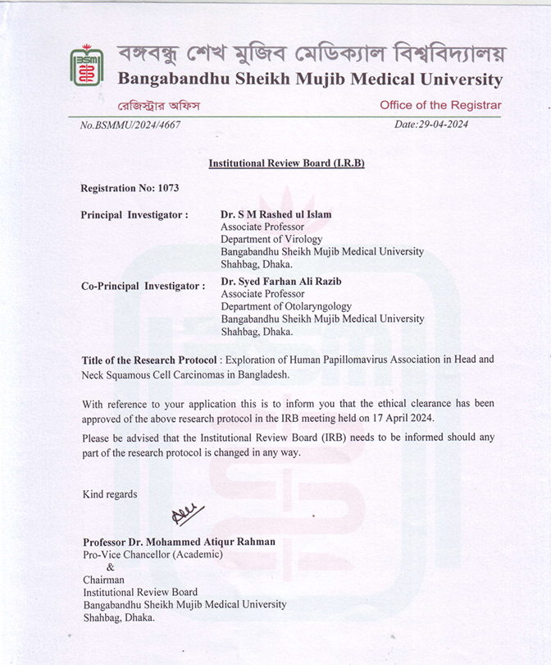Review Board (IRB) Certificate**

**Appendix II**

**Consent Form**

**Informed consent form for subjects**

**Title of the study**

“Genomic Exploration of HPV-Associated Head Neck Squamous Cell Carcinoma Occurrence in Bangladesh: An Integrative Histopathological Analysis and Molecular Profiling of HPV”

The purpose of this consent form is to introduce and inform you about the study. It will help you to decide whether you should take part in the study or not.

**Introduction**

Head-Neck Squamous Cell Carcinoma (HNSCC) represents a substantial global public health burden. However, in developing nations like Bangladesh, the association between HNSCC and Human Papillomavirus (HPV) infection presents a distinct challenge. Although HPV is a well-established risk factor for HNSCC on a global scale, its influence on disease prognosis and treatment outcomes, particularly within Bangladeshi populations, necessitates further investigation.

**Purpose and place of the study:**

This study will be held at the Department of Virology, BSMMU, human serum and tissue samples will be collected from the blood and organ respectively for further procedure.

**Procedure, risks, and hazards**

In this study, some information will be collected through a designed questionnaire. Individuals suffering from Head and Neck Squamous Cell Carcinoma (HNSCC) will be selected. In addition, healthy people will be enrolled in the study. About 10 ml of blood samples and 5 mm tissue will be collected from the selected persons by trained personnel for further laboratory procedures. During the procedure of blood and tissue collection, patients may feel some pain. Otherwise, there will be no other risk in this study.

**Potential benefits:**

In this study, HPV association in HNSCC will be detected. We will be able to know HPV-infected people who are more susceptible to Head and Neck Squamous Cell Carcinoma (HNSCC).

**Confidentiality:**

All the data and information of the patients will be kept confidential. Patients personal and confidential information will not be used in any publication and only the researcher will have access to them.

**Self-participation:**

The decision to take part in the study will be yours. You have every right to withdraw yourself from the study participation at any time. There will be no violation of your rights after signing the consent form.

**Giving consent:**

I am satisfied with the participation and purpose of the study after consulting with the researcher. I know that the decision will be only mine to take part in the study or to withdraw myself from the study. I have read the above facts/ all are read in front of me. I agree to take part in this study.

Name of the participant: ……………………………..

Signature/Thumbprint of the Participant Date

Name of the interviewer: ……………………………..

Signature of the interviewer Date

Name of the witness: ……………………………..

Signature of the witness Date

**Appendix II**

**অবহিতক্রমে m¤§wZ cÎ**

**শিরোনামঃ** "বাংলাদেশে এইচপিভি (Human Papillomavirus)- সংশ্লিষ্ট মাথা ও গলায় ক্যান্সারের (Head and Neck Squamous Cell Carcinomas) ঘটনার জিনোমিক অনুসন্ধান: HPV-এর সমন্বিত হিস্টোপ্যাথোলজিক্যাল বিশ্লেষণ ও আণবিক প্রোফাইলিং"

এই সম্মতিপত্রের উদ্দেশ্য হল আপনাকে প্রয়োজনীয় তথ্য প্রদান করা, তথ্যগুলো **আ**পনাকে সিদ্ধান্ত নিতে সাহায্য করবে যে, আপনি এই গবেষণায় অংশগ্রহন করবেন কি না ?

**ভুমিকাঃ**

মাথায় ও গলায় সৃষ্ট শল্ককলা, ক্যান্সার বিশ্বব্যাপী জনস্বাস্থ্যের ক্ষেত্রে একটি মারাত্মক সমস্যা। কিন্তু বাংলাদেশের মতো উন্নয়নশীল দেশগুলোতে, মাথায় ও গলায় এই ক্যান্সারের (HNSCC) সাথে হিউম্যান প্যাঁপিলোমা ভাইরাস (HPV) সংক্রমণের সম্পর্ক দেখা দেয়, যা আলাদা একটি চ্যালেঞ্জ হিসেবে দেখা দিয়েছে। বিশ্বব্যাপী এই ধরনের ক্যান্সারের (HNSCC) ঝুঁকিপূর্ণ কারণ হিসেবে HPV ইতিমধ্যেই স্বীকৃত, তবে বাংলাদেশি জনগণের ক্ষেত্রে বিশেষভাবে এই ভাইরাসের সংক্রমণ কীভাবে রোগের পূর্বাভাস এবং চিকিৎসার ফলাফলকে প্রভাবিত করে, সে বিষয়ে আরও গবেষণা প্রয়োজন।

**গবেষণার উদ্দেশ্যঃ**

এই গবেষণাটি বি.এস.এম.ম.উ. এর ভাইরোলজি বিভাগে অনুষ্ঠিত হবে। গবেষণার জন্য রক্ত থেকে মানব রক্তরস (এবং অঙ্গ থেকে টিস্যু নমুনা সংগ্রহ করা হবে। প্রয়োজনীয় পরীক্ষা-নিরীক্ষার জন্য এই নমুনা সংগ্রহ করা হবে।

**গবেষণার পদ্ধতিঃ**

এই গবেষণায়, বিশেষভাবে তৈরি করা প্রশ্নাবলীর মাধ্যমে কিছু তথ্য সংগ্রহ করা হবে। মাথায় ও গলায় সৃষ্ট শল্ককলা,ক্যান্সার রোগে আক্রান্ত ব্যক্তিদের বাছাই করা হবে। এছাড়াও, সুস্থ মানুষ্যদের এই গবেষণায় অংশগ্রহণ করানো হবে। নির্বাচিত ব্যক্তিদের থেকে প্রশিক্ষিত কর্মীরা পরবর্তী পরীক্ষাগার পদ্ধতির জন্য প্রায় ১০ মিলিলিটার রক্তের নমুনা এবং ৫ মিমি টিস্যু) সংগ্রহ করবেন। রক্ত ও টিস্যু সংগ্রহের সময়, রোগীরা কিছুটা ব্যথা অনুভব করতে পারেন। এর বাইরে এই গবেষণায় আর কোনো ঝুঁকি নেই।

**গবেষণা ঝুকিঃ**

এই গবেষণায় রোগীর শরীরের নির্দিষ্ট জীন এর বৈশিষ্ট্য সনাক্ত করা হবে। সামান্য রক্ত সংগ্রহ করার সময় সামান্য ব্যথা ব্যতিত রোগীর অন্য কোনো সমস্যা হবার আশঙ্কা থাকে না।

**গবেষণায় অংশগ্রহণের সুবিধাদিঃ**

গবেষণায় অংশগ্রহণের ফলে আপনার রক্তের বাছাইকৃত জীন এর বৈশিষ্ট্য সনাক্ত করা হবে।

**গোপনীয়তাঃ**

এই গবেষণার সময় আপনার যাবতীয় তথ্য যত্নের সাথে গোপনীয় রাখা হবে। আপনার আইডি নম্বর সম্বলিত সবধরনের কাগজপত্রে আপনার নাম ও ঠিকানা বসিয়ে গোপনীয়তার সাথে রাখা হবে এবং ব্যক্তিগত বিষয়াদি, তথ্য বিশ্লেষণ, প্রতিবেদন তৈরিতে এবং প্রকাশনার কাজে ব্যবহার করা হবে না এবং গবেষণার পরীক্ষক ব্যতিত কারো কাছে প্রকাশ করা হবে না।

**স্বেচ্ছামূলক অংশগ্রহণঃ**

এই গবেষণায় আপনার অংশগ্রহণ সম্পূর্ণ স্বেচ্ছামূলক। আপনি গবেষণায় অস্বীকৃতি জানাতে পারেন অথবা গবেষণা চলাকালীন যে কোন সময় গবেষণা থেকে নিজেকে প্রত্যাহার করে নিতে পারেন । এই ফরমে স্বাক্ষর করলে আপনার আইনগত কোনো অধিকার খর্ব হবে না।

**সম্মতির স্বীকারোক্তিঃ**

আমি গবেষণায় নিয়োজিত চিকিৎসকের সাথে এই গবেষণা নিয়ে আলোচনায় সন্তুষ্টি প্রকাশ করছি। আমি এটা বুঝেছি যে, গবেষণায় অংশগ্রহণ স্বেচ্ছামূলক এবং আমি যে কোন সময় কোনো বাধ্য বাধকতা ছাড়াই গবেষণা থেকে নিজেকে বিরত রাখতে পারবো। আমি উপরোক্ত শর্তগুলো পড়েছি/আমার সামনে পঠিত হয়েছে এবং আমি স্বেচ্ছায় এই গবেষণায় অংশগ্রহণ করতে সম্মতি জানাচ্ছি।

অংশগ্রহণকারীর নামঃ .......................................

অংশগ্রহণকারীর স্বাক্ষর / টিপসহি

তারিখ

সাক্ষাতগ্রহণকারীর নামঃ .........................................

সাক্ষাতগ্রহণকারীর স্বাক্ষর তারিখ

সাক্ষীর নামঃ.........................................

সাক্ষীর স্বাক্ষর তারিখ

**Appendix III**

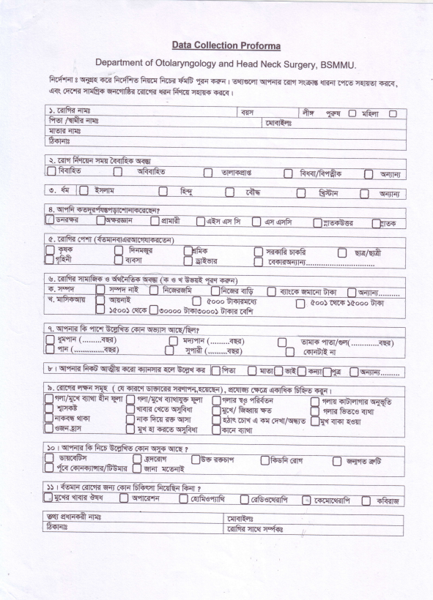**Data Collection Sheet**

1. No. of lifetime sex partners: i. 1 ii. 2 iii. 3

iv.4 v. >4

1. HPV Positive Sex partner: i. Yes ii. No
2. Age at first sexual intercourse:
3. Total lifetime number of

vaginal sex partners : i. 1 ii. 2 iii. 3 iv.4 v. >4

1. Total lifetime number of

oral sex partners : i. 1 ii. 2 iii. 3 iv.4 v. >4

1. History of casual sex : i. Yes ii. No



**Appendix IV**

**Table 1: Kit contents of QIAamp DNA FFPE tissue and DNA Mini Kit**

|  |  |
| --- | --- |
| **Components** | **Amounts** |
| QIAamp MinElute® Columns | **50 Pcs** |
| Collection Tubes (2 ml) | **50 Pcs** |
| Buffer ATL | **14 ml** |
| Buffer AL | **12 ml** |
| Concentrated Buffer AW1 | **9 ml** |
| Concentrated Buffer AW2 | **13 ml** |
| Buffer ATE | **20 ml** |
| Proteinase K | **1.25 ml** |

**Materials required for DNA extraction**

* Xylene (100%)
* Ethanol (70%, 80%, and 100%)
* Sterile, Nuclease-free pipet tips
* 2ml microcentrifuge tubes
* Microcentrifuge(s) (with rotor for 2 ml tubes) for centrifugation at 4°C and room temperature (15–25°C)
* Disposable gloves
* Eppendorf tube rack
* Vortex machine
* Waste disposal Bin

**Preparation of Buffer AW1**

25 ml ethanol 100% ethanol was added to prepare the AW1 working solution to the bottle containing 19 ml Buffer AW1 concentrate.

**Preparation of Buffer AW2**

Add 30 ml ethanol 100% to the bottle containing 13 ml Buffer AW2 concentrate for preparing the AW2 working solution.

**Appendix IV**

|  |  |  |  |
| --- | --- | --- | --- |
| **High Risk** | | | **Low Risk** |
| HPV 16 | HPV 39 | HPV 66 | HPV 6 |
| HPV 18 | HPV 45 | HPV 67 | HPV 11 |
| HPV 26 | HPV 51 | HPV 68 |  |
| HPV 30 | HPV 52 | HPV 69 |  |
| HPV 31 | HPV 53 | HPV 70 |  |
| HPV 33 | HPV 56 | HPV 73 |  |
| HPV 34 | HPV 58 | HPV 82 |  |
| HPV 35 | HPV 59 | HPV 97 |  |

**Table 2: Cancer-causing status of 26 Human Papillomavirus (HPV)**

|  |  |
| --- | --- |
| **Components Name** | **Amounts** |
| HPV Screening Master Mix (SMM) | **350 µl** |
| HPV Enzyme Mix | **25 µl** |
| Positive Control | **100 µl** |
| Negative Control | **100 µl** |

**Table 3: Kit contents of NoeDx HPV 26 screening kit**

|  |  |
| --- | --- |
| **Components Name** | **Amounts** |
| HPV GMM 1 | **350 µl** |
| HPV GMM 2 | **350 µl** |
| HPV GMM 3 | **350 µl** |
| HPV GMM 4 | **350 µl** |
| HPV GMM 5 | **350 µl** |
| HPV Enzyme Mix | **125 µl** |
| Positive Control | **100 µl** |
| Negative Control | **100 µl** |

**Table 4: Kit Contents of NoeDx HPV 14 Genotyping Kit**

**Materials required for performing RT-PCR**

* Sterile, Nuclease-free pipet tips
* PCR tubes
* Microcentrifuge(s) (with rotor for PCR tubes) disposable gloves
* Eppendorf tube rack
* Thermal Cycler machine
* Waste disposal bin

**Appendix VI**

**Table 5: Dye channel orientation during RT-PCR amplification of specific HPV strain**

|  |  |  |
| --- | --- | --- |
| **GMM Tube** | **Target HPV Strain** | **Dye Channel** |
| **HPV**  **GMM1** | HPV Genotype 18 | FAM |
| HPV Genotype 45 | VIC |
| HPV Genotype 39 | ROX |
| Internal Control | Cy 5 |
| **HPV**  **GMM2** | HPV Genotype 16 | FAM |
| HPV Genotype 52 | VIC |
| HPV Genotype 66 | ROX |
| Internal Control | Cy 5 |
| **HPV**  **GMM3** | HPV Genotype 31 | FAM |
| HPV Genotype 33 | VIC |
| HPV Genotype 59 | ROX |
| Internal Control | Cy 5 |
| **HPV**  **GMM4** | HPV Genotype 58 | FAM |
| HPV Genotype 51 | VIC |
| HPV Genotype 35 | ROX |
| Internal Control | Cy 5 |
| **HPV**  **GMM3** | HPV Genotype 56 | FAM |
| HPV Genotype 68 | VIC |
| Internal Control | Cy 5 |

**Appendix VII**

**Table 6: Kit contents of OneTaq Quick-Load 2X master mix**

|  |  |
| --- | --- |
| **Components** | **Amounts** |
| 2X OneTaq Quick-Load Master Mix | **2 X 125 ml** |
| Nuclease Free Water | **2 X 125 ml** |

**Required instruments for performing Nested PCR**

* Sterile, Nuclease-free pipet tips
* 2ml microcentrifuge tubes
* PCR tubes 0.2 ml
* Microcentrifuge(s) (with rotor for 0.2 ml PCR tubes)
* Vortex machine
* Thermal Cycler
* Disposable gloves
* Eppendorf tube rack

**Gel electrophoresis apparatus**

* Agarose powder
* 10X TBE Buffer (Tris-Borate-EDTA)
* Microwaveable flask
* Cylinder
* Weighting machine
* Gel casting tray
* Gloves
* DNA ladder

**Appendix VIII**

**Kit Contents of BigDyeTM Terminator v3.1 Cycle Sequencing Kit**

1. BigDye™ Terminator v3.1 Ready Reaction Mix-stored at -15°C to 250

**This mix contains-**

* DNA polymerase,
* NTPs (deoxynucleotide triphosphates),
* ddNTPs (dideoxynucleotide triphosphates
* Fluorescently labeled terminators

1. BigDye™™ Terminator v3.1 5X Sequencing Buffer- stored at 4°C

**Required material not supplied in the kit:**

* UltraPure™™ DNase/RNase-Free Distilled Water
* Hi-Di™™ Formamide
* Sequencing and PCR primer
* 0.5M EDTA
* Ethanol
* MicroAmp™™ Clear Adhesive Film
* MicroAmp™™ Optical 96-Well Reaction Plate
* Plate Septa, 96 well
* Digital Vortex-Genie™ 2 or equivalent
* Centrifuge with swinging bucket (with PCR plate adapter)

**Appendix IX**

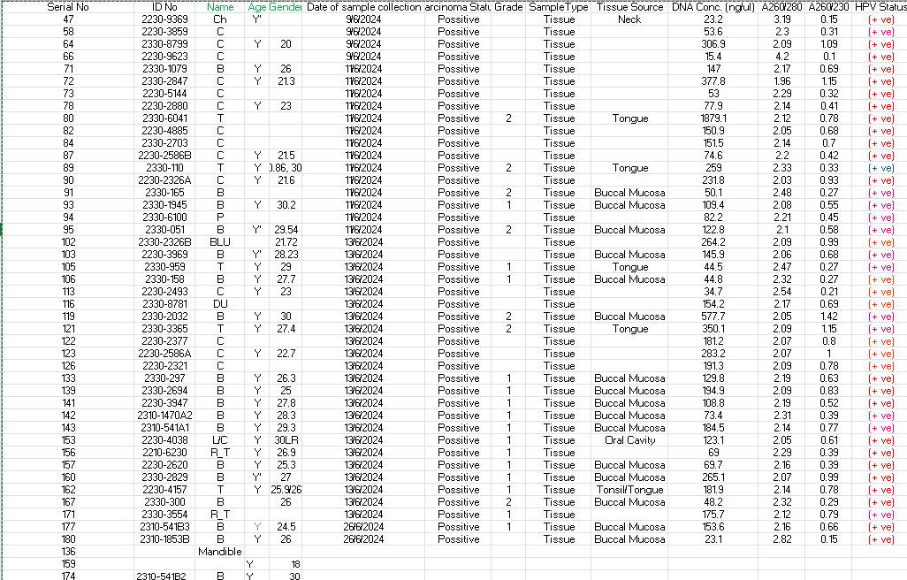**Table 7: HPV screening and genotyping status**

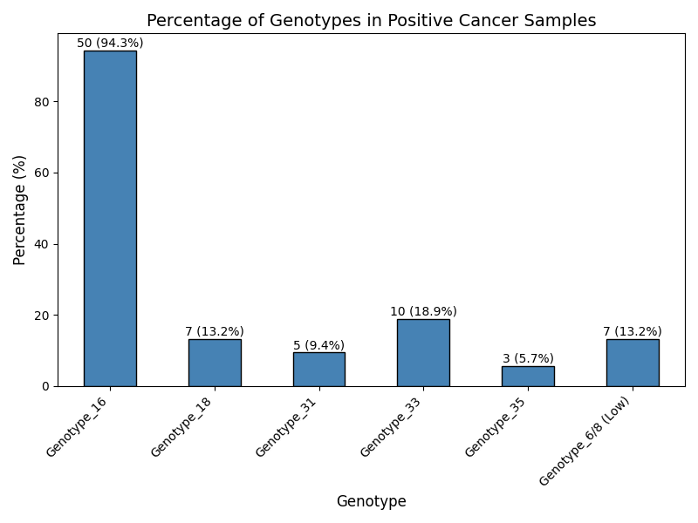**Appendix IX**

**Figure 1: Genotyping status of HPV in collected HNSCC-positive samples**

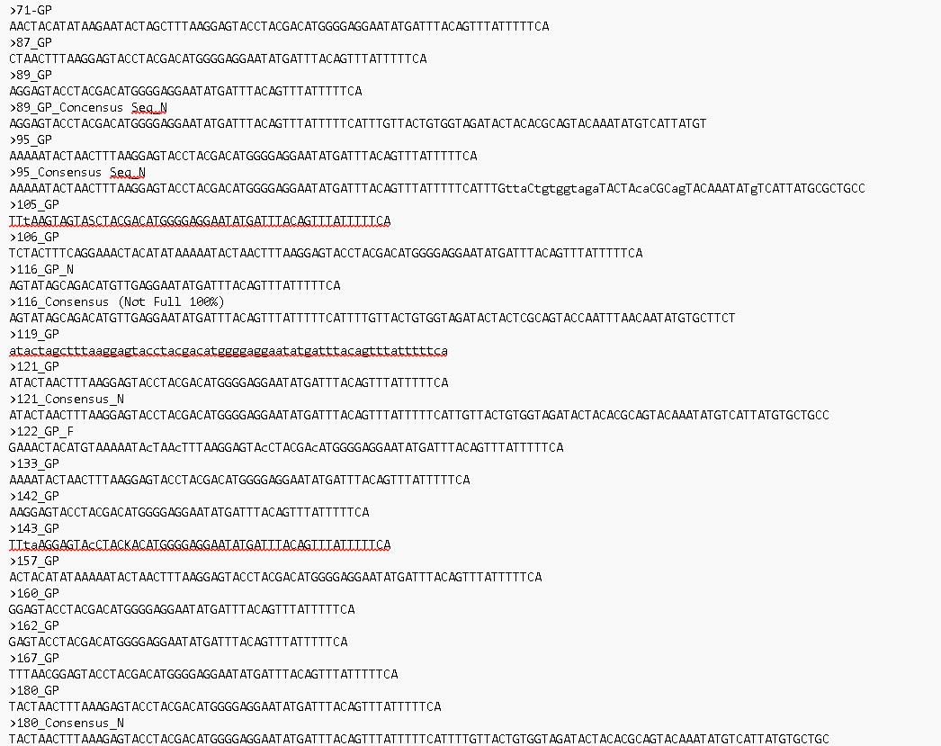**Appendix X**

**Figure 2: Retrieved Sanger Sequencing Data of HPV L1 gene from different samples**

**Appendix XI**

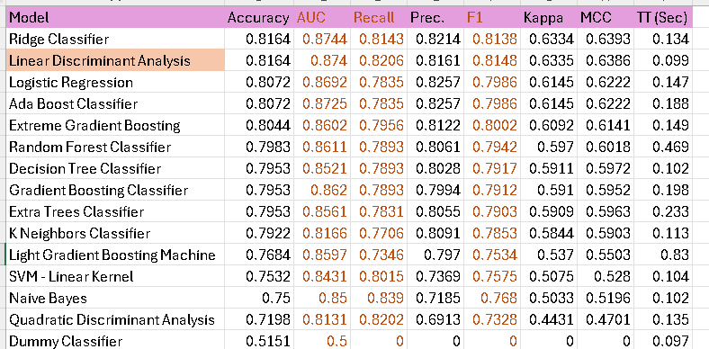**Table 8: Performance matrices of 15 machine learning (ML) model**

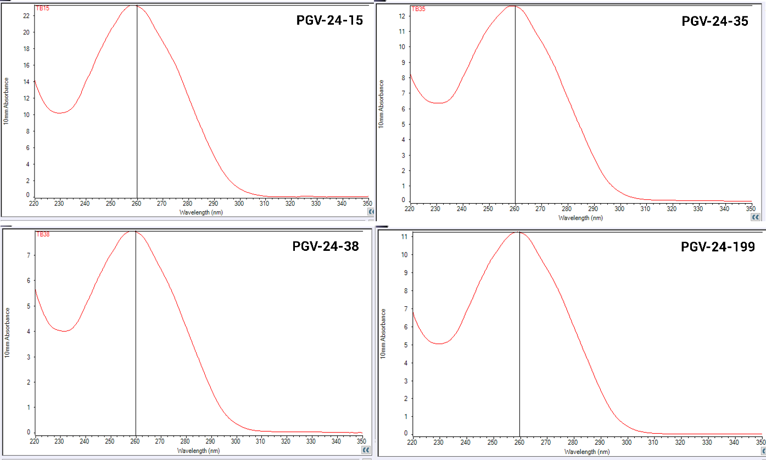**Appendix XII**

**Figure 3: Spectrophotometric analysis of extracted DNA samples.** (The X-axis represents the wavelength, considering the unit as a nanometer while the Y-axis presents the absorbance value.)

|  |  |  |  |
| --- | --- | --- | --- |
| **Sample ID** | **DNA Concentration** | **A260/280** | **A260/230** |
| PGV-24-15 | **1158.3 ng/µl** | **1.91** | **2.28** |
| PGV-24-35 | **631.7 ng/µl** | **1.89** | **2.0** |
| PGV-24-38 | **396.2 ng/µl** | **1.91** | **1.98** |
| PGV-24-199 | **562.0 ng/µl** | **1.88** | **2.23** |

**Table 9: Quantitative and purity assessment of extracted DNA**

**Appendix XIII**

**Figure 4: Phylogenetic tree analysis between query and reference sequences.**

**Appendix XIV**

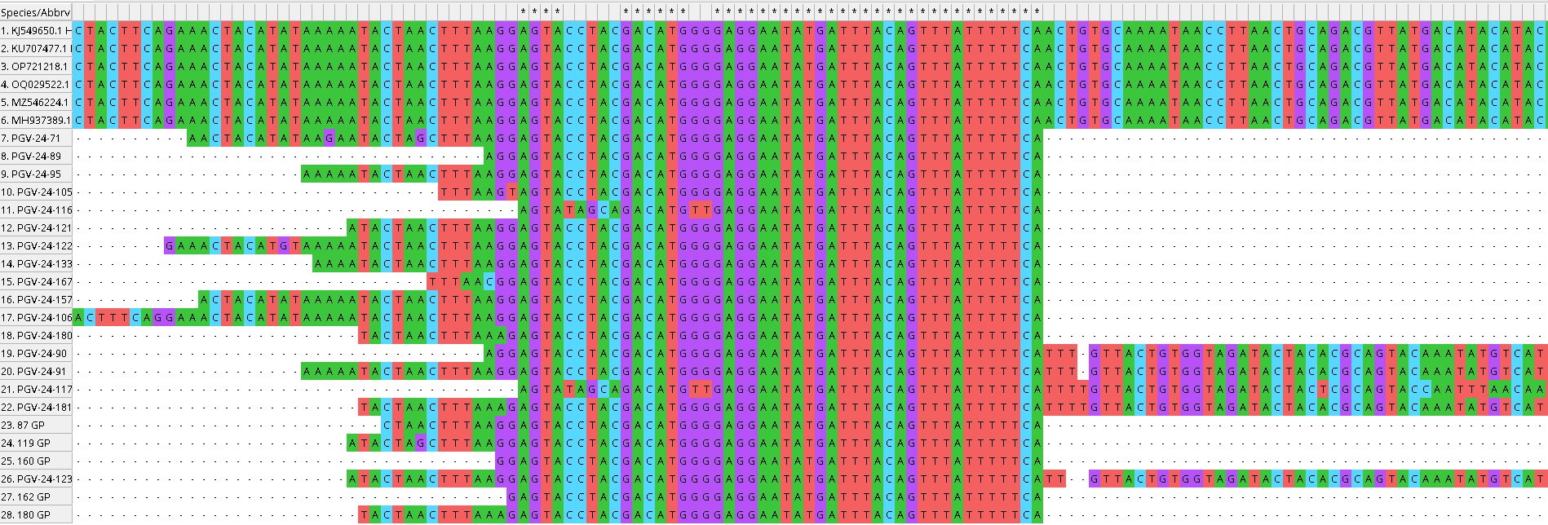

**Figure 5: Mutational analysis of our retrieval sequences.**

**Appendix XV**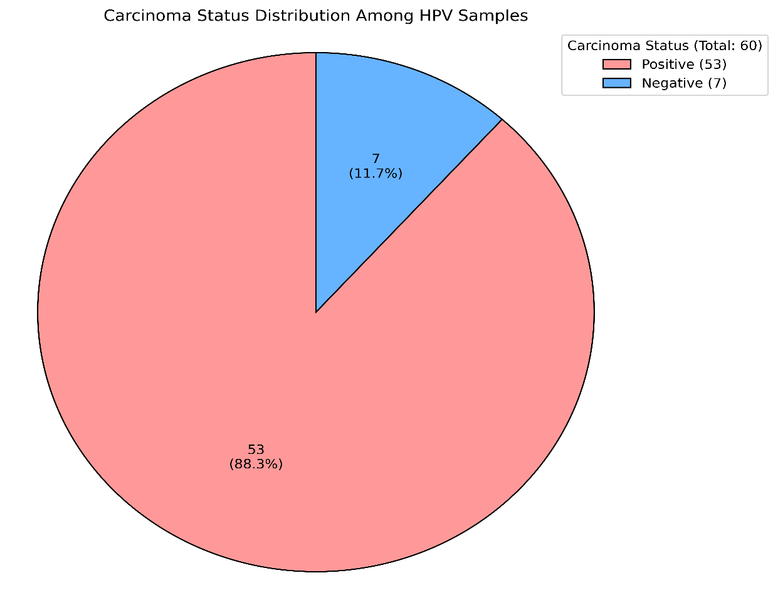

**Figure 6: Carcinoma status distribution among HPV-positive samples**